UNITED STATES
SECURITIES AND EXCHANGE COMMISSION
WASHINGTON, D.C. 20549

FORM 8-K

CURRENT REPORT
Pursuant to Section 13 or 15(d) of the Securities Exchange Act of 1934
Date of Report (Date of earliest event reported): August 04, 2026

Larimar Therapeutics, Inc.
(Exact name of Registrant as Specified in Its Charter)

Delaware |  |  | 001-36510 | 20-3857670
(State or Other Jurisdiction  of Incorporation) |  |  | (Commission File Number) | (IRS Employer  Identification No.)
Three Bala Plaza East
Bala Cynwyd, Pennsylvania |  |  |  | 19004
(Address of Principal Executive Offices) |  |  |  | (Zip Code)

Registrant’s Telephone Number, Including Area Code: (844) 511-9056

,
(Former Name or Former Address, if Changed Since Last Report)

Check the appropriate box below if the Form 8-K filing is intended to simultaneously satisfy the filing obligation of the registrant under any of the following provisions:
☐Written communications pursuant to Rule 425 under the Securities Act (17 CFR 230.425)
☐Soliciting material pursuant to Rule 14a-12 under the Exchange Act (17 CFR 240.14a-12)
☐Pre-commencement communications pursuant to Rule 14d-2(b) under the Exchange Act (17 CFR 240.14d-2(b))
☐Pre-commencement communications pursuant to Rule 13e-4(c) under the Exchange Act (17 CFR 240.13e-4(c))
Securities registered pursuant to Section 12(b) of the Act:
Title of each class |  | Trading  Symbol(s) |  | Name of each exchange on which registered
Common Stock, par value $0.001 per share |  | LRMR |  | Nasdaq Global Market
Indicate by check mark whether the registrant is an emerging growth company as defined in Rule 405 of the Securities Act of 1933 (§ 230.405 of this chapter) or Rule 12b-2 of the Securities Exchange Act of 1934 (§ 240.12b-2 of this chapter).
Emerging growth company ☐
If an emerging growth company, indicate by check mark if the registrant has elected not to use the extended transition period for complying with any new or revised financial accounting standards provided pursuant to Section 13(a) of the Exchange Act. ☐

Item 2.02 Results of Operations and Financial Condition.
On Augsut 4, 2026, Larimar Therapeutics, Inc. (the “Company”) announced its financial results and operational highlights for the second quarter ended June 30, 2026. A copy of the press release is being furnished as Exhibit 99.1 to this Current Report on Form 8-K and is incorporated herein by reference.
The information furnished pursuant to this Item 2.02, including Exhibit 99.1 attached hereto, is intended to be furnished and shall not be deemed “filed” for purposes of Section 18 of the Securities Exchange Act of 1934, as amended (the “Exchange Act”), or otherwise subject to the liabilities of that section, nor shall it be deemed incorporated by reference in any filing under the Securities Act of 1933, as amended, or the Exchange Act, except as expressly set forth by specific reference in such filing.

Item 8.01 Other Events.
On August 4, 2026, the Company posted on its website an updated slide presentation, which is attached as Exhibit 99.2 to this Current Report on Form 8-K and is incorporated herein by reference. Representatives of the Company will use the presentation in various meetings with investors, analysts and other parties from time to time.

Item 9.01 Financial Statements and Exhibits.
Exhibit No. |  | Document
99.1 |  | Press Release issued by Larimar Therapeutics, Inc. on August 4, 2026*
99.2 |  | Larimar Therapeutics, Inc. Corporate Presentation, dated August 4, 2026**
104 |  | Cover Page Interactive Data File (embedded within the Inline XBRL document)
* Furnished herewith.
** Filed herewith.

SIGNATURES
Pursuant to the requirements of the Securities Exchange Act of 1934, the registrant has duly caused this report to be signed on its behalf by the undersigned hereunto duly authorized.
 |  |  | Larimar Therapeutics, Inc.
Date: | August 4, 2026 | By: | /s/ Carole S. Ben-Maimon, M.D.
Name: Carole S. Ben-Maimon, M.D.
Title: President and Chief Executive Officer



Larimar Therapeutics Reports Second Quarter 2026 Financial and Business Update
•
Positive longer-term open label study data further demonstrated nomlabofusp's well-characterized safety profile, sustained increases in skin frataxin levels, and continued improvements in key clinical outcome measures
•
High patient and investigator enthusiasm continues with additional participants in the OL study dosed in July and several adults and adolescents in screening as of month-end

•
Rolling BLA submission seeking accelerated approval underway, with the first module submitted and completion expected 2H 2026
•
Dosing of first patient in global confirmatory Phase 3 study expected Q3 2026
•
$156.3 million in cash, cash equivalents and marketable securities as of June 30, 2026, with projected cash runway into the third quarter of 2027

Bala Cynwyd, PA, August 4, 2026 – Larimar Therapeutics, Inc. (Larimar) (Nasdaq: LRMR), a clinical-stage biotechnology company focused on developing treatments for complex rare diseases, today reported its second quarter 2026 operating and financial results.

“This is a defining period for Larimar as we advance nomlabofusp toward potential approval, supported by a clear path to submission, a robust data package, and continued clinical momentum,” said Carole Ben-Maimon, MD, President and Chief Executive Officer of Larimar. “Open label (OL) study data announced in June further reinforce the disease-modifying potential of nomlabofusp, demonstrating continued directional improvements in key clinical endpoints over time alongside a well-characterized safety profile. Following receipt of minutes from a successful Type B multidisciplinary pre-BLA meeting with the Food and Drug Administration (FDA), the first module of our rolling Biologics License Application (BLA) has been submitted, with completion expected in the second half of 2026. We continue to see strong enthusiasm from patients and investigators as we advance the OL study with additional participants dosed in July and several adults and adolescents in screening. We are also on track to initiate dosing in our global confirmatory study this quarter. Looking ahead, we are focused on execution as we work to bring forward nomlabofusp as the first potential therapy to address the underlying cause of disease for pediatric and adult patients living with Friedreich’s ataxia (FA).”

Highlights

•
June Open Label Study Data Release. As of June 2026, 43 adolescent and adult participants in the OL study received at least one dose of nomlabofusp and 22 participants remain in the study with a maximum treatment duration of more than 800 days. More than 10,000 doses of nomlabofusp have been administered.
o
Consistent Long-term Safety Profile.
▪
Longer-term dosing was generally well tolerated with thirteen adults on treatment for one year, seven for 18 months and three for two years.
▪
The most common adverse events remained mild-to-moderate local injection site reactions, which decreased in frequency over time and did not lead to any withdrawals from the study.
▪
Twenty-one participants discontinued since study initiation in January 2024.
•
Ten participants experienced anaphylaxis and discontinued the study, including nine participants with prior nomlabofusp exposure; all participants who experienced anaphylaxis responded to standard therapy and all returned to their usual state of health with no further sequelae.

•
Three participants experienced generalized urticaria and discontinued the study, with no new occurrences observed following initiation of antihistamine therapy.
•
Other discontinuations included three associated with other adverse events and five discontinuations unrelated to treatment, primarily due to logistical factors.
▪
Of the eleven participants who had previously not been exposed to nomlabofusp, one had anaphylaxis.
o
Sustained Increases in Skin FXN Levels Comparable to Asymptomatic Carriers. Skin frataxin (FXN) levels increased following nomlabofusp administration, with 82% (9/11) of participants achieving levels above those in asymptomatic carriers by six months, 100% (9/9) reaching this threshold at one year, and 100% (3/3) maintaining it through 18 months.
o
Improvements in Key Clinical Outcome Measures Relative to FACOMS Natural History Population.
▪
Directional improvement across key clinical endpoints, including mFARS, FARS-ADL, and 9-HPT1, was sustained following one year of nomlabofusp treatment (n=13) relative to a worsening in those outcomes observed in the Friedreich’s Ataxia Clinical Outcome Measures Study (FACOMS) reference population.
▪
Nomlabofusp led to a 2.6-point benefit in mFARS at one year.
▪
Improvement in clinical outcomes was associated with increased skin FXN levels, supporting the potential for nomlabofusp to provide clinical benefit across a broad spectrum of patients with FA, including those with advanced disease.

1Modified Friedreich Ataxia Rating Scale (mFARS), FARS-Activities of Daily Living (FARS-ADL), 9-hole peg test (9-HPT)

•
FDA Alignment on BLA Submission Following Multidisciplinary Type B Pre-BLA Meeting: In June, following minutes from a multidisciplinary Type B pre-BLA meeting and FDA review of the nomlabofusp briefing package, Larimar announced continued agreement with the FDA on key elements of a potential BLA submission including:
o
Sufficient Data Package: FDA confirmed that the existing data package appears capable of supporting submission and review of a BLA seeking accelerated approval based on data from the OL study; approval will be a matter of review.
o
FXN as a Novel Surrogate Endpoint: FDA reaffirmed its willingness to consider FXN as a novel surrogate endpoint and confirmed that Larimar's exposure-response analysis linking nomlabofusp exposure to clinical outcomes may support the BLA submission.
o
Gene Expression and Lipid Biomarkers: FDA stated that the prospectively collected gene expression and lipid biomarker data may provide an opportunity to further characterize the biological activity of nomlabofusp beyond FXN tissue concentrations.
o
Rolling BLA Submission: FDA agreed to a rolling BLA submission.

•
Rolling BLA Initiated. In June, Larimar submitted the first module of its rolling BLA submission seeking accelerated approval.

•
Ongoing Advancement of OL Study. As of the end of July, additional participants received their initial dose with several adults and adolescents currently in screening.

Upcoming Milestones
•
Global Confirmatory Phase 3 Study: Dosing of first patient expected Q3 2026.

•
Rolling BLA Submission: Completion expected 2H 2026 of submission seeking accelerated approval.

•
Launch Timing: Targeting mid-2027 launch, if approved.

Second Quarter 2026 Financial Results

As of June 30, 2026, the Company had cash, cash equivalents and marketable securities totaling $156.3 million. The Company projects its cash runway into the third quarter of 2027.

Second quarter of 2026 compared to the second quarter of 2025

The Company reported a net loss for the second quarter of 2026 of $32.8 million, or $0.30 per common share, compared to a net loss of $26.2 million, or $0.41 per common share, for the second quarter of 2025.

Research and development expenses for the second quarter of 2026 were $28.0 million compared to $23.4 million for the second quarter of 2025. The increase in research and development expenses was primarily driven by a $2.2 million increase in process performance qualification, and other drug manufacturing activities at our third-party manufacturers and a $2.0 million increase in professional and consulting fees associated with our ongoing and planned clinical trials, data analysis costs, FDA inspection readiness expenditures, as well as BLA preparation costs.

General and administrative expenses were $6.4 million in the second quarter of 2026 compared to $4.4 million in the second quarter of 2025. The increase in general and administrative expenses primarily related to the acceleration of commercial activities as we prepare for the planned mid-2027 launch of nomlabofusp, if approved. This included an increase of $0.7 million of increased compensation costs associated with additional commercial and related headcount, an increase of $0.5 million of market development activities and commercial readiness efforts as well as an increase of $0.5 million in legal fees supporting commercialization and development efforts.

Six months ended June 30, 2026 compared to the six months ended June 30, 2025

The Company reported a net loss for the first six months of 2026 of $62.4 million, or $0.61 per common share, compared to a net loss of $55.5 million, or $0.87 per common share, for the first six months of 2025.

Research and development expenses for the six months ended June 30, 2026, were $53.0 million compared to $49.9 million for the six months ended June 30, 2025. This increase was driven by a $3.7 million increase in professional and consulting fees associated with our ongoing and planned clinical trials, data analysis costs, inspection readiness expenditures as well as BLA preparation costs partially offset by lower manufacturing activities and there related costs in the six month period ended June 30, 2026 compared to the six month period ended June 30, 2026.

General and administrative expenses were $12.4 million for the first six months of 2026 compared to $9.1 million for the six months ended June 30, 2025. The increase in general and administrative expenses primarily related to the acceleration of commercial activities as we prepare for the planned mid-2027 launch of nomlabofusp, if approved. This included an increase of $1.6 million in market research, market development and other commercial readiness activities, an increase of $1.0 million of increased compensation costs associated with additional commercial and related headcount, as well as an increase of $0.5 million in legal fees supporting commercialization and development efforts.

About Larimar Therapeutics
Larimar Therapeutics, Inc. (Nasdaq: LRMR), is a clinical-stage biotechnology company focused on developing treatments for complex rare diseases. Larimar’s lead compound, nomlabofusp, is being developed as a potential treatment for Friedreich's ataxia. Larimar also plans to use its intracellular delivery platform to design other fusion proteins to target additional rare diseases characterized by deficiencies in intracellular bioactive compounds. For more information, please visit: https://larimartx.com.

Forward-Looking Statements
This press release contains forward-looking statements that are based on Larimar’s management’s beliefs and assumptions and on information currently available to management. All statements contained in this release other than statements of historical fact are forward-looking statements, including but not limited to statements regarding Larimar’s ability to develop and commercialize nomlabofusp and any other planned product candidates, Larimar’s planned research and development efforts, including the timing of its nomlabofusp clinical trials, dosing of the first patient in a global confirmatory Phase 3 study, interactions and filings with the FDA, the safety and therapeutic potential of nomlabofusp, expectations regarding the timing of completion of the BLA submission, the expectations of the timing of, and potential for, accelerated approval or accelerated access, time to launch and market and overall development plans and other matters regarding Larimar’s business strategies, ability to raise capital, use of capital, results of operations and financial position, and plans and objectives for future operations.

In some cases, you can identify forward-looking statements by the words “may,” “will,” “could,” “would,” “should,” “expect,” “intend,” “plan,” “anticipate,” “believe,” “estimate,” “predict,” “project,” “potential,” “continue,” “ongoing” or the negative of these terms or other comparable terminology, although not all forward-looking statements contain these words. These statements involve risks, uncertainties and other factors that may cause actual results, performance, or achievements to be materially different from the information expressed or implied by these forward-looking statements. These risks, uncertainties and other factors include, among others, the success, cost and timing of Larimar’s product development activities, nonclinical studies and clinical trials, including nomlabofusp clinical milestones and continued interactions with the FDA; that preliminary clinical trial results may differ from final clinical trial results, that earlier non-clinical and clinical data and testing of nomlabofusp may not be predictive of the results or success of later non-clinical or clinical trials, and assessments; delays in patient recruitment, including as a result of changes in clinical protocols and adverse events; that the FDA may not ultimately agree with Larimar’s nomlabofusp development strategy; Larimar’s ability to submit BLA modules on the intended timeline; Larimar’s ability to realize the benefits of Breakthrough Therapy Designation; the potential impact of public health crises on Larimar’s future clinical trials, manufacturing, regulatory, nonclinical study timelines and operations, and general economic conditions; Larimar’s ability and the ability of third-party manufacturers Larimar engages, to optimize and scale nomlabofusp’s manufacturing process; Larimar’s ability to obtain regulatory approvals for nomlabofusp and future product candidates; Larimar’s ability to develop sales and marketing capabilities, whether alone or with potential future collaborators, and to successfully commercialize any approved product candidates; Larimar’s ability to raise the necessary capital to conduct its product development activities; and other risks described in the filings made by Larimar with the Securities and Exchange Commission (SEC), including but not limited to Larimar’s periodic reports, including the annual report on Form 10-K, quarterly reports on Form 10-Q and current reports on Form 8-K, filed with or furnished to the SEC and available at www.sec.gov. These forward-looking statements are based on a combination of facts and factors currently known by Larimar and its projections of the future, about which it cannot be certain. As a result, the forward-looking statements may not prove to be accurate. The forward-looking statements in this press release represent Larimar’s management’s views only as of the date hereof. Larimar undertakes no obligation to update any forward-looking statements for any reason, except as required by law.

Investor Contact:  Joyce Allaire  LifeSci Advisors  jallaire@lifesciadvisors.com  (212) 915-2569 | Company Contact:  Michael Celano  Chief Financial Officer  mcelano@larimartx.com  (484) 414-2715

Larimar Therapeutics, Inc.
Consolidated Balance Sheets
(In thousands except share data)
(unaudited)
 |  | June 30, |  | December 31,
 |  | 2026 |  | 2025
Assets
Current assets:
Cash and cash equivalents |  | $ 92,687 |  | $ 85,412
Marketable securities |  | 63,580 |  | 51,440
Prepaid expenses and other current assets |  | 4,405 |  | 5,170
Total current assets |  | 160,672 |  | 142,022
Property and equipment, net |  | 639 |  | 622
Operating lease right-of-use assets |  | 3,055 |  | 2,069
Restricted cash |  | 456 |  | 606
Other assets |  | 480 |  | 523
Total assets |  | $ 165,302 |  | $ 145,842
Liabilities and Stockholders’ Equity
Current liabilities:
Accounts payable |  | $ 7,597 |  | $ 5,216
Accrued expenses |  | 25,367 |  | 58,474
Operating lease liabilities, current |  | 1,202 |  | 1,105
Total current liabilities |  | 34,166 |  | 64,795
Operating lease liabilities |  | 3,754 |  | 2,962
Total liabilities |  | 37,920 |  | 67,757
Commitments and contingencies (See Note 8)
Stockholders’ equity:
Preferred stock; $0.001 par value per share; 5,000,000 shares authorized as of June 30, 2026 and December 31, 2025; 500,000 and 250,000 shares issued and outstanding as of June 30, 2026 and December 31, 2025, respectively |  | 1 |  | —
Common stock, $0.001 par value per share; 215,000,000 and 115,000,000 shares authorized as of June 30, 2026 and December 31, 2025, respectively; 103,882,937 and 83,090,392 shares issued and outstanding as of June 30, 2026 and December 31, 2025, respectively |  | 103 |  | 83
Additional paid-in capital |  | 624,516 |  | 512,779
Accumulated deficit |  | (497,226) |  | (434,831)
Accumulated other comprehensive gain (loss) |  | (12) |  | 54
Total stockholders’ equity |  | 127,382 |  | 78,085
Total liabilities and stockholders’ equity |  | $ 165,302 |  | $ 145,842

Larimar Therapeutics, Inc.
Consolidated Statements of Operations
(In thousands, except share and per share data)
(unaudited)
 | Three Months Ended June 30, |  | Six Months Ended June 30,
 | 2026 | 2025 | 2026 | 2025
Operating expenses:
Research and development | $ 28,000 | $ 23,368 | $ 53,031 | $ 49,919
General and administrative | 6,351 | 4,424 | 12,437 | 9,060
Total operating expenses | 34,351 | 27,792 | 65,468 | 58,979
Loss from operations | (34,351) | (27,792) | (65,468) | (58,979)
Other income, net | 1,569 | 1,610 | 3,073 | 3,516
Net loss | $ (32,782) | $ (26,182) | $ (62,395) | $ (55,463)
Comprehensive loss:
Net loss | $ (32,782) | $ (26,182) | $ (62,395) | $ (55,463)
Other comprehensive loss:
Unrealized loss on marketable securities | (18) | (63) | (66) | (157)
Total other comprehensive loss | (18) | (63) | (66) | (157)
Total comprehensive loss | $ (32,800) | $ (26,245) | $ (62,461) | $ (55,620)
Basic and diluted net loss per share:
Common stock | $ 0.30 | $ 0.41 | $ 0.61 | $ 0.87
Preferred stock | 3.01 | $ — | 6.14 | —
Weighted-average shares used in computing basic and
diluted net loss per share:
Common stock | 103,882,937 | 64,027,892 | 96,887,741 | 63,996,126
Preferred stock | 500,000 | — | 470,994 | —


pro August 2026 Larimar Therapeutics Corporate Deck

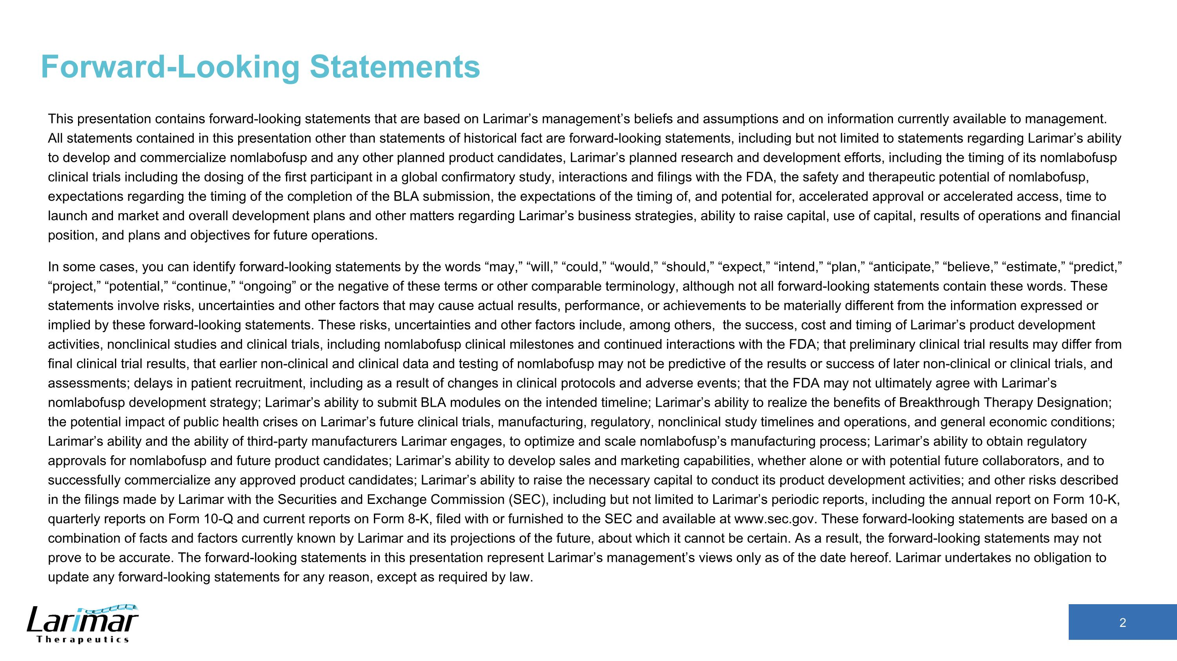
Forward-Looking Statements This presentation contains forward-looking statements that are based on Larimar’s management’s beliefs and assumptions and on information currently available to management. All statements contained in this presentation other than statements of historical fact are forward-looking statements, including but not limited to statements regarding Larimar’s ability to develop and commercialize nomlabofusp and any other planned product candidates, Larimar’s planned research and development efforts, including the timing of its nomlabofusp clinical trials including the dosing of the first participant in a global confirmatory study, interactions and filings with the FDA, the safety and therapeutic potential of nomlabofusp, expectations regarding the timing of the completion of the BLA submission, the expectations of the timing of, and potential for, accelerated approval or accelerated access, time to launch and market and overall development plans and other matters regarding Larimar’s business strategies, ability to raise capital, use of capital, results of operations and financial position, and plans and objectives for future operations. In some cases, you can identify forward-looking statements by the words “may,” “will,” “could,” “would,” “should,” “expect,” “intend,” “plan,” “anticipate,” “believe,” “estimate,” “predict,” “project,” “potential,” “continue,” “ongoing” or the negative of these terms or other comparable terminology, although not all forward-looking statements contain these words. These statements involve risks, uncertainties and other factors that may cause actual results, performance, or achievements to be materially different from the information expressed or implied by these forward-looking statements. These risks, uncertainties and other factors include, among others, the success, cost and timing of Larimar’s product development activities, nonclinical studies and clinical trials, including nomlabofusp clinical milestones and continued interactions with the FDA; that preliminary clinical trial results may differ from final clinical trial results, that earlier non-clinical and clinical data and testing of nomlabofusp may not be predictive of the results or success of later non-clinical or clinical trials, and assessments; delays in patient recruitment, including as a result of changes in clinical protocols and adverse events; that the FDA may not ultimately agree with Larimar’s nomlabofusp development strategy; Larimar’s ability to submit BLA modules on the intended timeline; Larimar’s ability to realize the benefits of Breakthrough Therapy Designation; the potential impact of public health crises on Larimar’s future clinical trials, manufacturing, regulatory, nonclinical study timelines and operations, and general economic conditions; Larimar’s ability and the ability of third-party manufacturers Larimar engages, to optimize and scale nomlabofusp’s manufacturing process; Larimar’s ability to obtain regulatory approvals for nomlabofusp and future product candidates; Larimar’s ability to develop sales and marketing capabilities, whether alone or with potential future collaborators, and to successfully commercialize any approved product candidates; Larimar’s ability to raise the necessary capital to conduct its product development activities; and other risks described in the filings made by Larimar with the Securities and Exchange Commission (SEC), including but not limited to Larimar’s periodic reports, including the annual report on Form 10-K, quarterly reports on Form 10-Q and current reports on Form 8-K, filed with or furnished to the SEC and available at www.sec.gov. These forward-looking statements are based on a combination of facts and factors currently known by Larimar and its projections of the future, about which it cannot be certain. As a result, the forward-looking statements may not prove to be accurate. The forward-looking statements in this presentation represent Larimar’s management’s views only as of the date hereof. Larimar undertakes no obligation to update any forward-looking statements for any reason, except as required by law.

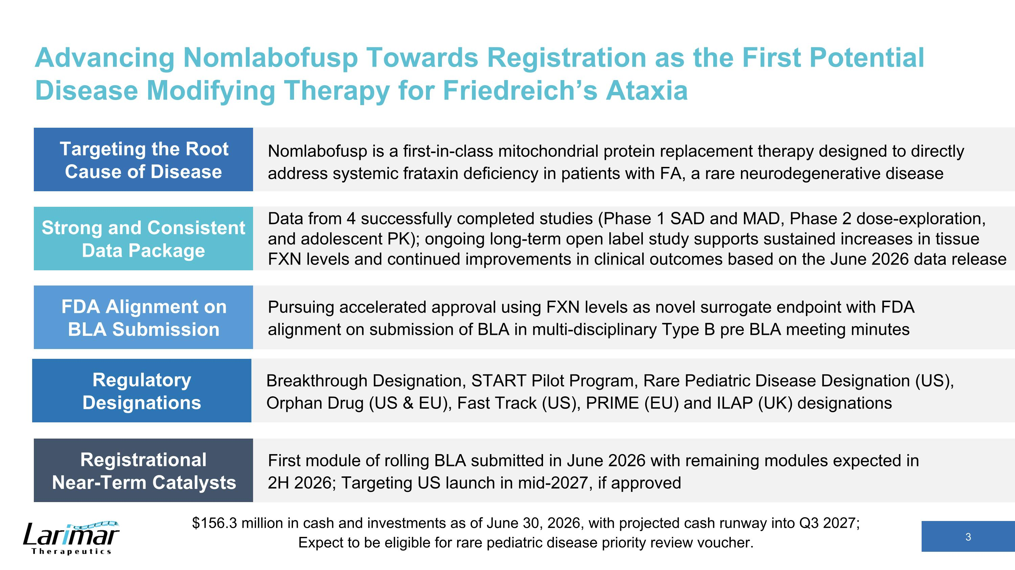
Advancing Nomlabofusp Towards Registration as the First Potential Disease Modifying Therapy for Friedreich’s Ataxia Nomlabofusp is a first-in-class mitochondrial protein replacement therapy designed to directly address systemic frataxin deficiency in patients with FA, a rare neurodegenerative disease Targeting the Root Cause of Disease Strong and Consistent Data Package Data from 4 successfully completed studies (Phase 1 SAD and MAD, Phase 2 dose-exploration,?and adolescent PK); ongoing long-term open label study supports sustained increases in tissue FXN levels and continued improvements in clinical outcomes based on the June 2026 data release FDA Alignment on BLA Submission Pursuing accelerated approval using FXN levels as novel surrogate endpoint with FDA alignment on submission of BLA in multi-disciplinary Type B pre BLA meeting minutes Registrational ?Near-Term Catalysts First module of rolling BLA submitted in June 2026 with remaining modules expected in ?2H 2026; Targeting US launch in mid-2027, if approved Regulatory Designations Breakthrough Designation, START Pilot Program, Rare Pediatric Disease Designation (US), Orphan Drug (US & EU), Fast Track (US), PRIME (EU) and ILAP (UK) designations $156.3 million in cash and investments as of June 30, 2026, with projected cash runway into Q3 2027; ?Expect to be eligible for rare pediatric disease priority review voucher.

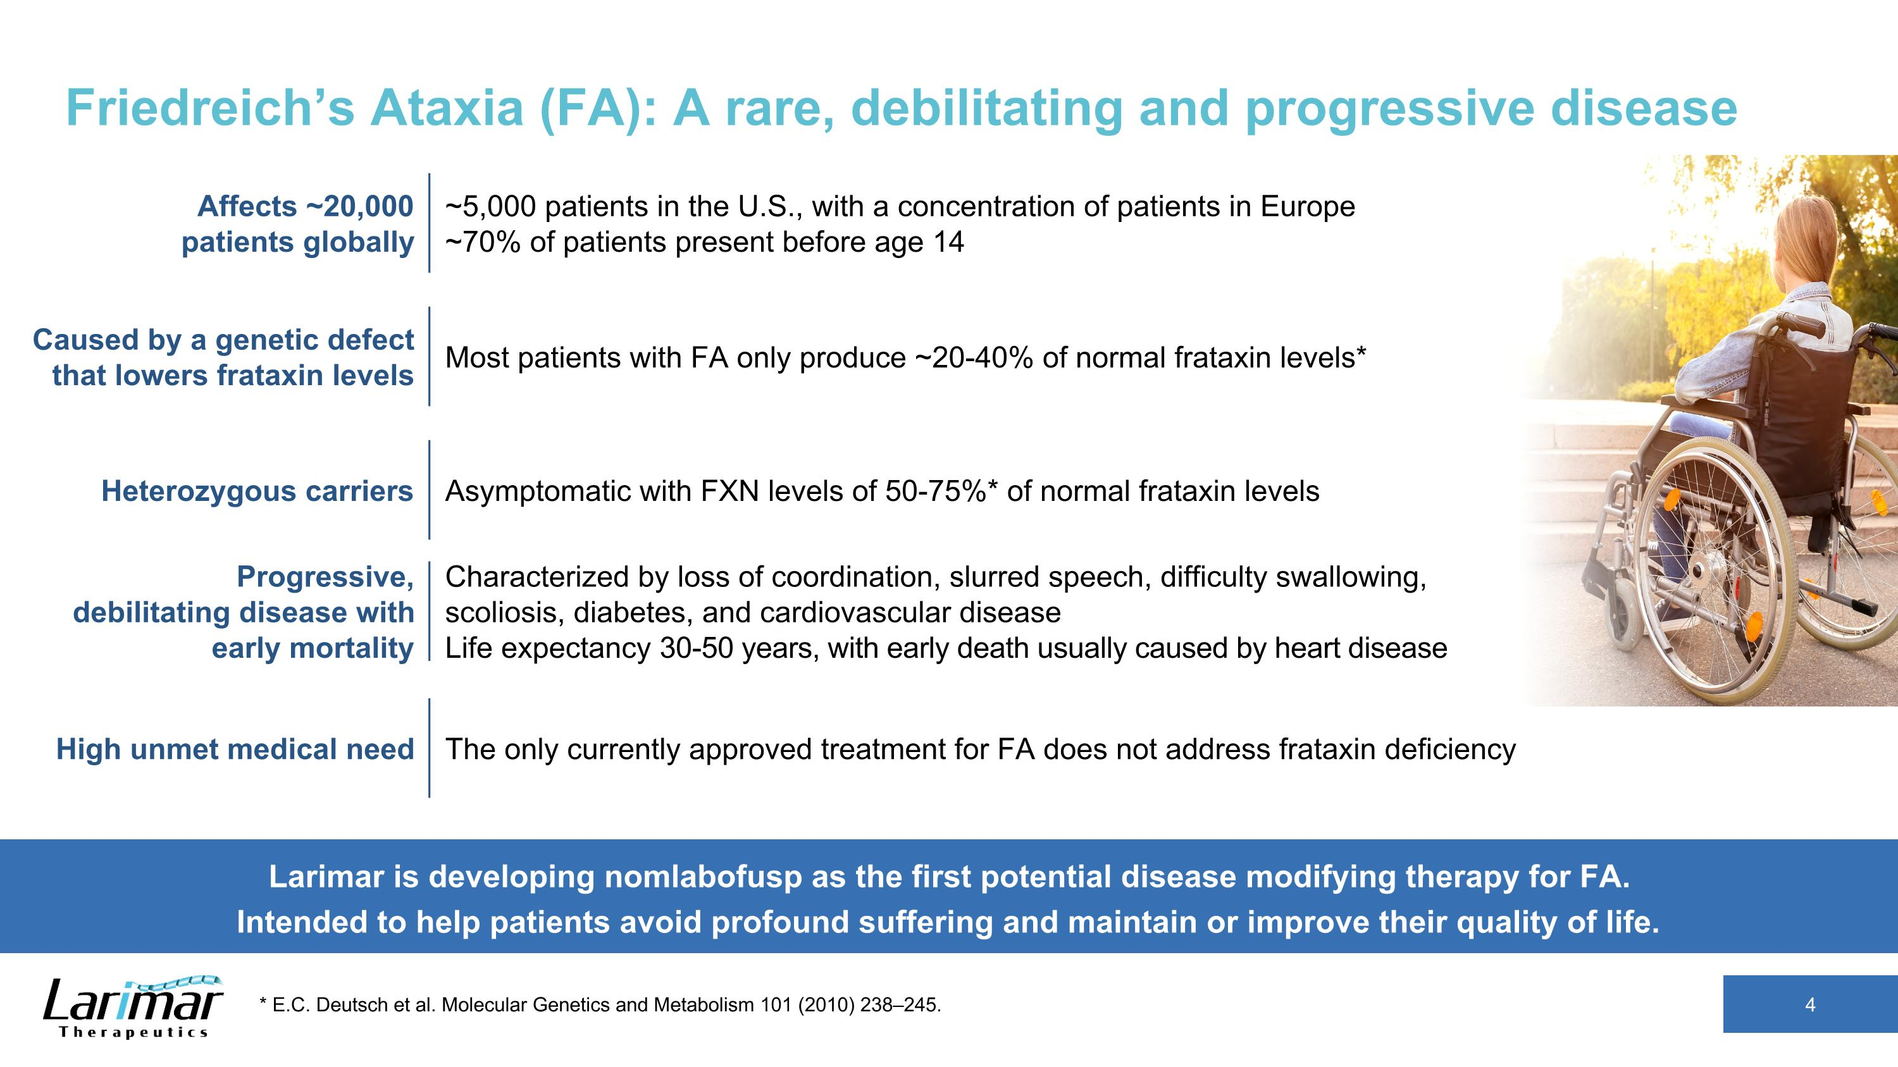
Friedreich’s Ataxia (FA): A rare, debilitating and progressive disease 4 * E.C. Deutsch et al. Molecular Genetics and Metabolism 101 (2010) 238–245. Larimar is developing nomlabofusp as the first potential disease modifying therapy for FA. Intended to help patients avoid profound suffering and maintain or improve their quality of life. Affects ~20,000 patients globally ~5,000 patients in the U.S., with a concentration of patients in Europe?~70% of patients present before age 14 Caused by a genetic defect that lowers frataxin levels Most patients with FA only produce ~20-40% of normal frataxin levels* Heterozygous carriers Asymptomatic with FXN levels of 50-75%* of normal frataxin levels High unmet medical need The only currently approved treatment for FA does not address frataxin deficiency Progressive, debilitating disease with early mortality Characterized by loss of coordination, slurred speech, difficulty swallowing, scoliosis, diabetes, and cardiovascular disease ?Life expectancy 30-50 years, with early death usually caused by heart disease

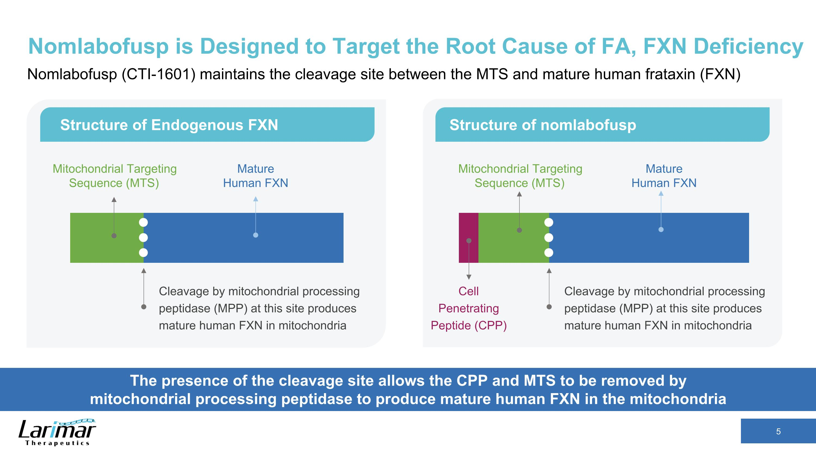
Nomlabofusp is Designed to Target the Root Cause of FA, FXN Deficiency Nomlabofusp (CTI-1601) maintains the cleavage site between the MTS and mature human frataxin (FXN) The presence of the cleavage site allows the CPP and MTS to be removed by ?mitochondrial processing peptidase to produce mature human FXN in the mitochondria Structure of Endogenous FXN Structure of nomlabofusp Cleavage by mitochondrial processing peptidase (MPP) at this site produces mature human FXN in mitochondria Mitochondrial Targeting Sequence (MTS) Mature Human FXN Cleavage by mitochondrial processing peptidase (MPP) at this site produces mature human FXN in mitochondria Mature Human FXN Cell Penetrating Peptide (CPP) Mitochondrial Targeting Sequence (MTS)

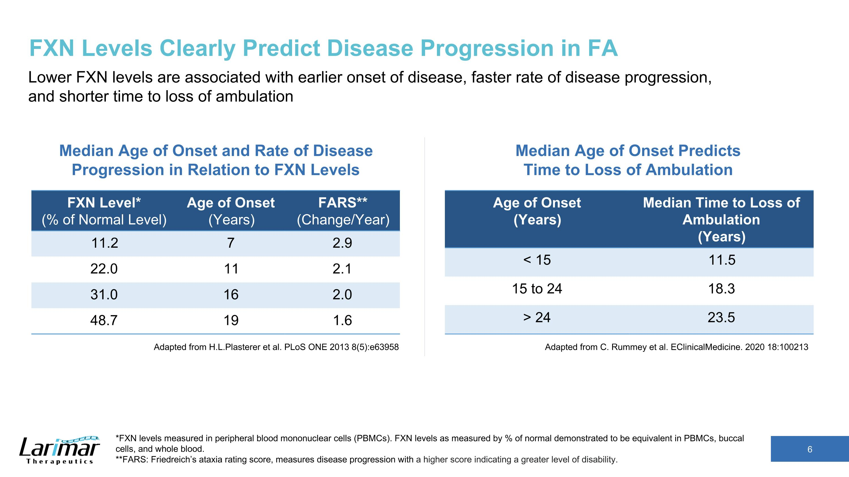
FXN Levels Clearly Predict Disease Progression in FA Lower FXN levels are associated with earlier onset of disease, faster rate of disease progression, and shorter time to loss of ambulation Adapted from H.L.Plasterer et al. PLoS ONE 2013 8(5):e63958 Age of Onset (Years) Median Time to Loss of Ambulation (Years) < 15 11.5 15 to 24 18.3 > 24 23.5 Median Age of Onset and Rate of Disease Progression in Relation to FXN Levels *FXN levels measured in peripheral blood mononuclear cells (PBMCs). FXN levels as measured by % of normal demonstrated to be equivalent in PBMCs, buccal cells, and whole blood. **FARS: Friedreich’s ataxia rating score, measures disease progression with a higher score indicating a greater level of disability. FXN Level* (% of Normal Level) Age of Onset (Years) FARS** (Change/Year) 11.2 7 2.9 22.0 11 2.1 31.0 16 2.0 48.7 19 1.6 Adapted from C. Rummey et al. EClinicalMedicine. 2020 18:100213 Median Age of Onset Predicts ?Time to Loss of Ambulation

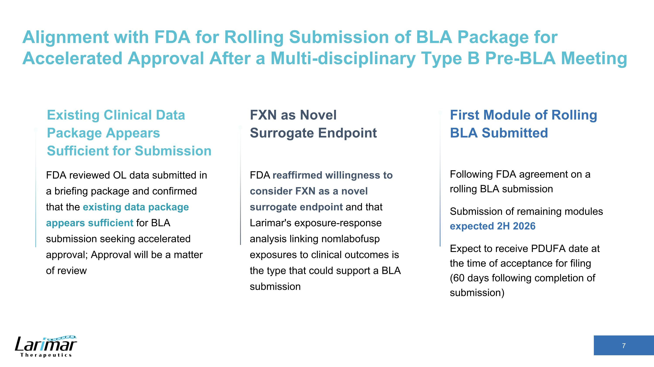
Alignment with FDA for Rolling Submission of BLA Package for Accelerated Approval After a Multi-disciplinary Type B Pre-BLA Meeting FXN as Novel?Surrogate Endpoint FDA reaffirmed willingness to consider FXN as a novel surrogate endpoint and that Larimar's exposure-response analysis linking nomlabofusp exposures to clinical outcomes is the type that could support a BLA submission Existing Clinical Data ?Package Appears Sufficient for Submission FDA reviewed OL data submitted in a briefing package and confirmed that the existing data package appears sufficient for BLA submission seeking accelerated approval; Approval will be a matter of review First Module of Rolling BLA Submitted Following FDA agreement on a rolling BLA submission??Submission of remaining modules ?expected 2H 2026??Expect to receive PDUFA date at the time of acceptance for filing ?(60 days following completion of submission)

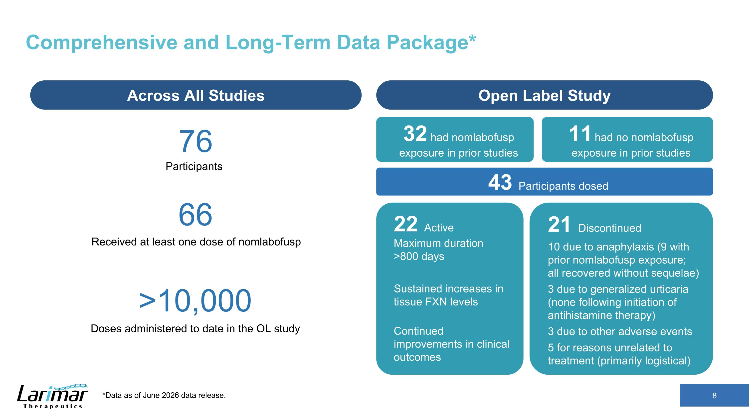
Comprehensive and Long-Term Data Package* Across All Studies Open Label Study 76 Participants >10,000 Doses administered to date in the OL study 66 Received at least one dose of nomlabofusp 43 Participants dosed 22 Active?Maximum duration ?>800 days Sustained increases in tissue FXN levels Continued improvements in clinical outcomes 21 Discontinued 10 due to anaphylaxis (9 with prior nomlabofusp exposure; ?all recovered without sequelae) 3 due to generalized urticaria (none following initiation of antihistamine therapy) 3 due to other adverse events 5 for reasons unrelated to treatment (primarily logistical) 32 had nomlabofusp exposure in prior studies 11 had no nomlabofusp exposure in prior studies *Data as of June 2026 data release.

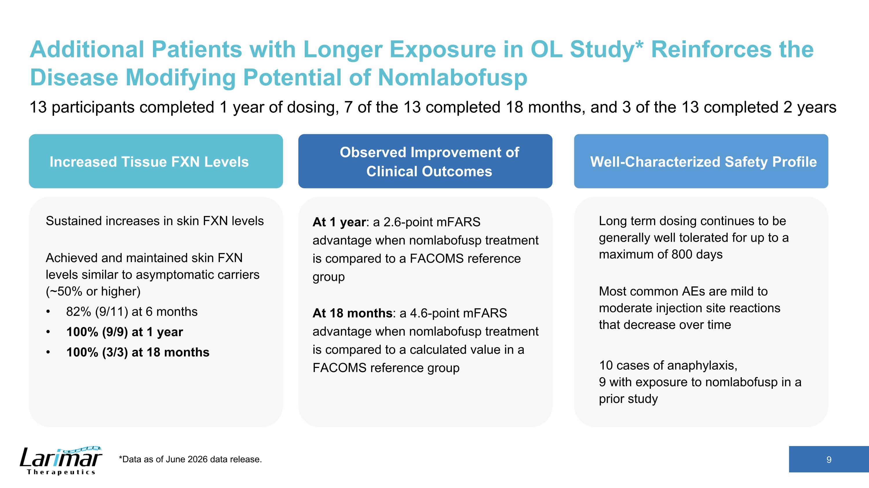
Additional Patients with Longer Exposure in OL Study* Reinforces the Disease Modifying Potential of Nomlabofusp 13 participants completed 1 year of dosing, 7 of the 13 completed 18 months, and 3 of the 13 completed 2 years Well-Characterized Safety Profile Increased Tissue FXN Levels Observed Improvement of Clinical Outcomes Sustained increases in skin FXN levels Achieved and maintained skin FXN levels similar to asymptomatic carriers (~50% or higher) 82% (9/11) at 6 months 100% (9/9) at 1 year 100% (3/3) at 18 months At 1 year: a 2.6-point mFARS advantage when nomlabofusp treatment is compared to a FACOMS reference group At 18 months: a 4.6-point mFARS advantage when nomlabofusp treatment is compared to a calculated value in a FACOMS reference group Long term dosing continues to be generally well tolerated for up to a maximum of 800 days Most common AEs are mild to moderate injection site reactions that decrease over time 10 cases of anaphylaxis, ?9 with exposure to nomlabofusp in a prior study *Data as of June 2026 data release.

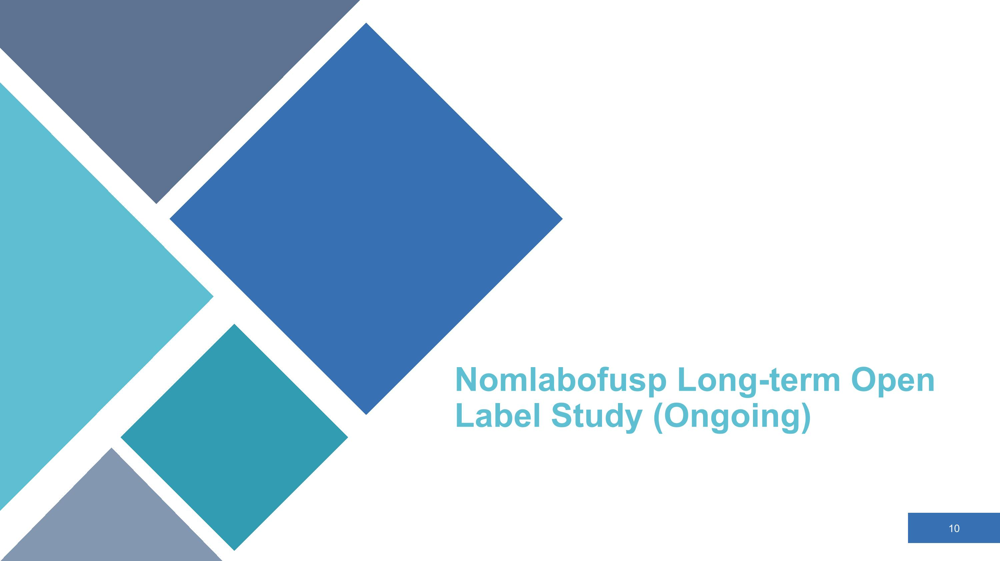
Nomlabofusp Long-term Open Label Study (Ongoing)

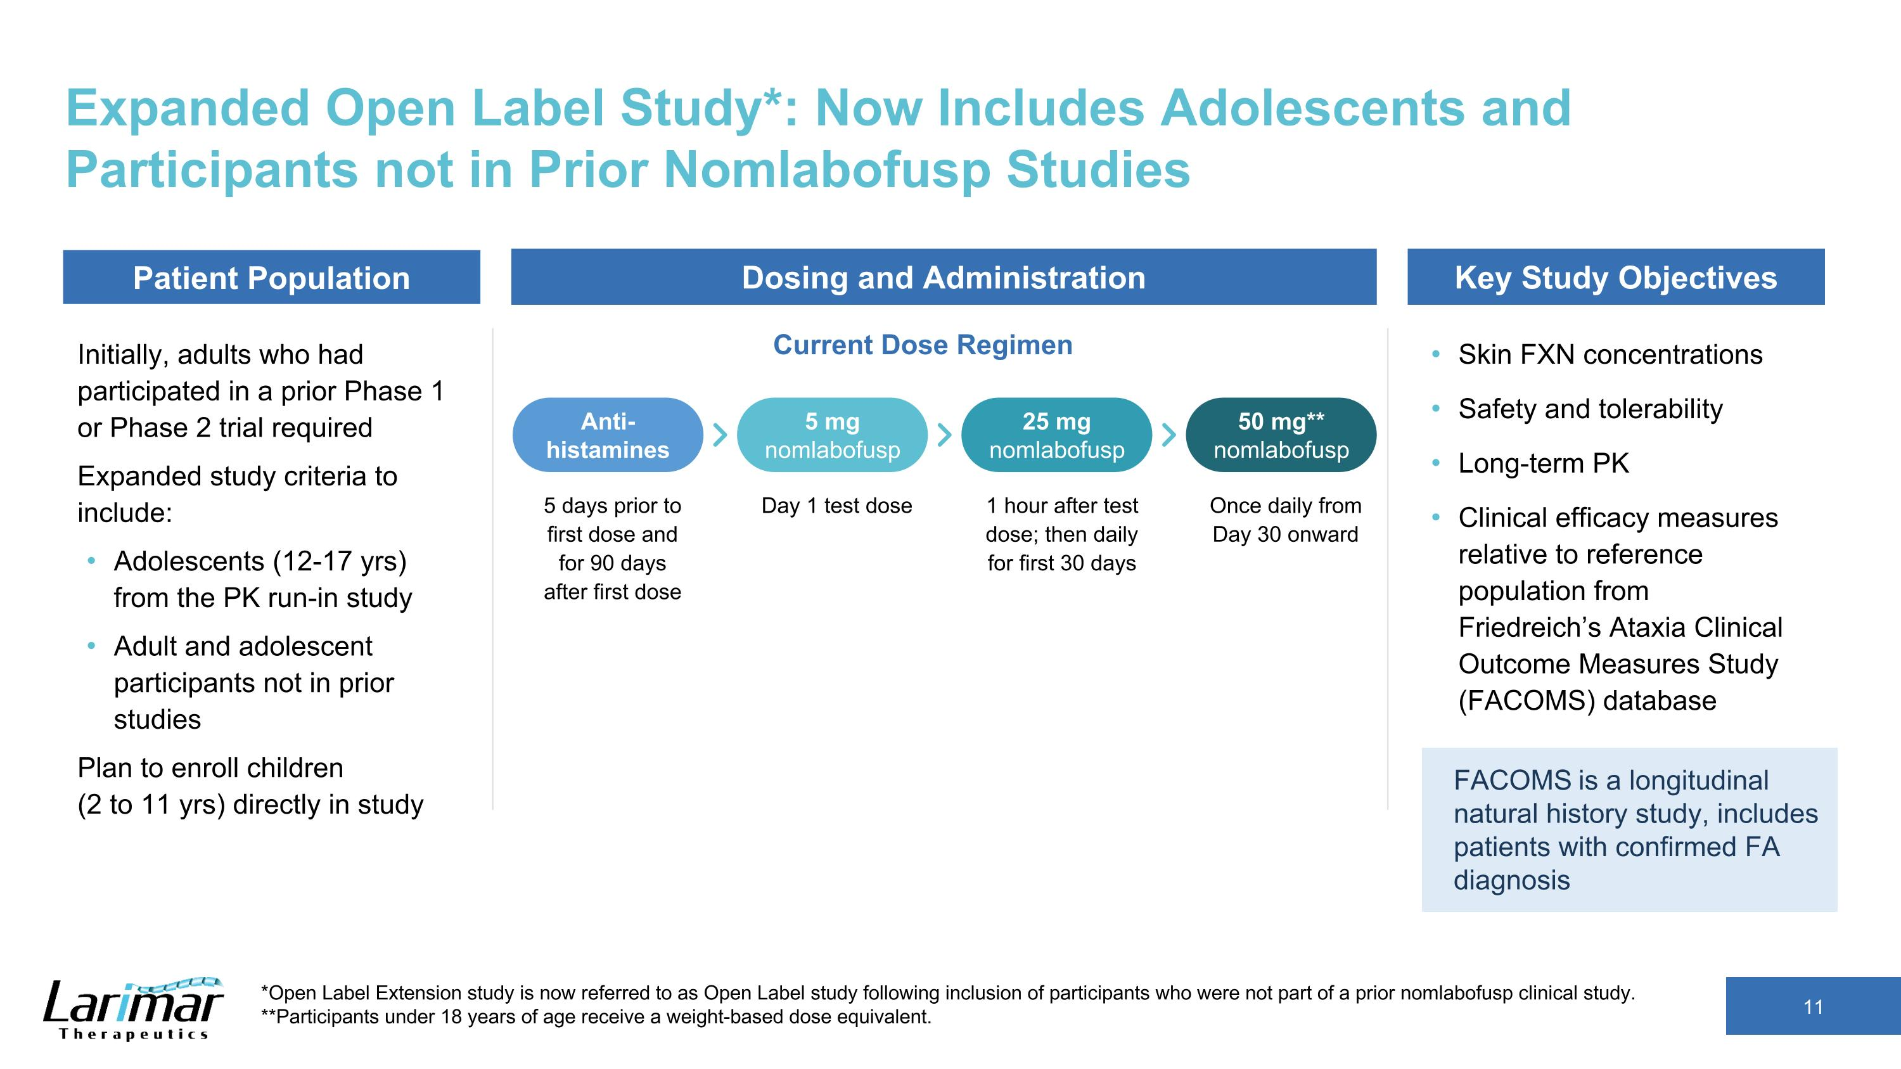
Expanded Open Label Study*: Now Includes Adolescents and Participants not in Prior Nomlabofusp Studies Initially, adults who had participated in a prior Phase 1 or Phase 2 trial required Expanded study criteria to include: Adolescents (12-17 yrs) from the PK run-in study Adult and adolescent participants not in prior studies Plan to enroll children ?(2 to 11 yrs) directly in study Skin FXN concentrations Safety and tolerability Long-term PK Clinical efficacy measures relative to reference population from Friedreich’s Ataxia Clinical Outcome Measures Study (FACOMS) database *Open Label Extension study is now referred to as Open Label study following inclusion of participants who were not part of a prior nomlabofusp clinical study. **Participants under 18 years of age receive a weight-based dose equivalent. Patient Population Current Dose Regimen Dosing and Administration Key Study Objectives 5 days prior to first dose and for 90 days after first dose Anti-histamines 5 mg nomlabofusp 25 mg nomlabofusp 50 mg** nomlabofusp Day 1 test dose 1 hour after test dose; then daily for first 30 days Once daily from Day 30 onward FACOMS is a longitudinal natural history study, includes patients with confirmed FA diagnosis

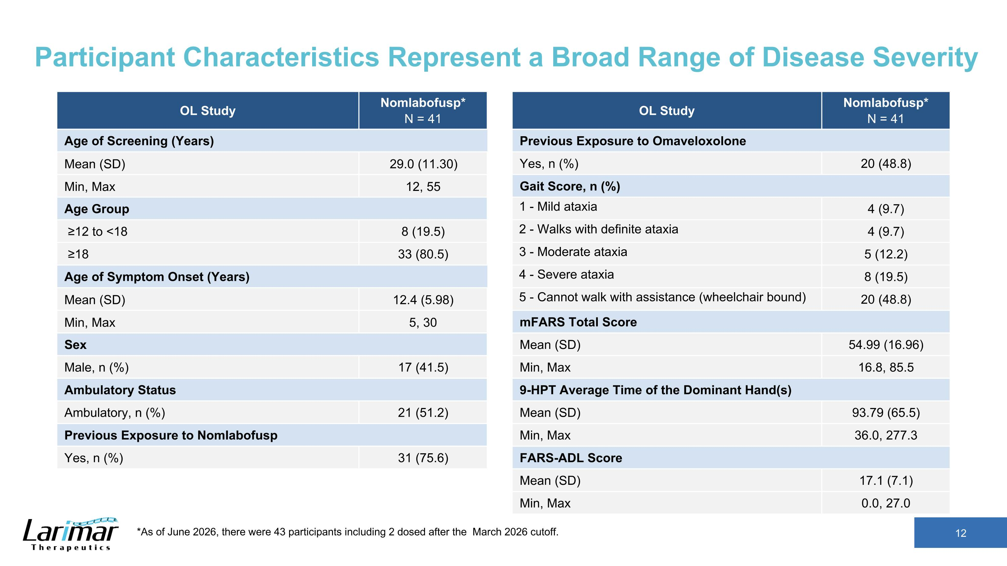
Participant Characteristics Represent a Broad Range of Disease Severity *As of June 2026, there were 43 participants including 2 dosed after the March 2026 cutoff. OL Study Nomlabofusp* N = 41 Age of Screening (Years) Mean (SD) 29.0 (11.30) Min, Max 12, 55 Age Group ≥12 to <18 8 (19.5) ≥18 33 (80.5) Age of Symptom Onset (Years) Mean (SD) 12.4 (5.98) Min, Max 5, 30 Sex Male, n (%) 17 (41.5) Ambulatory Status Ambulatory, n (%) 21 (51.2) Previous Exposure to Nomlabofusp Yes, n (%) 31 (75.6) OL Study Nomlabofusp* N = 41 Previous Exposure to Omaveloxolone Yes, n (%) 20 (48.8) Gait Score, n (%) 1 - Mild ataxia 4 (9.7) 2 - Walks with definite ataxia 4 (9.7) 3 - Moderate ataxia 5 (12.2) 4 - Severe ataxia 8 (19.5) 5 - Cannot walk with assistance (wheelchair bound) 20 (48.8) mFARS Total Score Mean (SD) 54.99 (16.96) Min, Max 16.8, 85.5 9-HPT Average Time of the Dominant Hand(s) Mean (SD) 93.79 (65.5) Min, Max 36.0, 277.3 FARS-ADL Score Mean (SD) 17.1 (7.1) Min, Max 0.0, 27.0

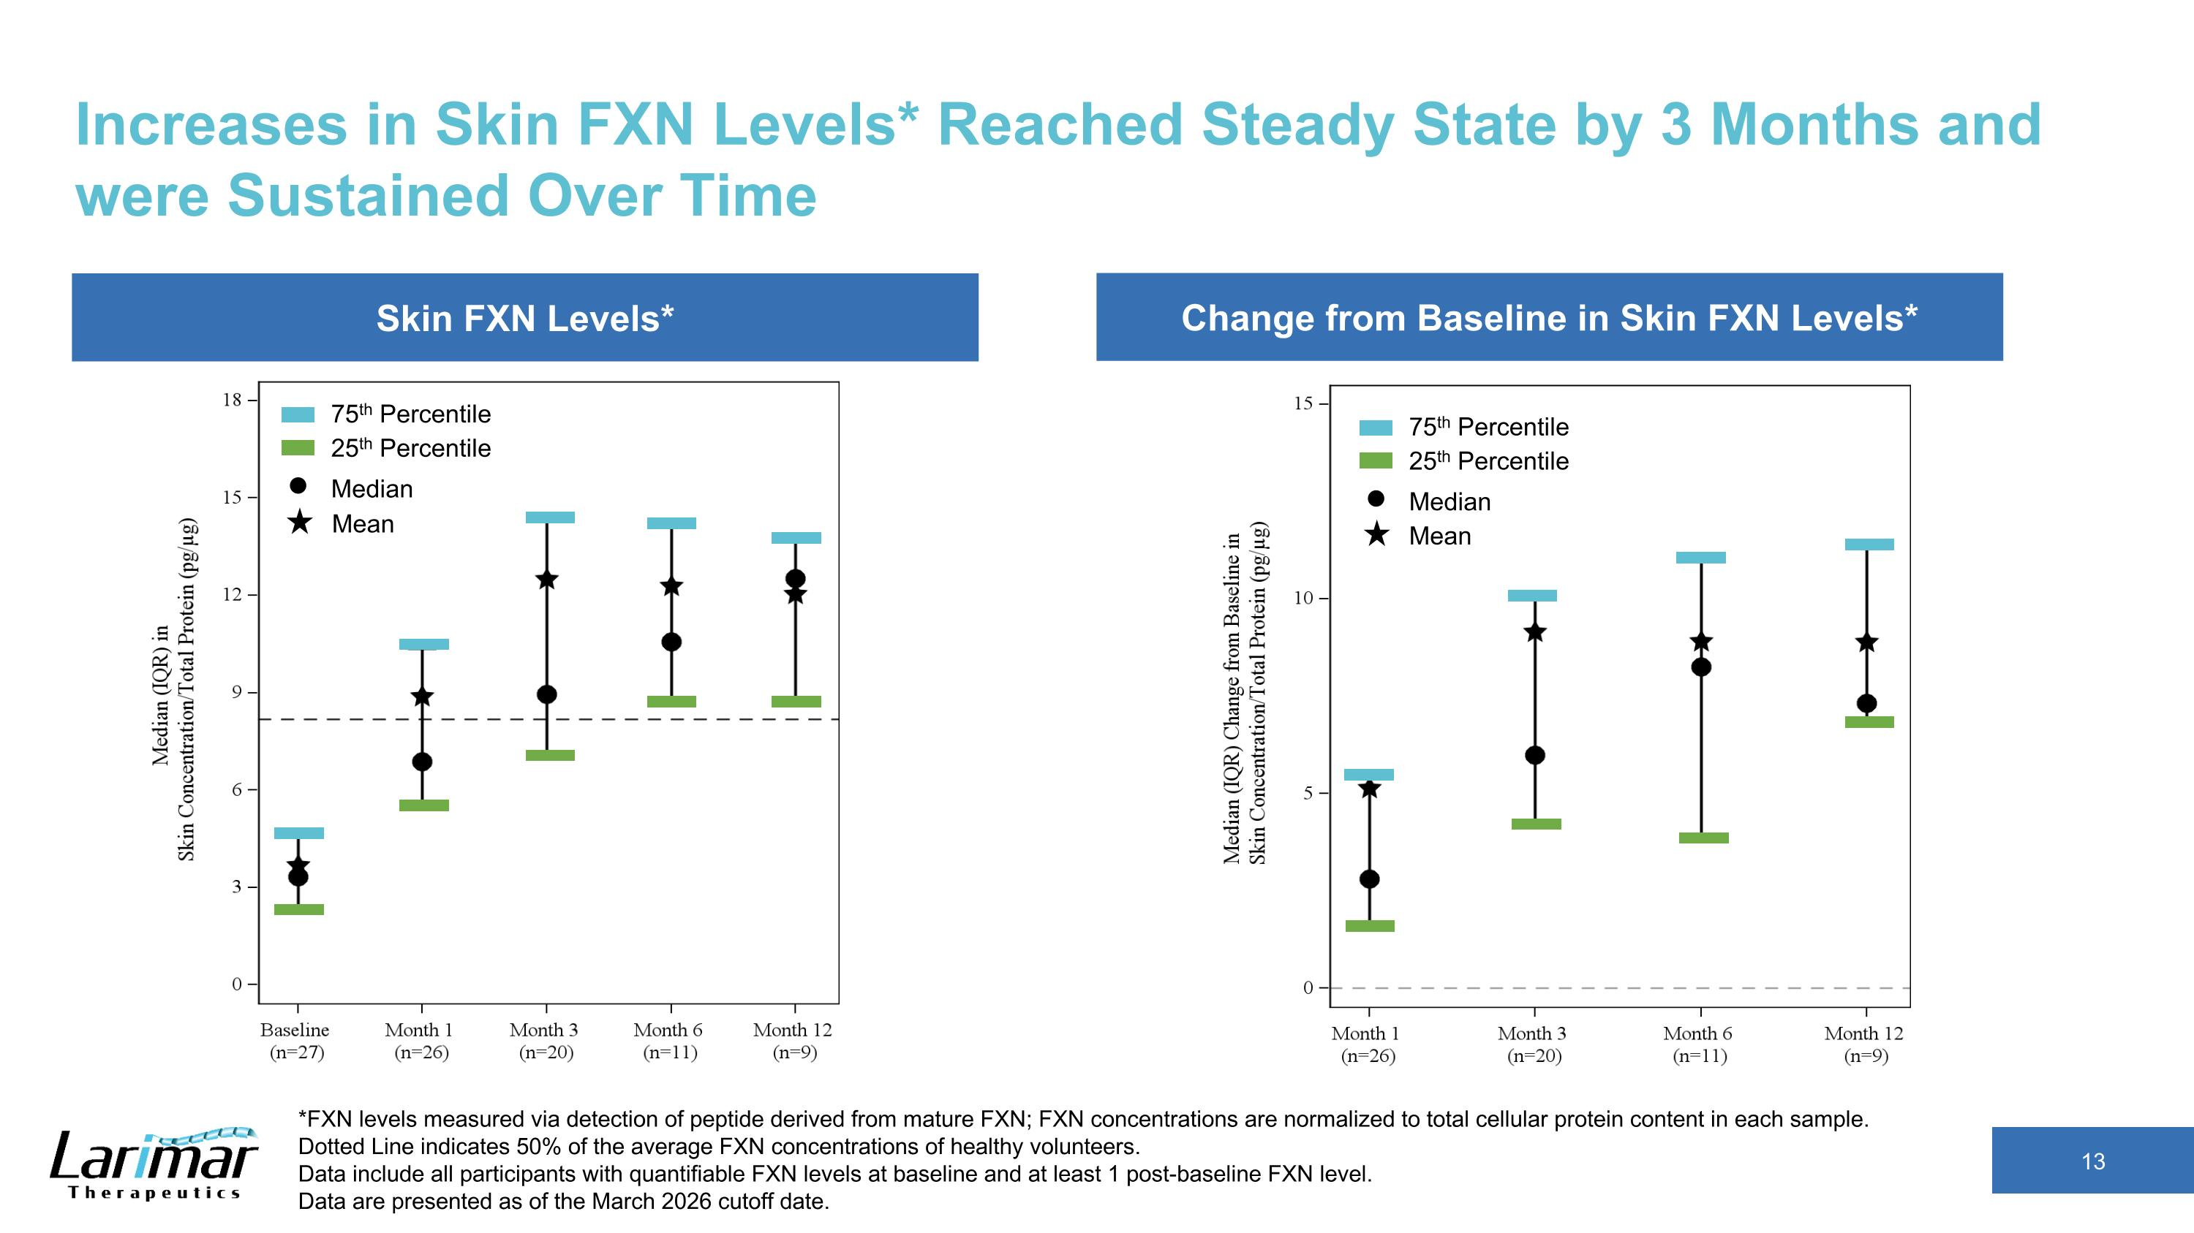
Change from Baseline in Skin FXN Levels* Skin FXN Levels* Increases in Skin FXN Levels* Reached Steady State by 3 Months and were Sustained Over Time *FXN levels measured via detection of peptide derived from mature FXN; FXN concentrations are normalized to total cellular protein content in each sample. Dotted Line indicates 50% of the average FXN concentrations of healthy volunteers.?Data include all participants with quantifiable FXN levels at baseline and at least 1 post-baseline FXN level. Data are presented as of the March 2026 cutoff date. 25th Percentile 75th Percentile Median 25th Percentile 75th Percentile Median Mean Mean

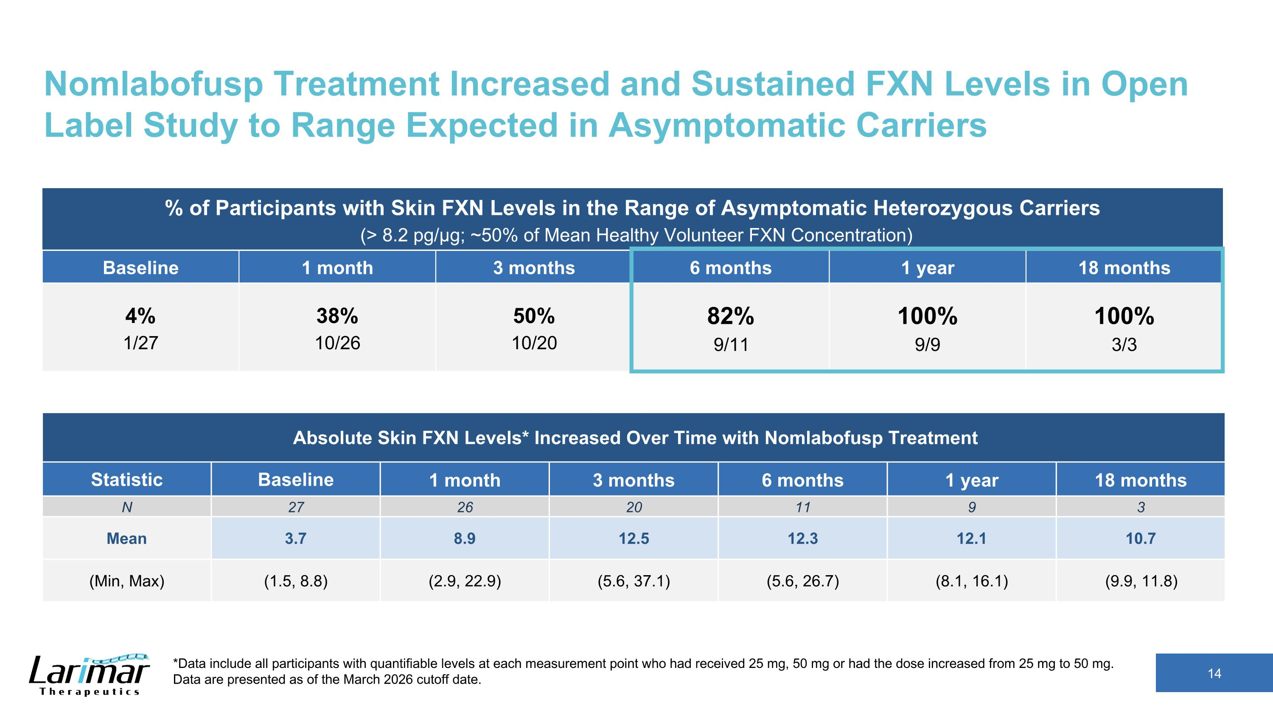
Nomlabofusp Treatment Increased and Sustained FXN Levels in Open Label Study to Range Expected in Asymptomatic Carriers % of Participants with Skin FXN Levels in the Range of Asymptomatic Heterozygous Carriers? (> 8.2 pg/µg; ~50% of Mean Healthy Volunteer FXN Concentration) Baseline 1 month 3 months 6 months 1 year 18 months 4%?1/27 38%?10/26 50%?10/20 82%?9/11 100%?9/9 100%?3/3 *Data include all participants with quantifiable levels at each measurement point who had received 25 mg, 50 mg or had the dose increased from 25 mg to 50 mg. Data are presented as of the March 2026 cutoff date. Absolute Skin FXN Levels* Increased Over Time with Nomlabofusp Treatment Statistic Baseline 1 month 3 months 6 months 1 year 18 months N 27 26 20 11 9 3 Mean 3.7 8.9 12.5 12.3 12.1 10.7 (Min, Max) (1.5, 8.8) (2.9, 22.9) (5.6, 37.1) (5.6, 26.7) (8.1, 16.1) (9.9, 11.8)

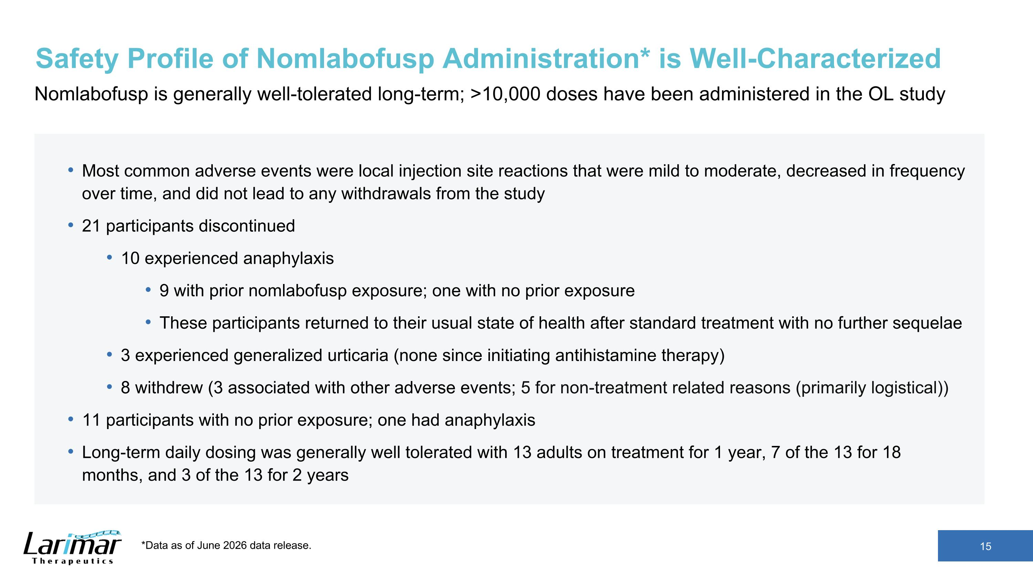
Safety Profile of Nomlabofusp Administration* is Well-Characterized Nomlabofusp is generally well-tolerated long-term; >10,000 doses have been administered in the OL study Most common adverse events were local injection site reactions that were mild to moderate, decreased in frequency over time, and did not lead to any withdrawals from the study 21 participants discontinued 10 experienced anaphylaxis 9 with prior nomlabofusp exposure; one with no prior exposure These participants returned to their usual state of health after standard treatment with no further sequelae 3 experienced generalized urticaria (none since initiating antihistamine therapy) 8 withdrew (3 associated with other adverse events; 5 for non-treatment related reasons (primarily logistical)) 11 participants with no prior exposure; one had anaphylaxis Long-term daily dosing was generally well tolerated with 13 adults on treatment for 1 year, 7 of the 13 for 18 months, and 3 of the 13 for 2 years *Data as of June 2026 data release.

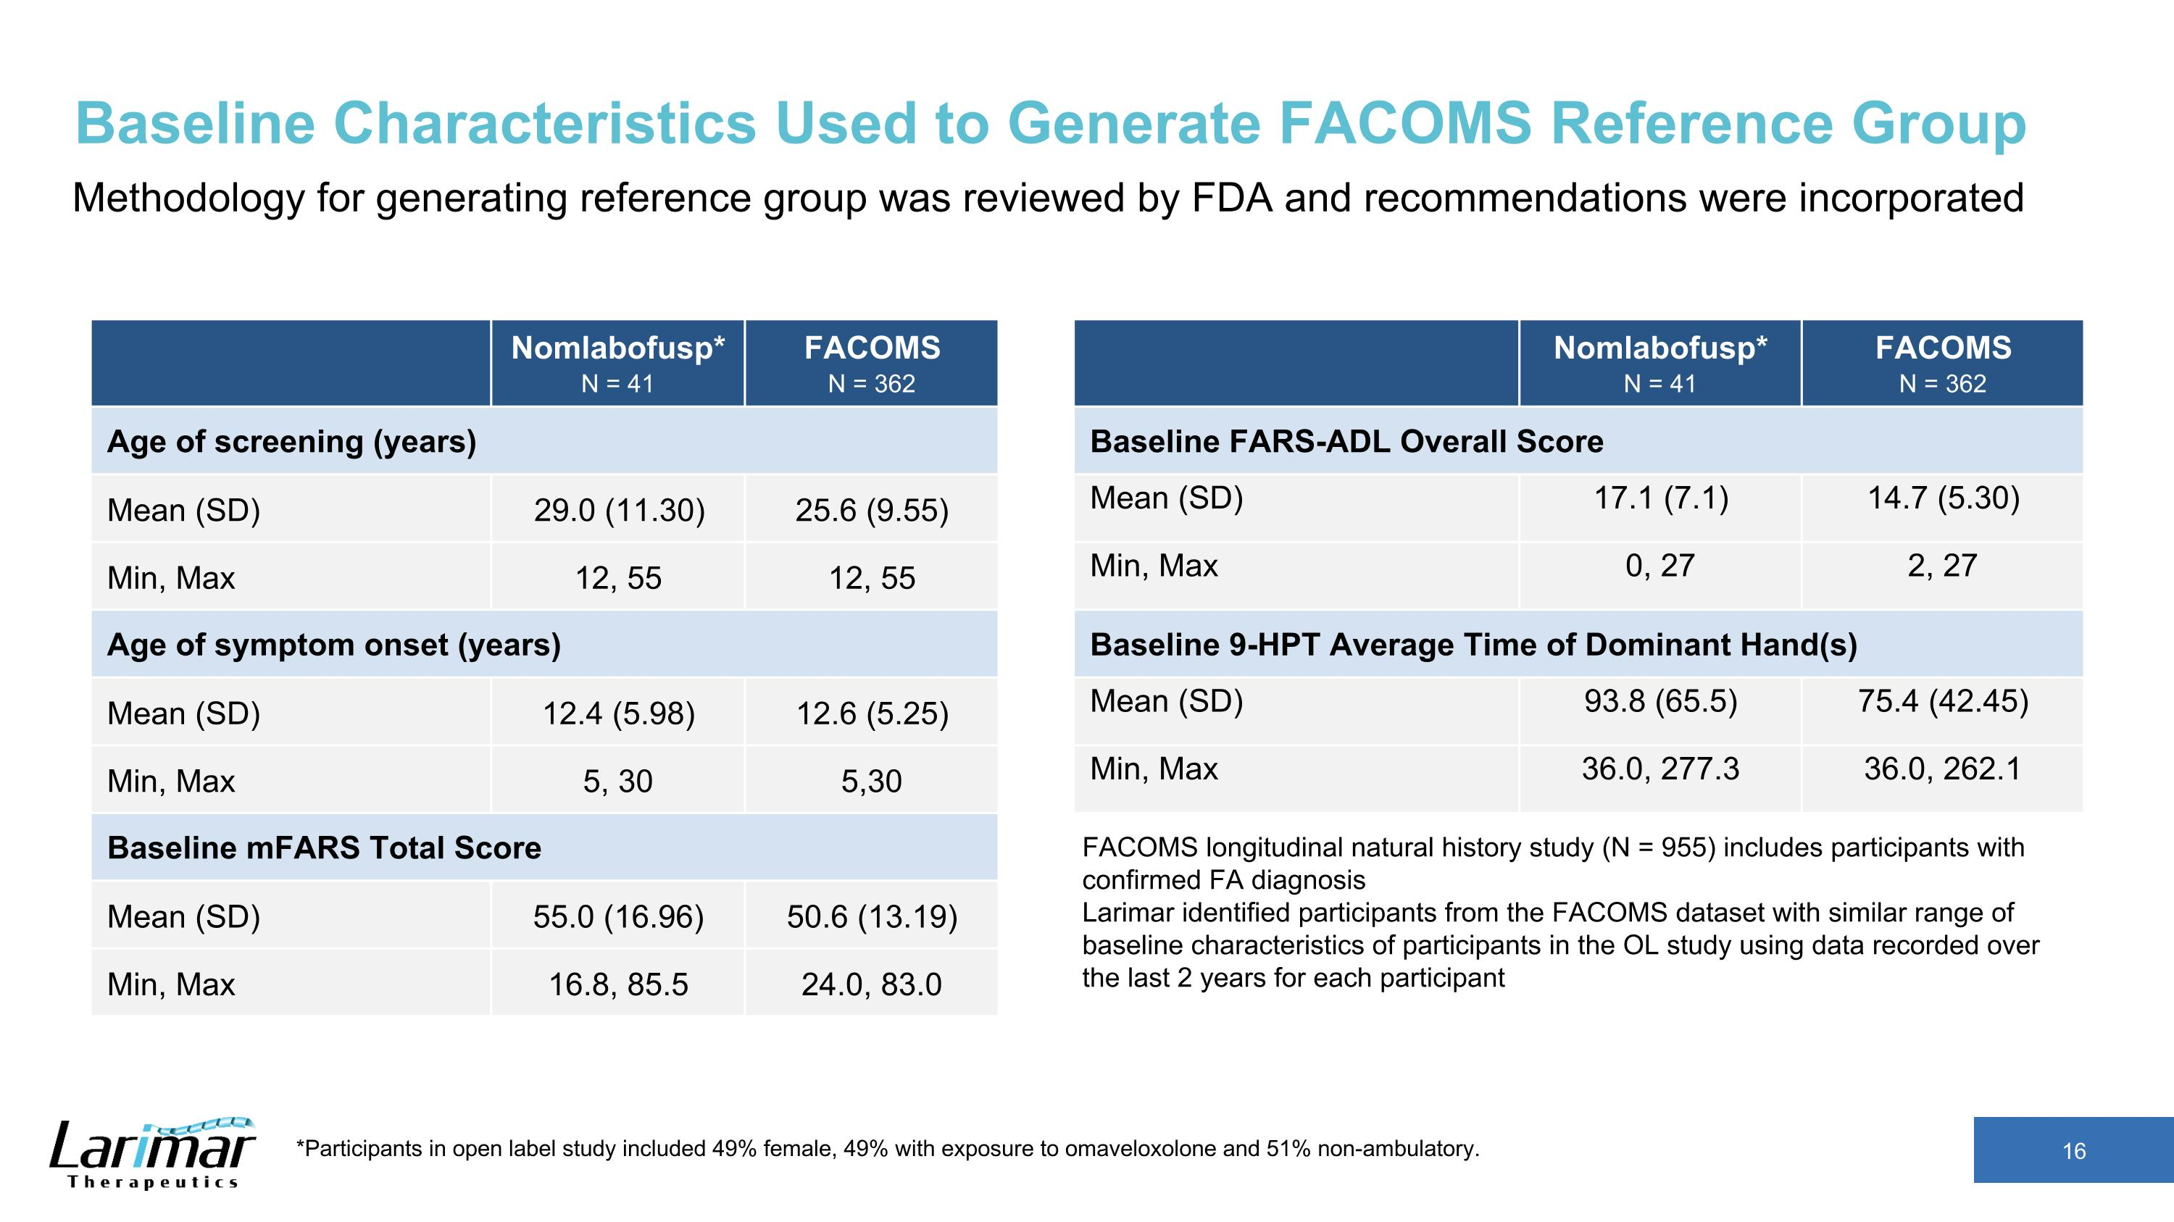
Baseline Characteristics Used to Generate FACOMS Reference Group Methodology for generating reference group was reviewed by FDA and recommendations were incorporated FACOMS longitudinal natural history study (N = 955) includes participants with confirmed FA diagnosis?Larimar identified participants from the FACOMS dataset with similar range of baseline characteristics of participants in the OL study using data recorded over the last 2 years for each participant *Participants in open label study included 49% female, 49% with exposure to omaveloxolone and 51% non-ambulatory. Nomlabofusp* N = 41 FACOMS N = 362 Age of screening (years) Mean (SD) 29.0 (11.30) 25.6 (9.55) Min, Max 12, 55 12, 55 Age of symptom onset (years) Mean (SD) 12.4 (5.98) 12.6 (5.25) Min, Max 5, 30 5,30 Baseline mFARS Total Score Mean (SD) 55.0 (16.96) 50.6 (13.19) Min, Max 16.8, 85.5 24.0, 83.0 Nomlabofusp* N = 41 FACOMS N = 362 Baseline FARS-ADL Overall Score Mean (SD) 17.1 (7.1) 14.7 (5.30) Min, Max 0, 27 2, 27 Baseline 9-HPT Average Time of Dominant Hand(s) Mean (SD) 93.8 (65.5) 75.4 (42.45) Min, Max 36.0, 277.3 36.0, 262.1

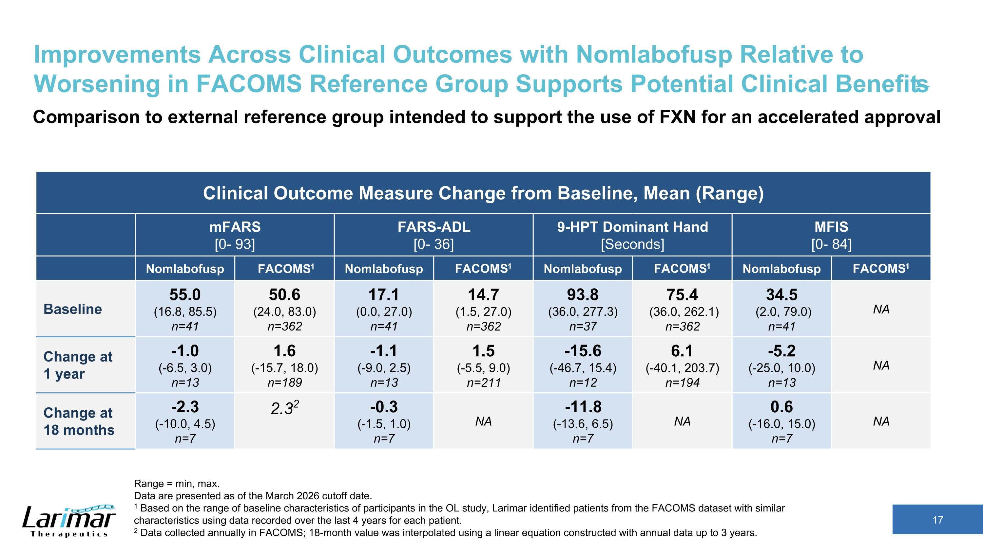
Improvements Across Clinical Outcomes with Nomlabofusp Relative to Worsening in FACOMS Reference Group Supports Potential Clinical Benefits Range = min, max. Data are presented as of the March 2026 cutoff date. 1 Based on the range of baseline characteristics of participants in the OL study, Larimar identified patients from the FACOMS dataset with similar characteristics using data recorded over the last 4 years for each patient. 2 Data collected annually in FACOMS; 18-month value was interpolated using a linear equation constructed with annual data up to 3 years. Clinical Outcome Measure Change from Baseline, Mean (Range) mFARS [0- 93] FARS-ADL [0- 36] 9-HPT Dominant Hand [Seconds] MFIS [0- 84] Nomlabofusp FACOMS1 Nomlabofusp FACOMS1 Nomlabofusp FACOMS1 Nomlabofusp FACOMS1 Baseline 55.0 (16.8, 85.5) n=41 50.6 (24.0, 83.0) n=362 17.1 (0.0, 27.0) n=41 14.7 (1.5, 27.0) n=362 93.8 (36.0, 277.3) n=37 75.4 (36.0, 262.1) n=362 34.5 (2.0, 79.0) n=41 NA Change at ?1 year -1.0 (-6.5, 3.0) n=13 1.6 (-15.7, 18.0) n=189 -1.1 (-9.0, 2.5) n=13 1.5 (-5.5, 9.0) n=211 -15.6 (-46.7, 15.4) n=12 6.1 (-40.1, 203.7) n=194 -5.2 (-25.0, 10.0) n=13 NA Change at ?18 months -2.3 (-10.0, 4.5) n=7 2.32 -0.3 (-1.5, 1.0) n=7 NA -11.8 (-13.6, 6.5) n=7 NA 0.6 (-16.0, 15.0) n=7 NA Comparison to external reference group intended to support the use of FXN for an accelerated approval

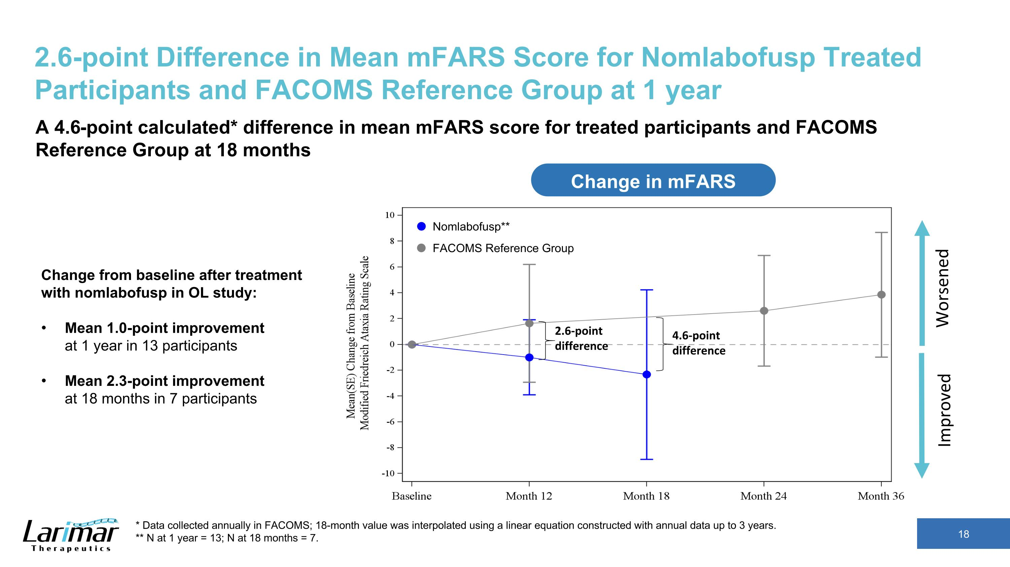
2.6-point Difference in Mean mFARS Score for Nomlabofusp Treated Participants and FACOMS Reference Group at 1 year Change in mFARS Change from baseline after treatment with nomlabofusp in OL study: Mean 1.0-point improvement ?at 1 year in 13 participants Mean 2.3-point improvement ?at 18 months in 7 participants A 4.6-point calculated* difference in mean mFARS score for treated participants and FACOMS Reference Group at 18 months Improved Worsened Nomlabofusp** FACOMS Reference Group 2.6-point difference 4.6-point difference * Data collected annually in FACOMS; 18-month value was interpolated using a linear equation constructed with annual data up to 3 years. ** N at 1 year = 13; N at 18 months = 7.

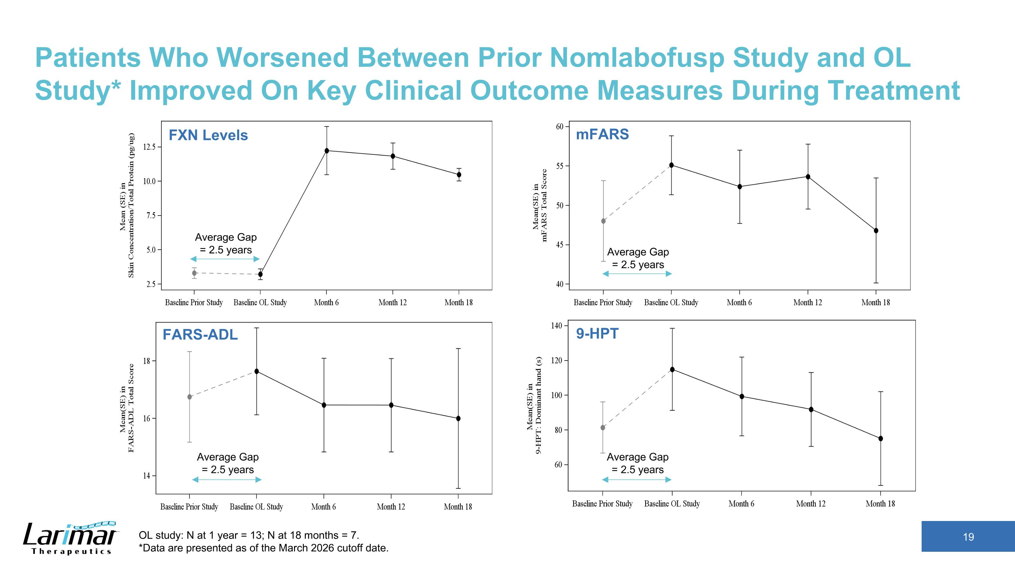
Patients Who Worsened Between Prior Nomlabofusp Study and OL Study* Improved On Key Clinical Outcome Measures During Treatment Average Gap = 2.5 years Average Gap = 2.5 years Average Gap = 2.5 years Average Gap = 2.5 years FXN Levels mFARS FARS-ADL 9-HPT OL study: N at 1 year = 13; N at 18 months = 7. *Data are presented as of the March 2026 cutoff date.

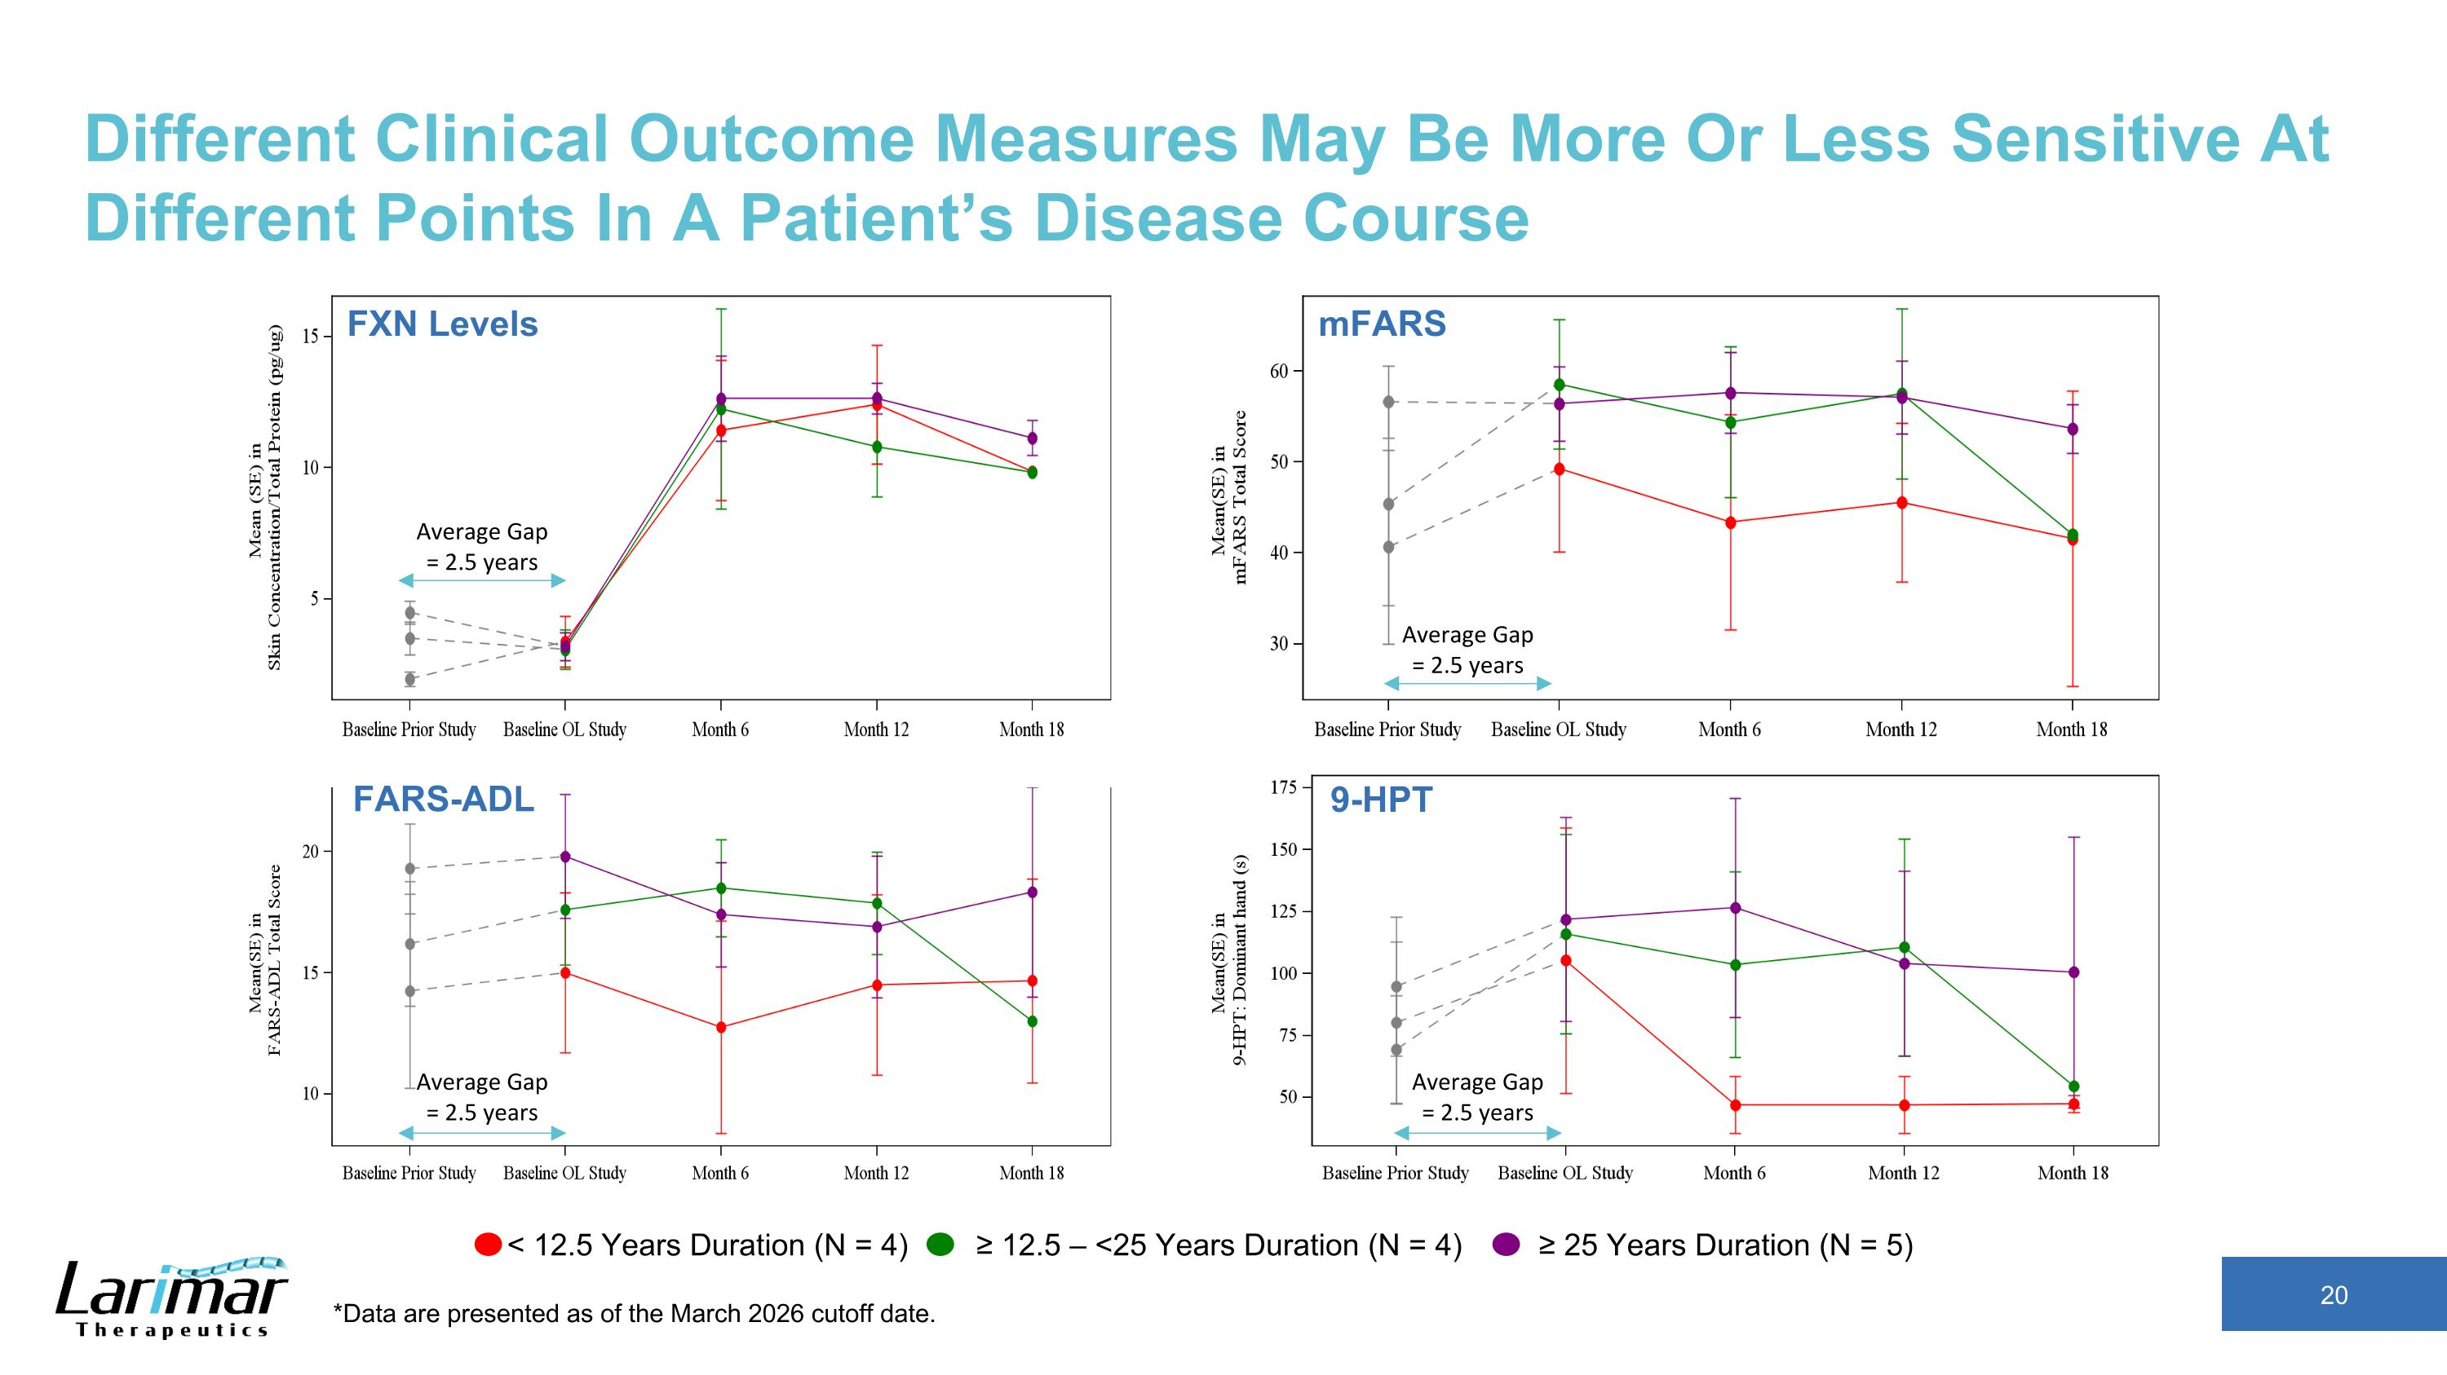
Different Clinical Outcome Measures May Be More Or Less Sensitive At Different Points In A Patient’s Disease Course Average Gap = 2.5 years Average Gap = 2.5 years Average Gap = 2.5 years Average Gap = 2.5 years FXN Levels mFARS FARS-ADL 9-HPT < 12.5 Years Duration (N = 4) ≥ 12.5 – <25 Years Duration (N = 4) ≥ 25 Years Duration (N = 5) *Data are presented as of the March 2026 cutoff date.

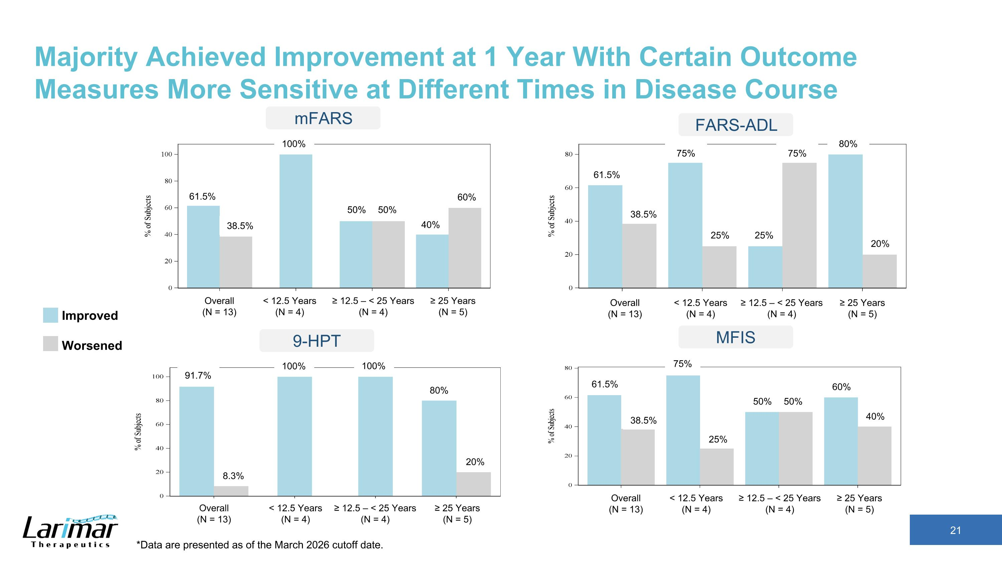
Majority Achieved Improvement at 1 Year With Certain Outcome Measures More Sensitive at Different Times in Disease Course mFARS Improved Worsened MFIS 9-HPT 61.5% 38.5% 100% 50% 50% 40% 60% 100% 100% 61.5% 61.5% 38.5% 60% 40% 50% 50% 80% 20% 38.5% 75% 25% 25% 25% 20% 75% 75% 80% 91.7% 8.3% ≥ 12.5 – < 25 Years (N = 4) < 12.5 Years (N = 4) Overall (N = 13) ≥ 25 Years (N = 5) ≥ 12.5 – < 25 Years (N = 4) < 12.5 Years (N = 4) Overall (N = 13) ≥ 25 Years (N = 5) ≥ 12.5 – < 25 Years (N = 4) < 12.5 Years (N = 4) Overall (N = 13) ≥ 25 Years (N = 5) ≥ 12.5 – < 25 Years (N = 4) < 12.5 Years (N = 4) Overall (N = 13) ≥ 25 Years (N = 5) *Data are presented as of the March 2026 cutoff date. FARS-ADL

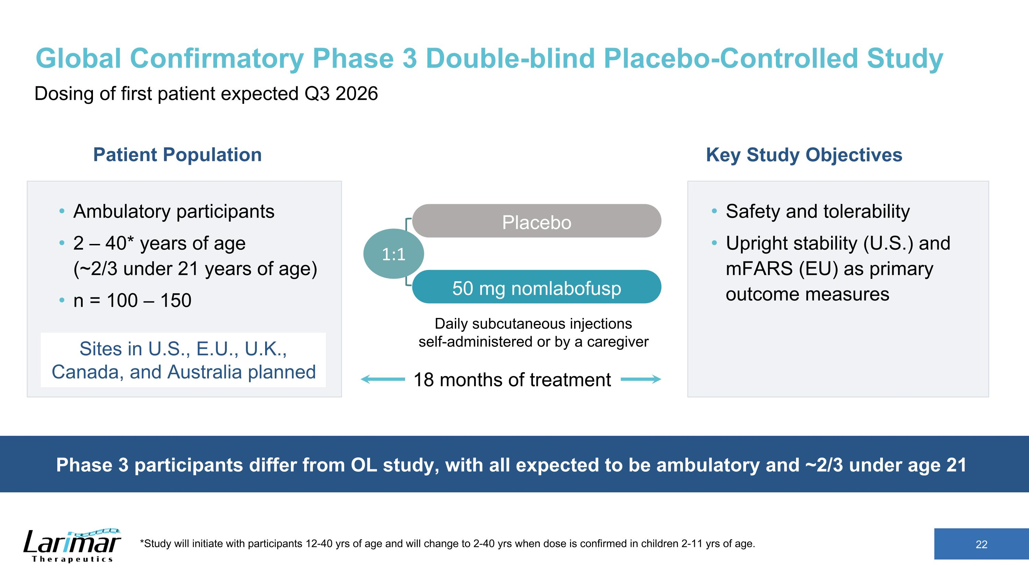
Global Confirmatory Phase 3 Double-blind Placebo-Controlled Study Dosing of first patient expected Q3 2026 18 months of treatment Ambulatory participants 2 – 40* years of age ?(~2/3 under 21 years of age) n = 100 – 150 Key Study Objectives Safety and tolerability Upright stability (U.S.) and mFARS (EU) as primary outcome measures Daily subcutaneous injections ?self-administered or by a caregiver Placebo 50 mg nomlabofusp Patient Population *Study will initiate with participants 12-40 yrs of age and will change to 2-40 yrs when dose is confirmed in children 2-11 yrs of age. 1:1 Phase 3 participants differ from OL study, with all expected to be ambulatory and ~2/3 under age 21 Sites in U.S., E.U., U.K., Canada, and Australia planned

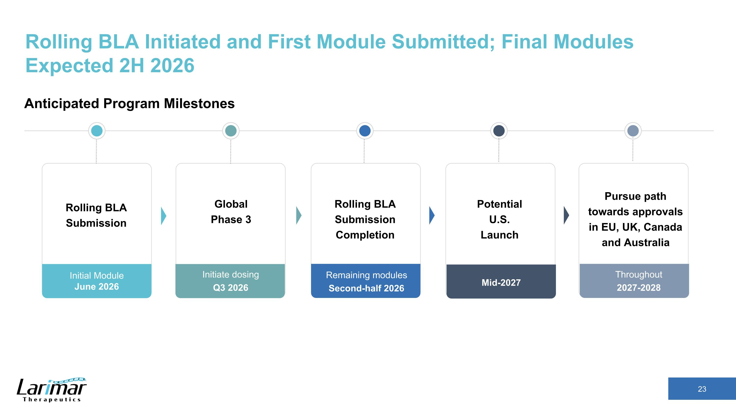
Rolling BLA Initiated and First Module Submitted; Final Modules Expected 2H 2026 Rolling BLA ?Submission Global ?Phase 3 Rolling BLA ?Submission Completion Potential U.S. Launch Pursue path towards approvals in EU, UK, Canada and Australia Initial Module June 2026 Initiate dosing Q3 2026 Remaining modules Second-half 2026 Mid-2027 Throughout 2027-2028 Anticipated Program Milestones

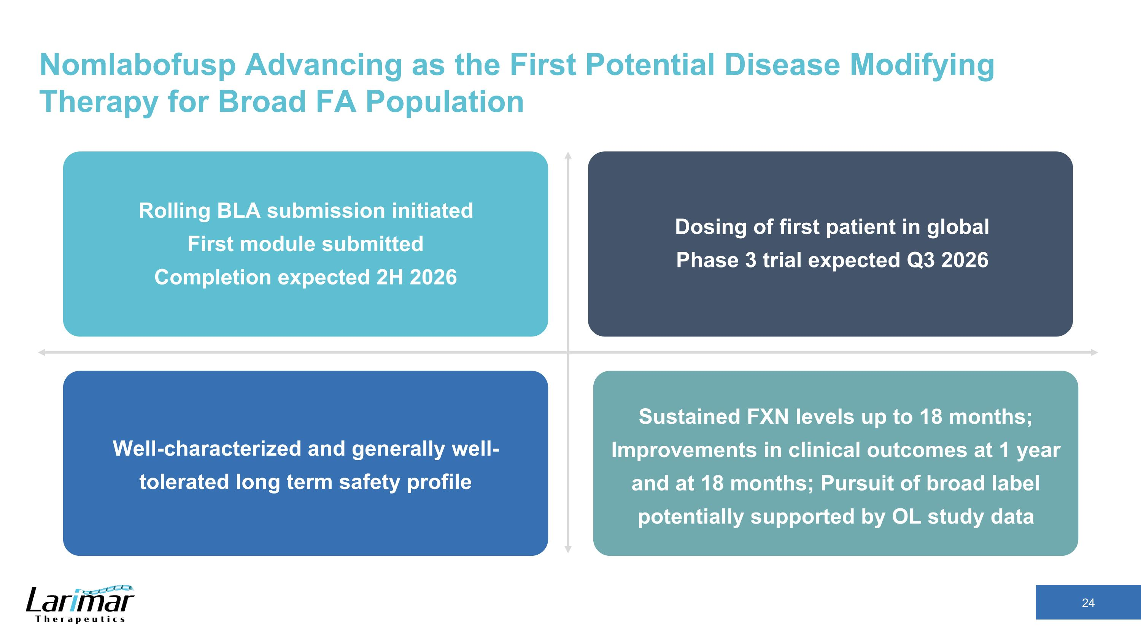
Nomlabofusp Advancing as the First Potential Disease Modifying Therapy for Broad FA Population Rolling BLA submission initiated ?First module submitted?Completion expected 2H 2026 Dosing of first patient in global ?Phase 3 trial expected Q3 2026 Sustained FXN levels up to 18 months;?Improvements in clinical outcomes at 1 year and at 18 months; Pursuit of broad label potentially supported by OL study data Well-characterized and generally well-tolerated long term safety profile


Appendix Larimar Therapeutics

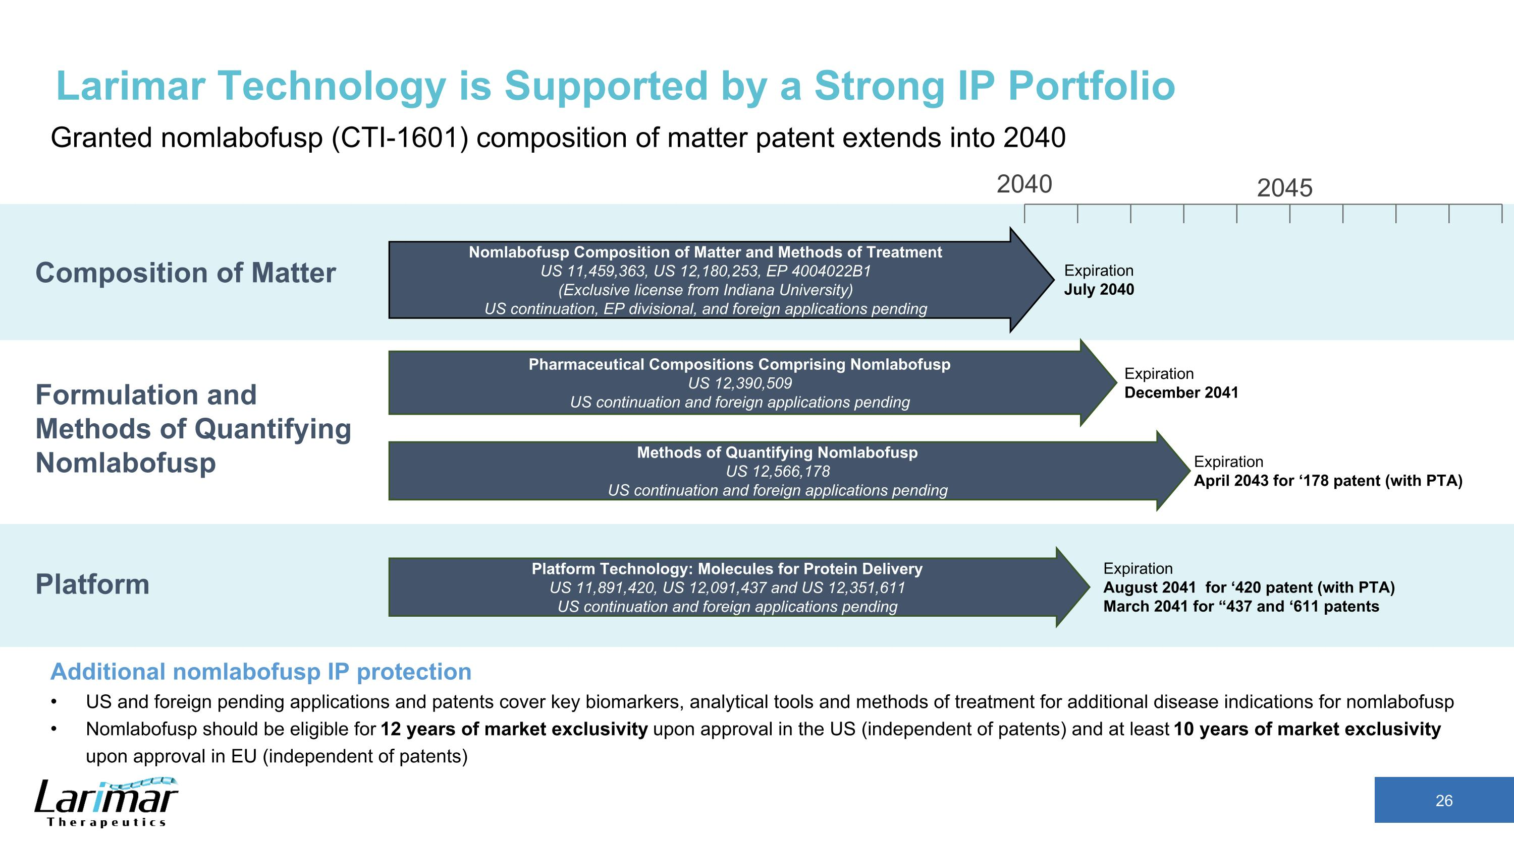
2040 Nomlabofusp Composition of Matter and Methods of Treatment US 11,459,363, US 12,180,253, EP 4004022B1 (Exclusive license from Indiana University) US continuation, EP divisional, and foreign applications pending Expiration July 2040 Composition of Matter Larimar Technology is Supported by a Strong IP Portfolio Granted nomlabofusp (CTI-1601) composition of matter patent extends into 2040 Additional nomlabofusp IP protection US and foreign pending applications and patents cover key biomarkers, analytical tools and methods of treatment for additional disease indications for nomlabofusp Nomlabofusp should be eligible for 12 years of market exclusivity upon approval in the US (independent of patents) and at least 10 years of market exclusivity upon approval in EU (independent of patents) Platform Formulation and Methods of Quantifying Nomlabofusp Platform Technology: Molecules for Protein Delivery US 11,891,420, US 12,091,437 and US 12,351,611 US continuation and foreign applications pending Pharmaceutical Compositions Comprising Nomlabofusp US 12,390,509 US continuation and foreign applications pending Methods of Quantifying Nomlabofusp US 12,566,178 US continuation and foreign applications pending Expiration December 2041 Expiration April 2043 for ‘178 patent (with PTA) Expiration August 2041 for ‘420 patent (with PTA) March 2041 for “437 and ‘611 patents 2045

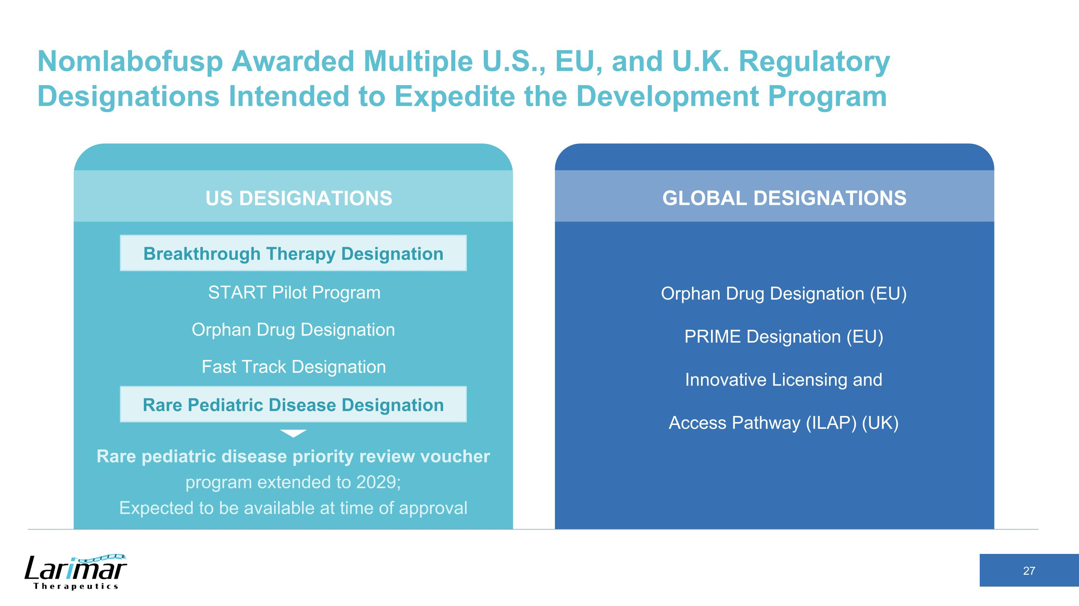
Nomlabofusp Awarded Multiple U.S., EU, and U.K. Regulatory Designations Intended to Expedite the Development Program Orphan Drug Designation (EU) PRIME Designation (EU) Innovative Licensing and Access Pathway (ILAP) (UK) Breakthrough Therapy Designation START Pilot Program Orphan Drug Designation Fast Track Designation Rare Pediatric Disease Designation Rare pediatric disease priority review voucher program extended to 2029; ?Expected to be available at time of approval GLOBAL DESIGNATIONS US DESIGNATIONS Rare Pediatric Disease Designation Breakthrough Therapy Designation


Mitochondrial Localization and Preclinical Data

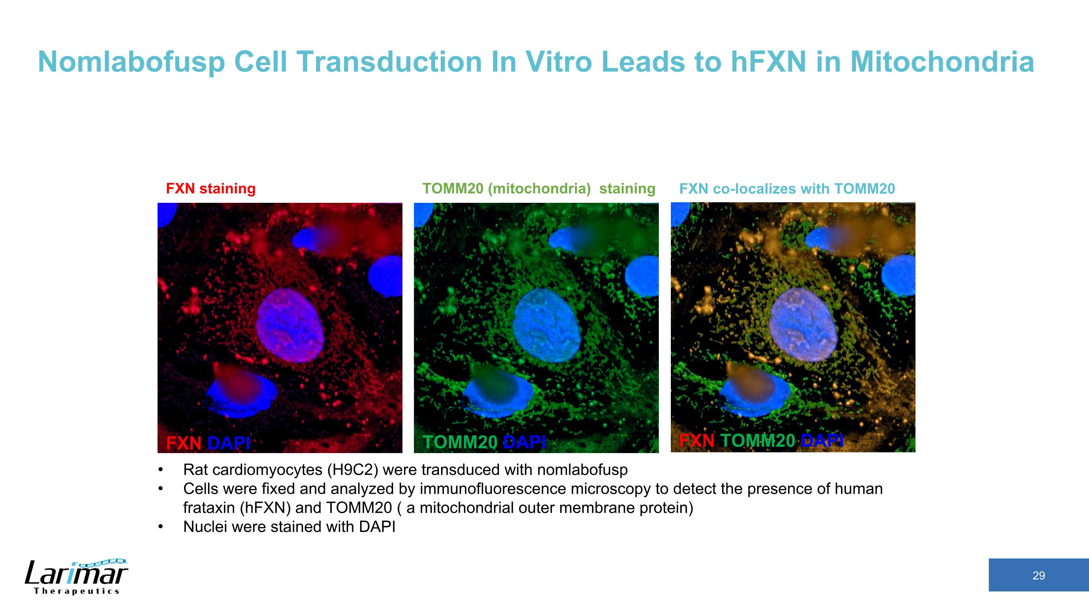
Nomlabofusp Cell Transduction In Vitro Leads to hFXN in Mitochondria FXN DAPI TOMM20 DAPI FXN TOMM20 DAPI FXN co-localizes with TOMM20 FXN staining TOMM20 (mitochondria) staining Rat cardiomyocytes (H9C2) were transduced with nomlabofusp Cells were fixed and analyzed by immunofluorescence microscopy to detect the presence of human frataxin (hFXN) and TOMM20 ( a mitochondrial outer membrane protein) Nuclei were stained with DAPI

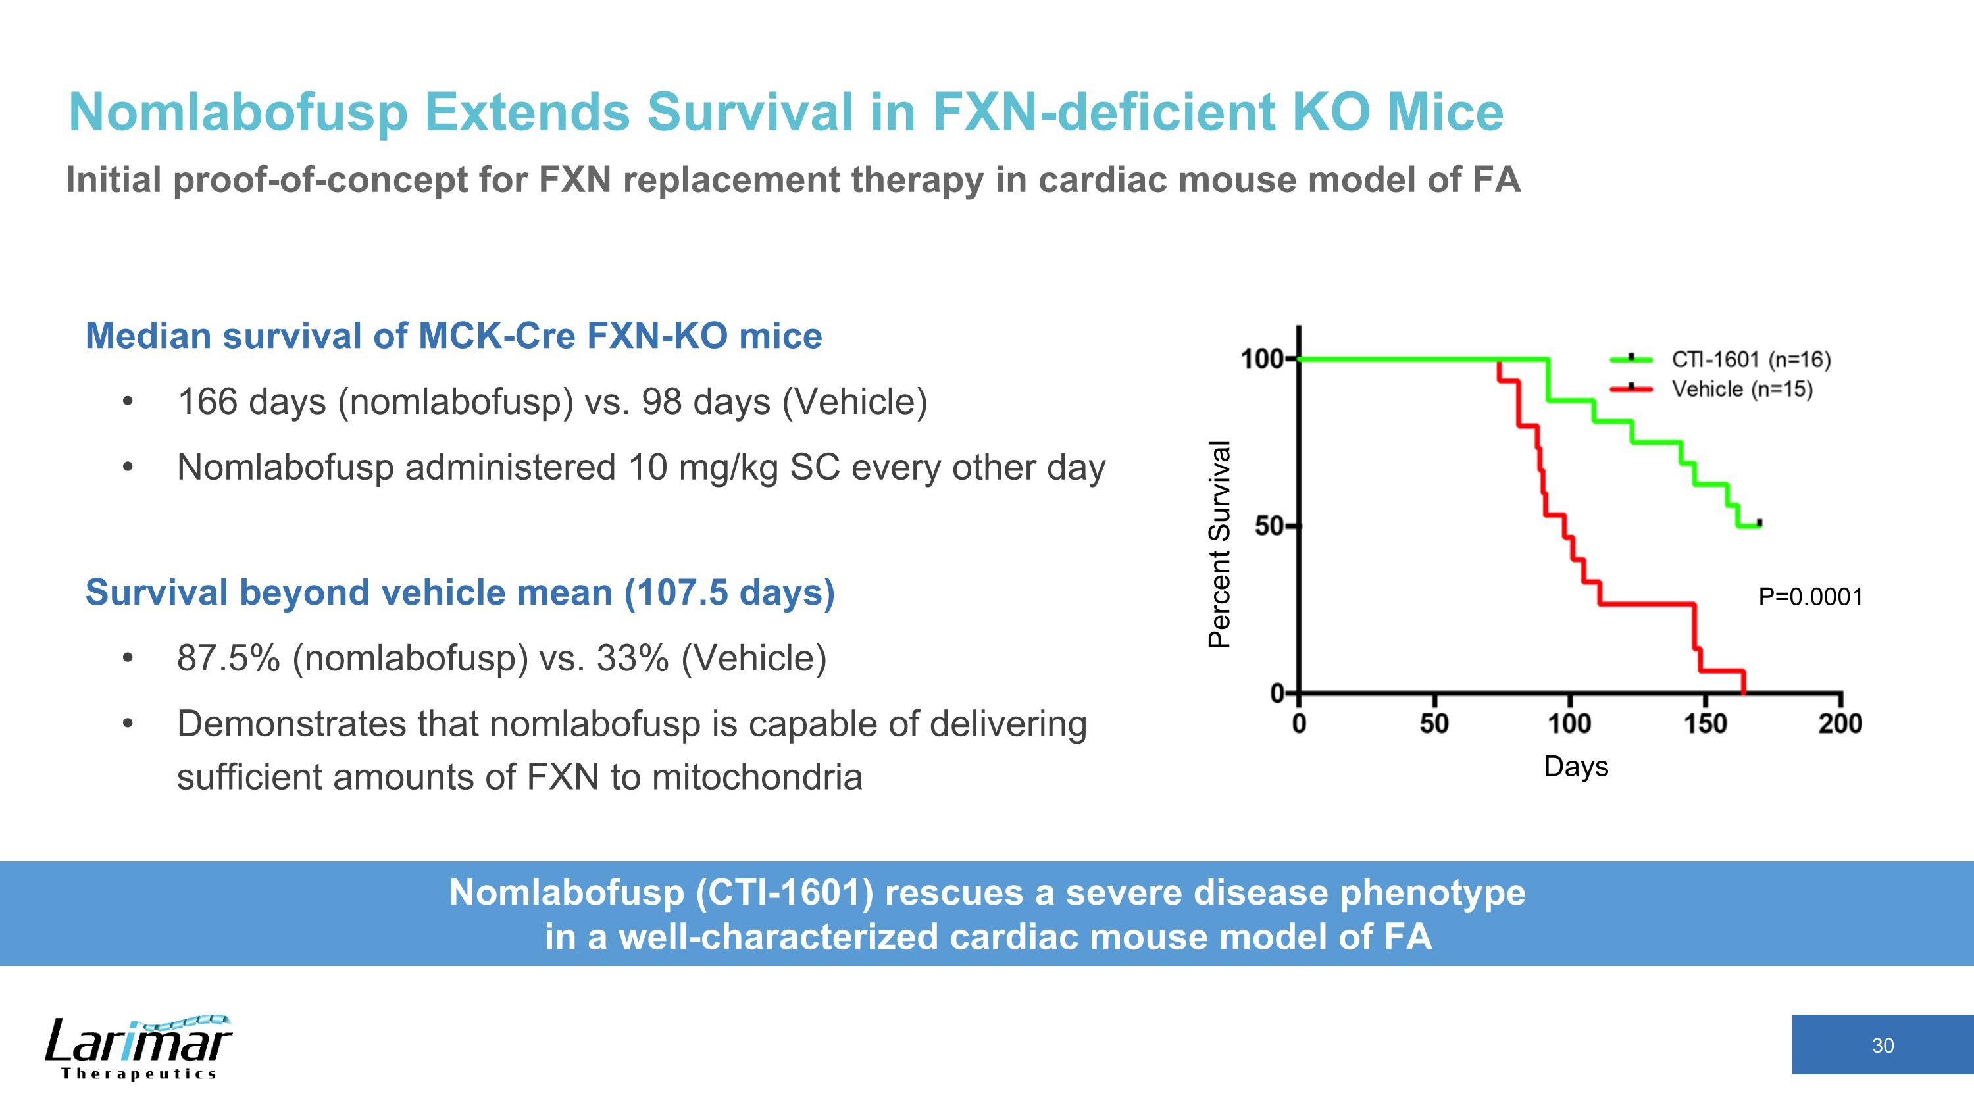
Nomlabofusp Extends Survival in FXN-deficient KO Mice Initial proof-of-concept for FXN replacement therapy in cardiac mouse model of FA Median survival of MCK-Cre FXN-KO mice 166 days (nomlabofusp) vs. 98 days (Vehicle) Nomlabofusp administered 10 mg/kg SC every other day Survival beyond vehicle mean (107.5 days) 87.5% (nomlabofusp) vs. 33% (Vehicle) Demonstrates that nomlabofusp is capable of delivering sufficient amounts of FXN to mitochondria Days Percent Survival Nomlabofusp (CTI-1601) rescues a severe disease phenotype ?in a well-characterized cardiac mouse model of FA P=0.0001

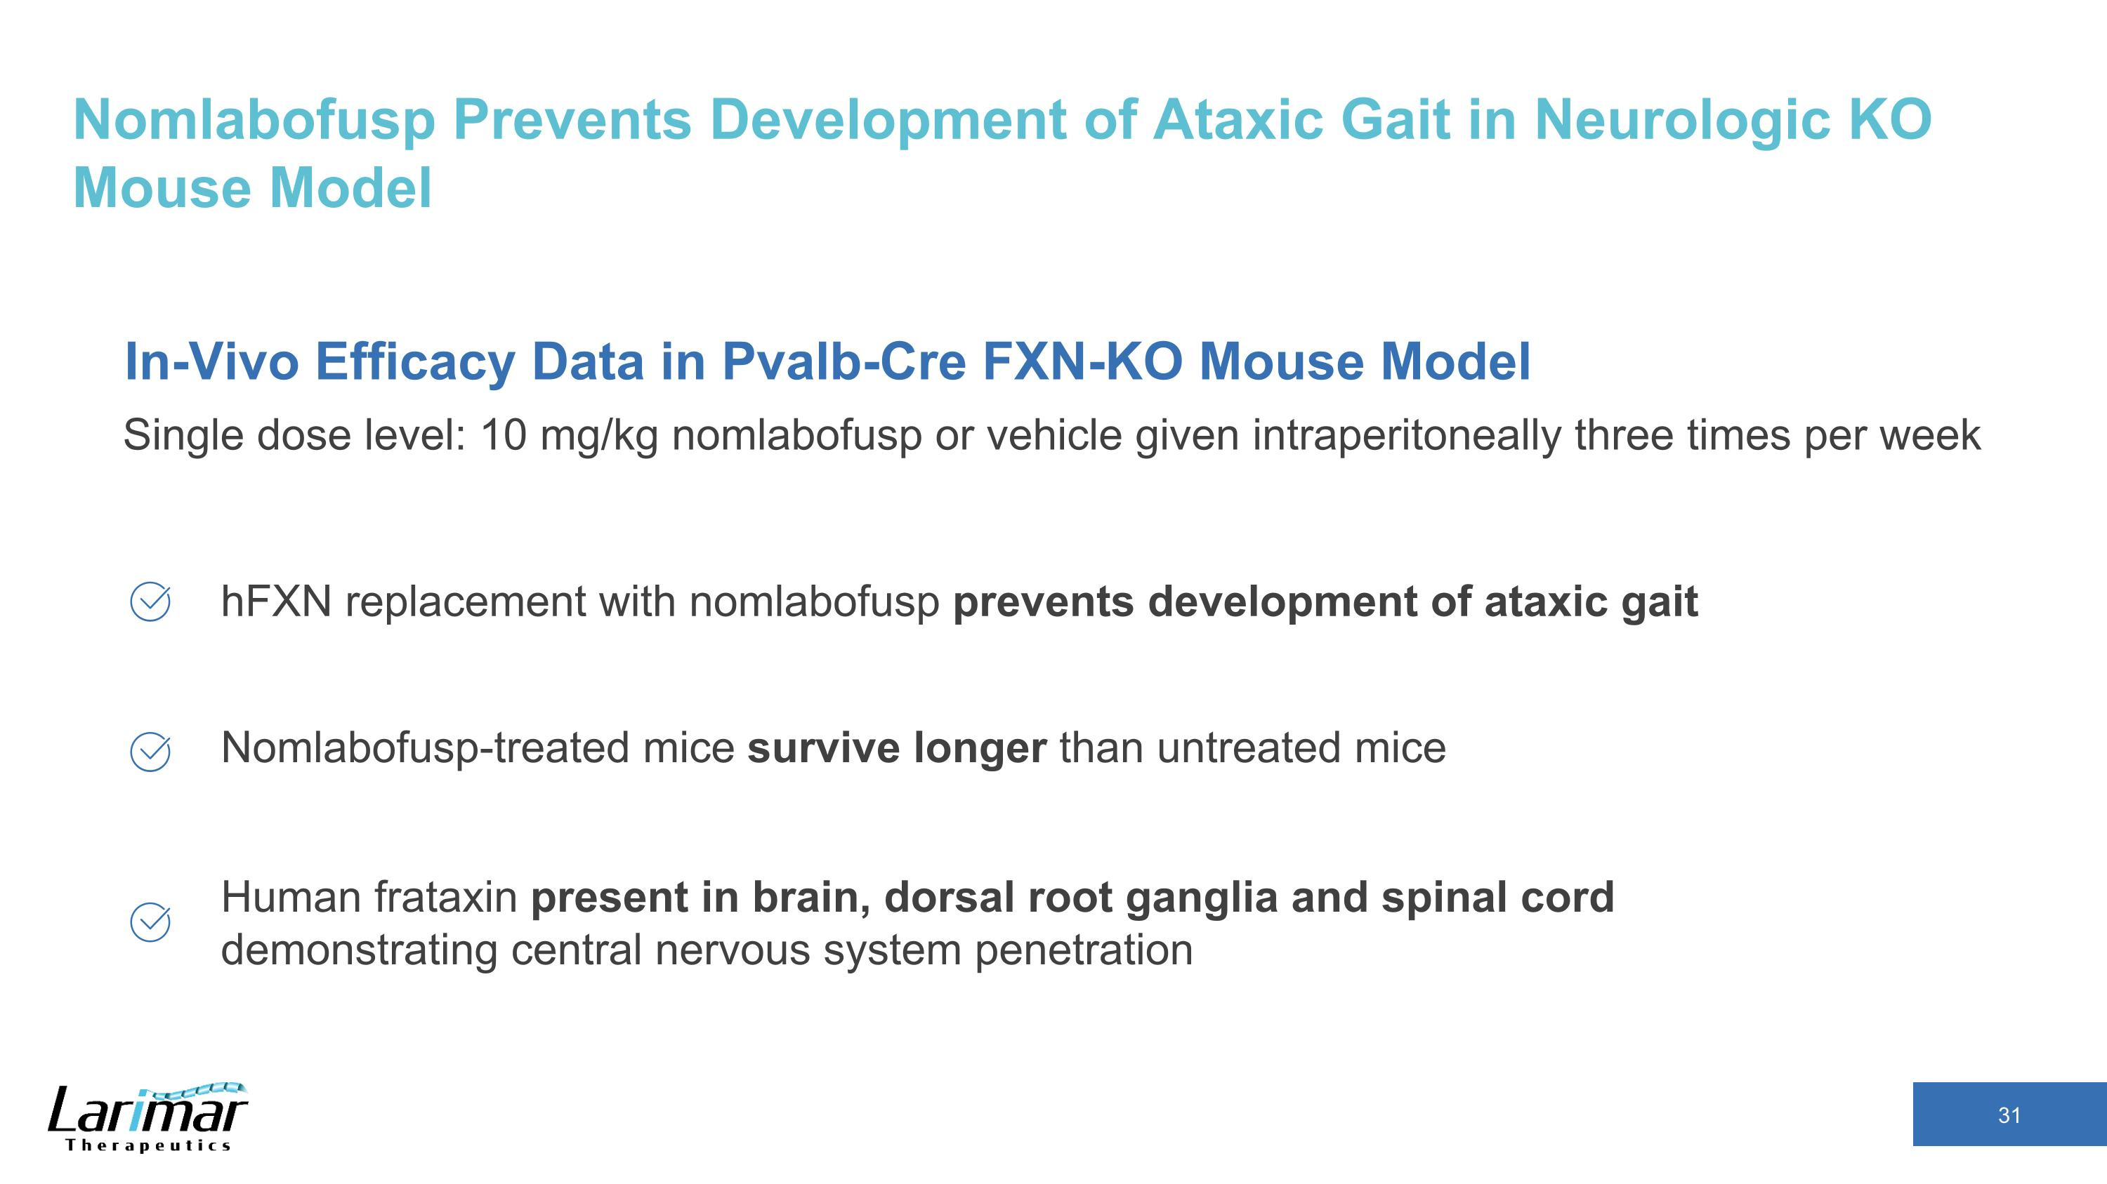
Nomlabofusp Prevents Development of Ataxic Gait in Neurologic KO Mouse Model hFXN replacement with nomlabofusp prevents development of ataxic gait Nomlabofusp-treated mice survive longer than untreated mice Human frataxin present in brain, dorsal root ganglia and spinal cord demonstrating central nervous system penetration In-Vivo Efficacy Data in Pvalb-Cre FXN-KO Mouse Model Single dose level: 10 mg/kg nomlabofusp or vehicle given intraperitoneally three times per week

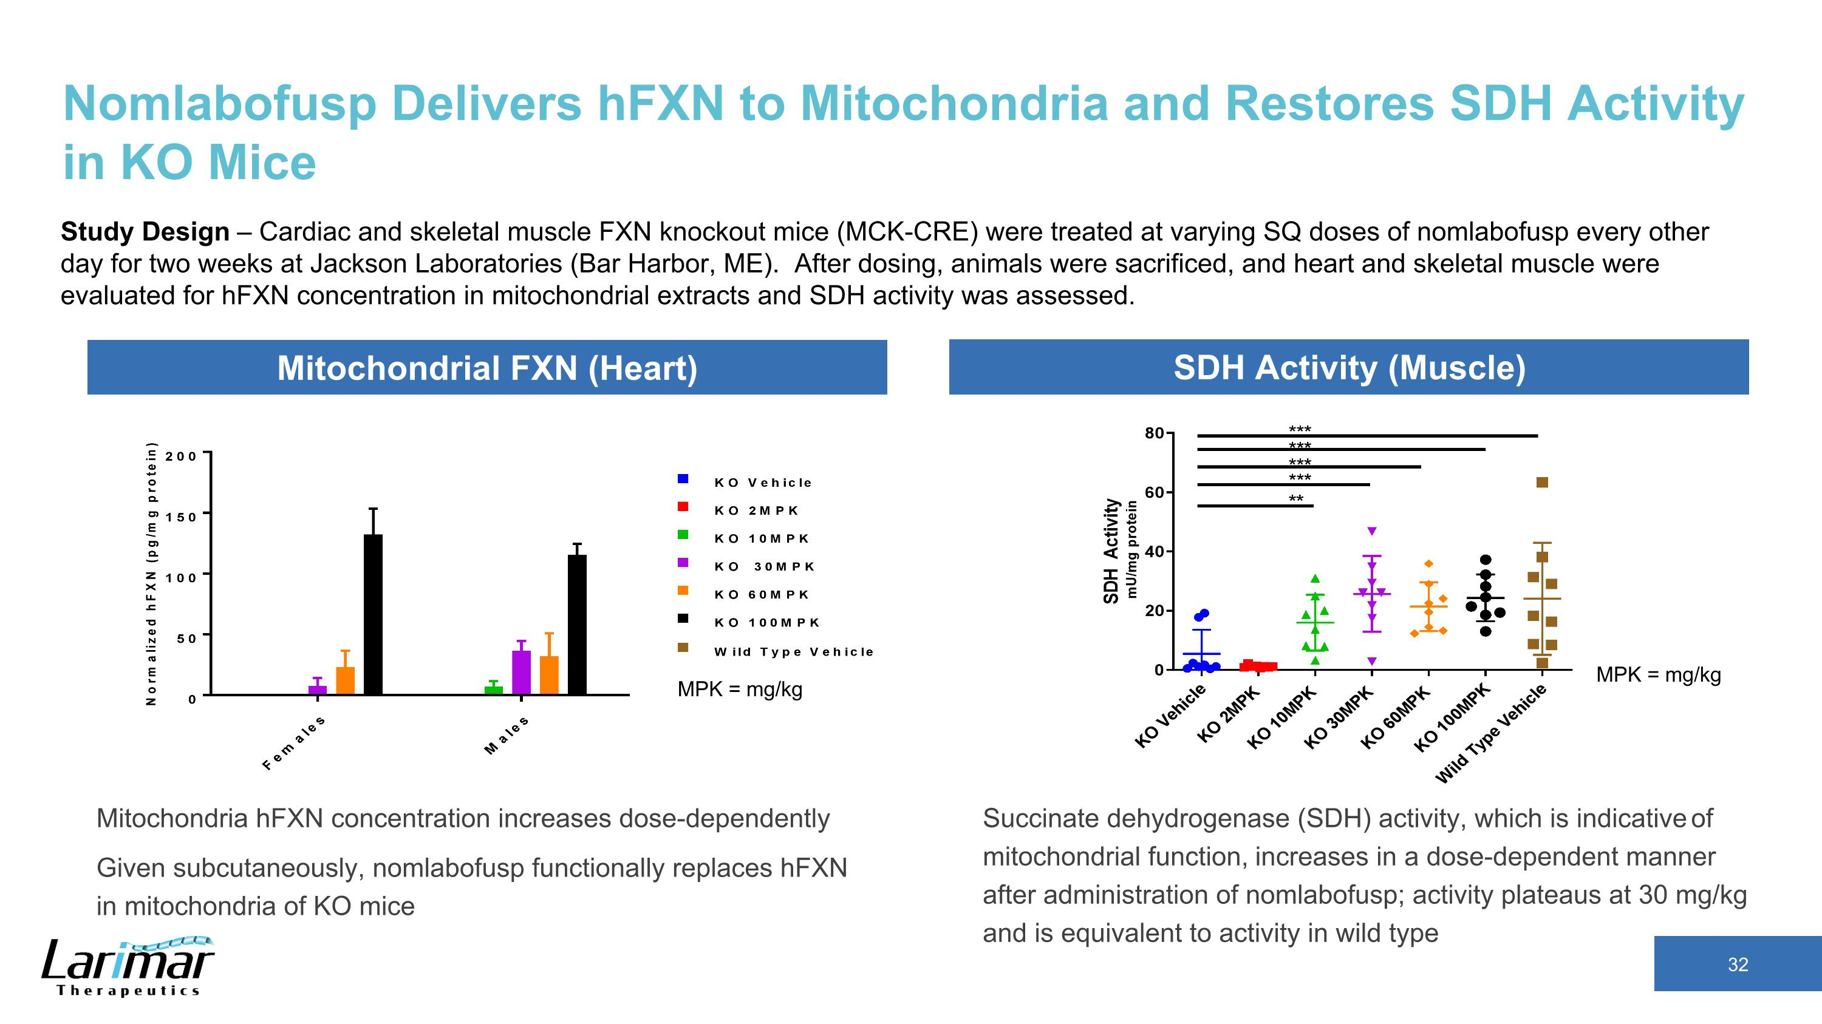
Nomlabofusp Delivers hFXN to Mitochondria and Restores SDH Activity in KO Mice Study Design – Cardiac and skeletal muscle FXN knockout mice (MCK-CRE) were treated at varying SQ doses of nomlabofusp every other day for two weeks at Jackson Laboratories (Bar Harbor, ME). After dosing, animals were sacrificed, and heart and skeletal muscle were evaluated for hFXN concentration in mitochondrial extracts and SDH activity was assessed. Mitochondria hFXN concentration increases dose-dependently Given subcutaneously, nomlabofusp functionally replaces hFXN in mitochondria of KO mice MPK = mg/kg MPK = mg/kg Mitochondrial FXN (Heart) SDH Activity (Muscle) Succinate dehydrogenase (SDH) activity, which is indicative of mitochondrial function, increases in a dose-dependent manner after administration of nomlabofusp; activity plateaus at 30 mg/kg and is equivalent to activity in wild type

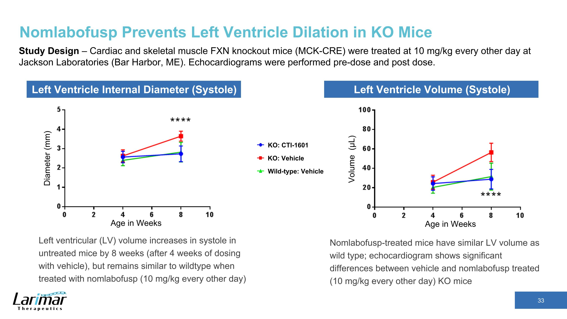
Nomlabofusp Prevents Left Ventricle Dilation in KO Mice Study Design – Cardiac and skeletal muscle FXN knockout mice (MCK-CRE) were treated at 10 mg/kg every other day at Jackson Laboratories (Bar Harbor, ME). Echocardiograms were performed pre-dose and post dose. Left ventricular (LV) volume increases in systole in untreated mice by 8 weeks (after 4 weeks of dosing with vehicle), but remains similar to wildtype when treated with nomlabofusp (10 mg/kg every other day) Diameter (mm) Age in Weeks Age in Weeks Volume (μL) KO: CTI-1601 Wild-type: Vehicle KO: Vehicle Left Ventricle Internal Diameter (Systole) Left Ventricle Volume (Systole) Nomlabofusp-treated mice have similar LV volume as wild type; echocardiogram shows significant differences between vehicle and nomlabofusp treated (10 mg/kg every other day) KO mice

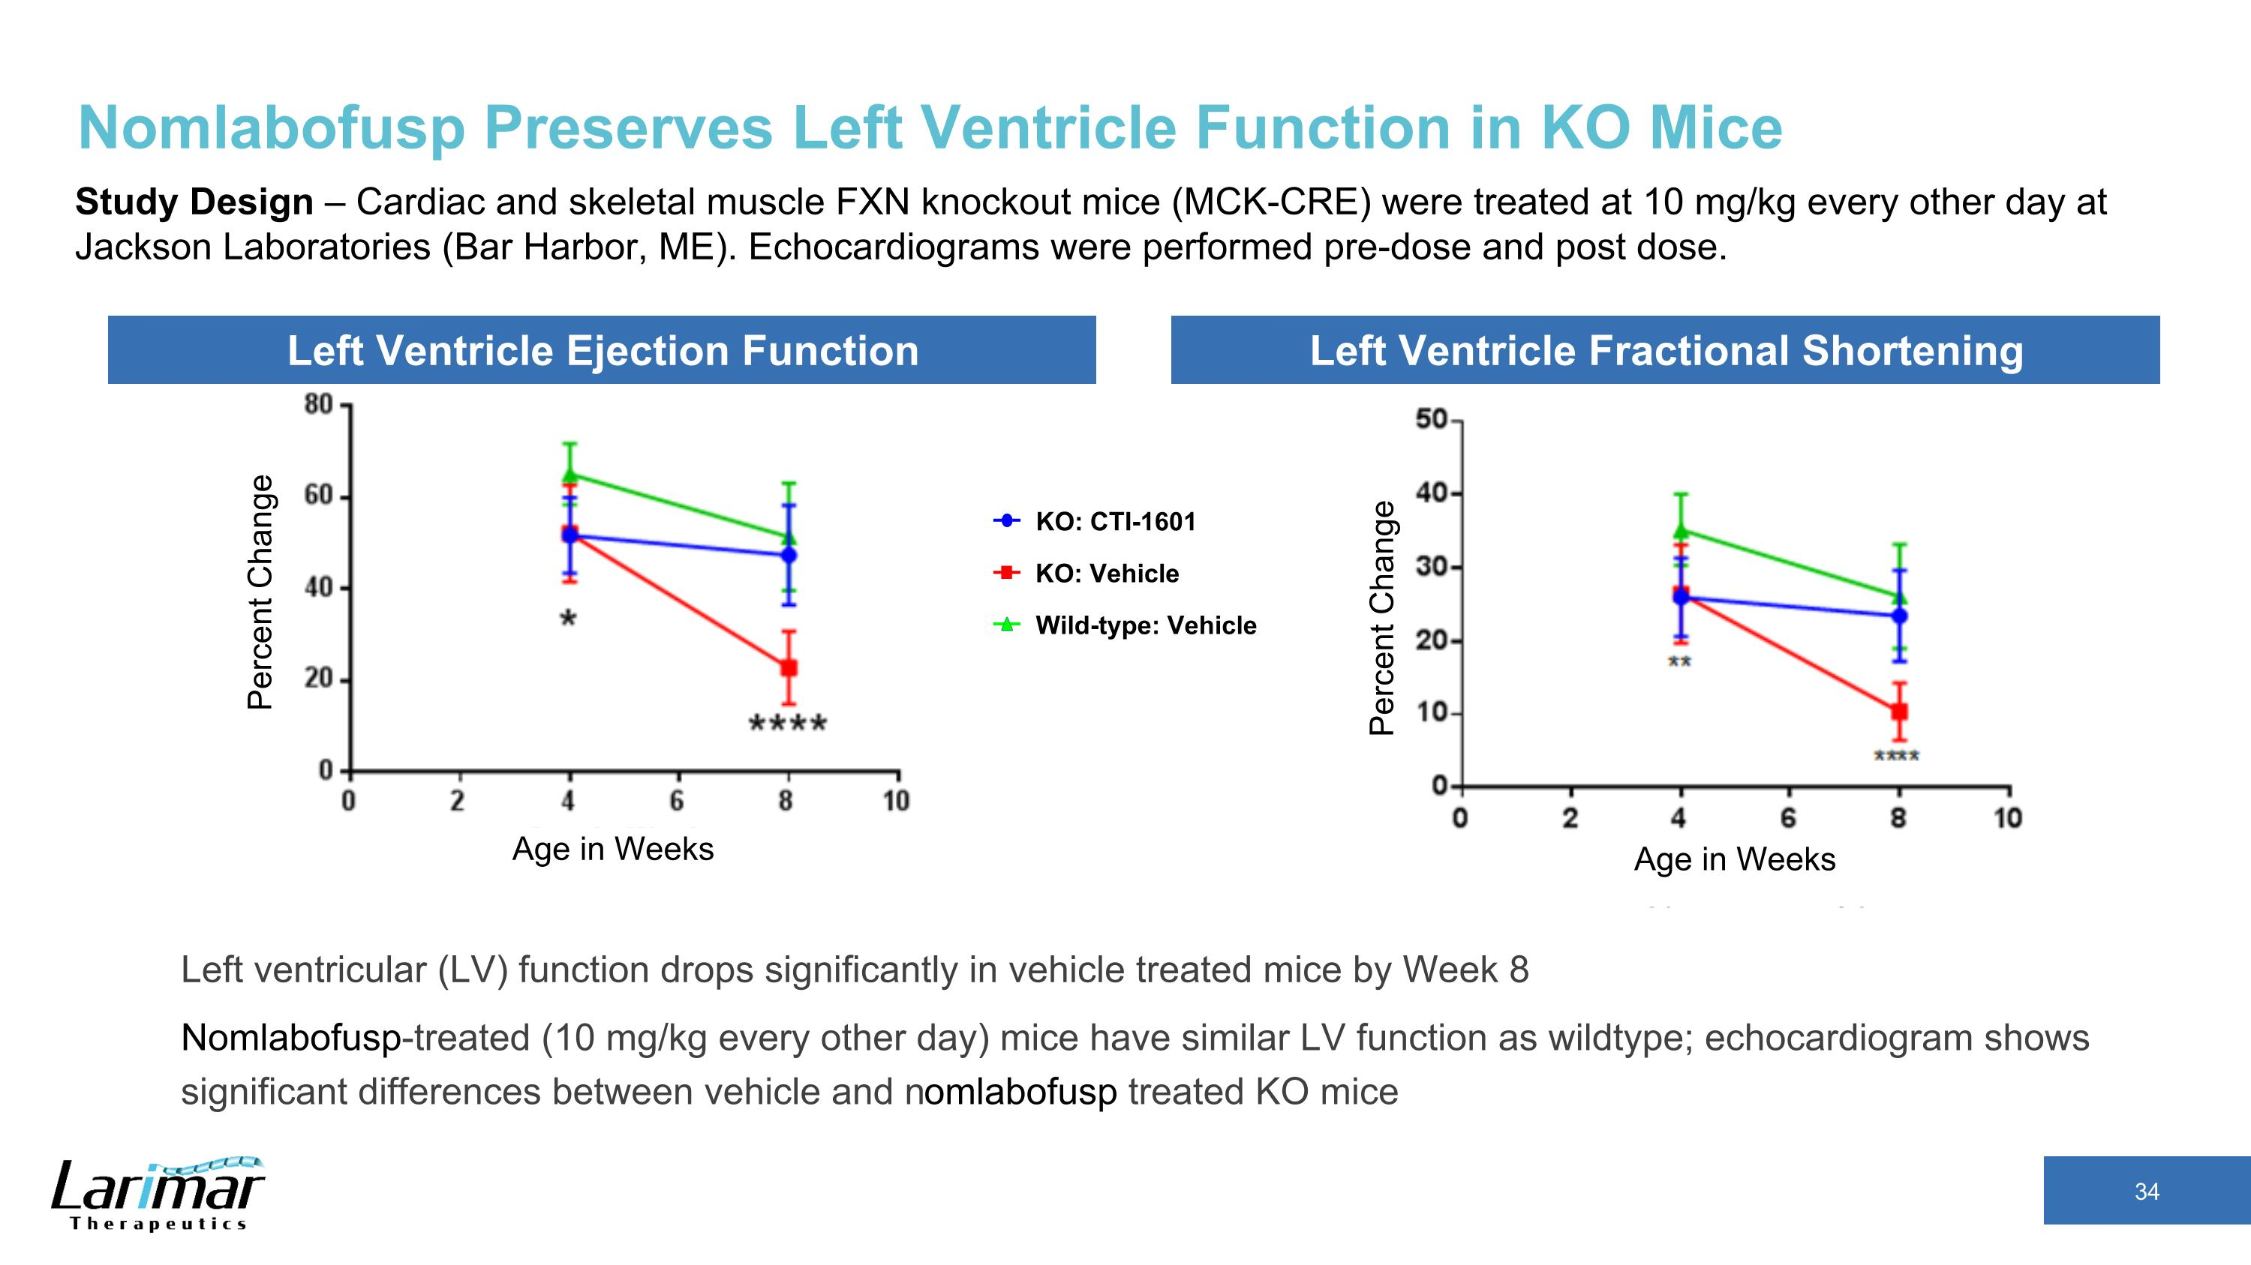
Nomlabofusp Preserves Left Ventricle Function in KO Mice Study Design – Cardiac and skeletal muscle FXN knockout mice (MCK-CRE) were treated at 10 mg/kg every other day at Jackson Laboratories (Bar Harbor, ME). Echocardiograms were performed pre-dose and post dose. Percent Change Age in Weeks Left Ventricle Ejection Function Left Ventricle Fractional Shortening Percent Change Age in Weeks KO: CTI-1601 Wild-type: Vehicle KO: Vehicle Left ventricular (LV) function drops significantly in vehicle treated mice by Week 8 Nomlabofusp-treated (10 mg/kg every other day) mice have similar LV function as wildtype; echocardiogram shows significant differences between vehicle and nomlabofusp treated KO mice


Non-Interventional Study Data

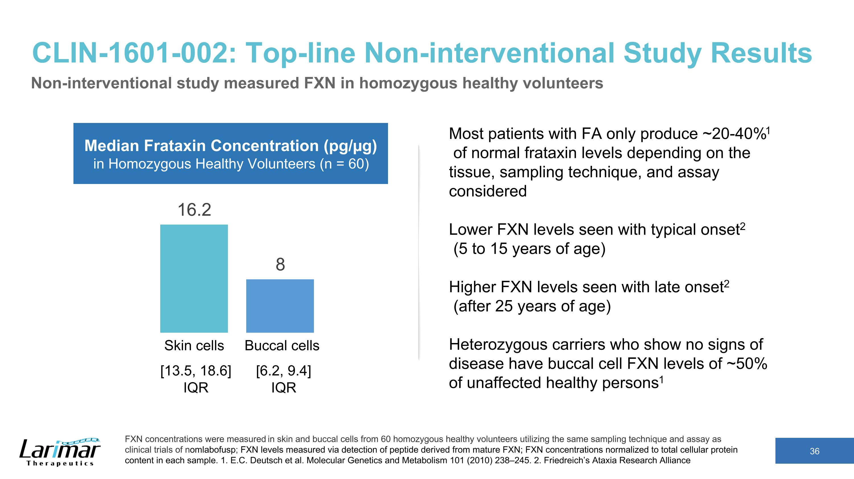
CLIN-1601-002: Top-line Non-interventional Study Results Non-interventional study measured FXN in homozygous healthy volunteers FXN concentrations were measured in skin and buccal cells from 60 homozygous healthy volunteers utilizing the same sampling technique and assay as clinical trials of nomlabofusp; FXN levels measured via detection of peptide derived from mature FXN; FXN concentrations normalized to total cellular protein content in each sample. 1. E.C. Deutsch et al. Molecular Genetics and Metabolism 101 (2010) 238–245. 2. Friedreich’s Ataxia Research Alliance Skin cells Buccal cells Median Frataxin Concentration (pg/µg) in Homozygous Healthy Volunteers (n = 60) Most patients with FA only produce ~20-40%1 of normal frataxin levels depending on the tissue, sampling technique, and assay considered Lower FXN levels seen with typical onset2 (5 to 15 years of age) Higher FXN levels seen with late onset2 (after 25 years of age) Heterozygous carriers who show no signs of disease have buccal cell FXN levels of ~50% of unaffected healthy persons1 [13.5, 18.6] IQR [6.2, 9.4] IQR

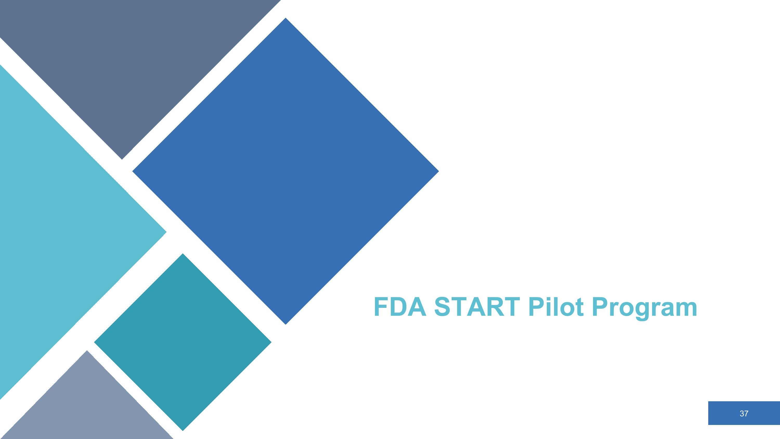
FDA START Pilot Program

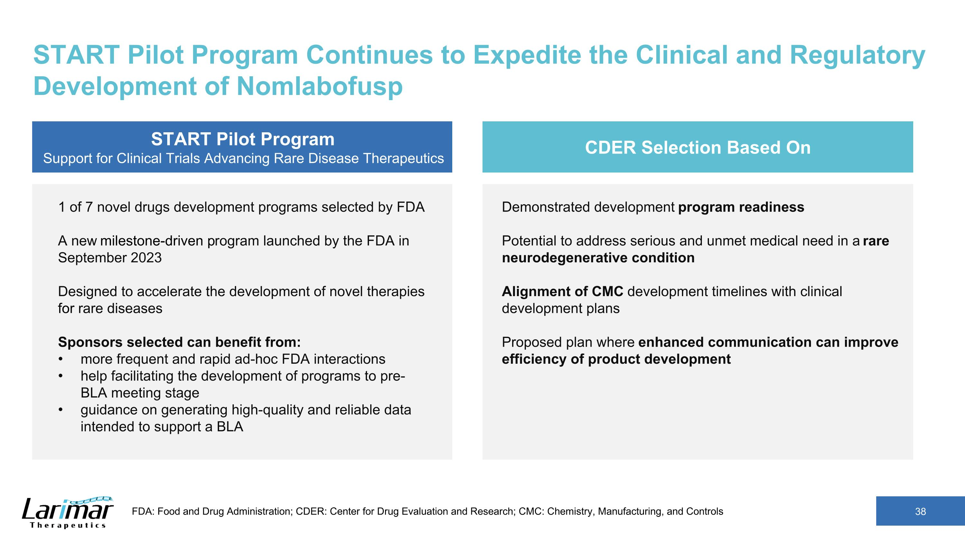
START Pilot Program Continues to Expedite the Clinical and Regulatory Development of Nomlabofusp START Pilot Program Support for Clinical Trials Advancing Rare Disease Therapeutics 1 of 7 novel drugs development programs selected by FDA A new milestone-driven program launched by the FDA in September 2023 Designed to accelerate the development of novel therapies for rare diseases Sponsors selected can benefit from: more frequent and rapid ad-hoc FDA interactions help facilitating the development of programs to pre-BLA meeting stage guidance on generating high-quality and reliable data intended to support a BLA CDER Selection Based On Demonstrated development program readiness Potential to address serious and unmet medical need in a rare neurodegenerative condition Alignment of CMC development timelines with clinical development plans Proposed plan where enhanced communication can improve efficiency of product development FDA: Food and Drug Administration; CDER: Center for Drug Evaluation and Research; CMC: Chemistry, Manufacturing, and Controls

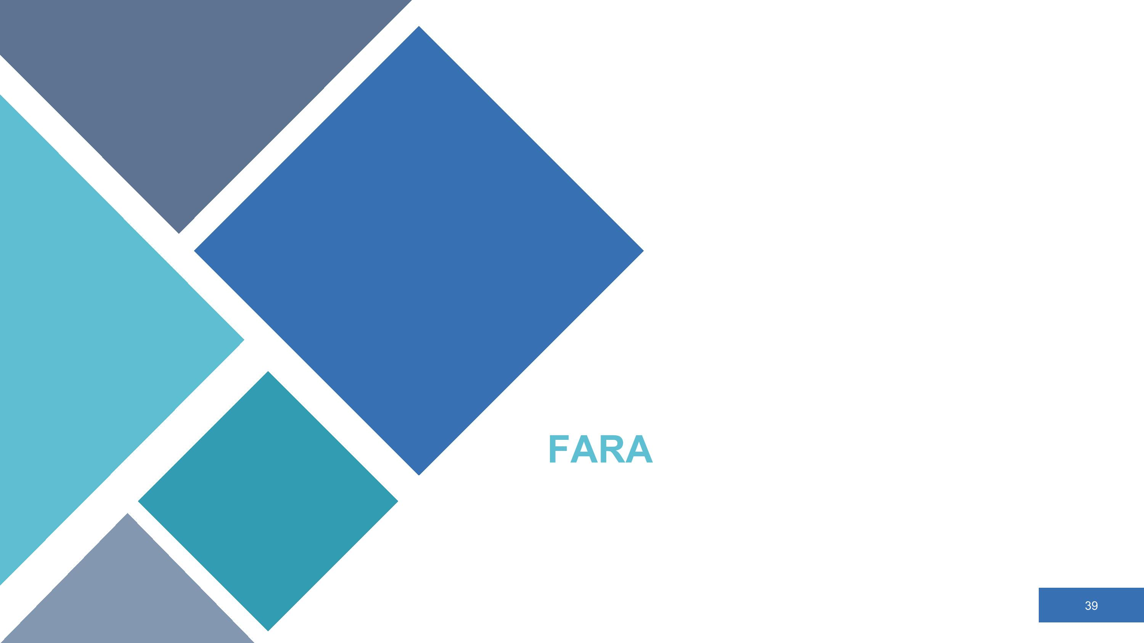
FARA

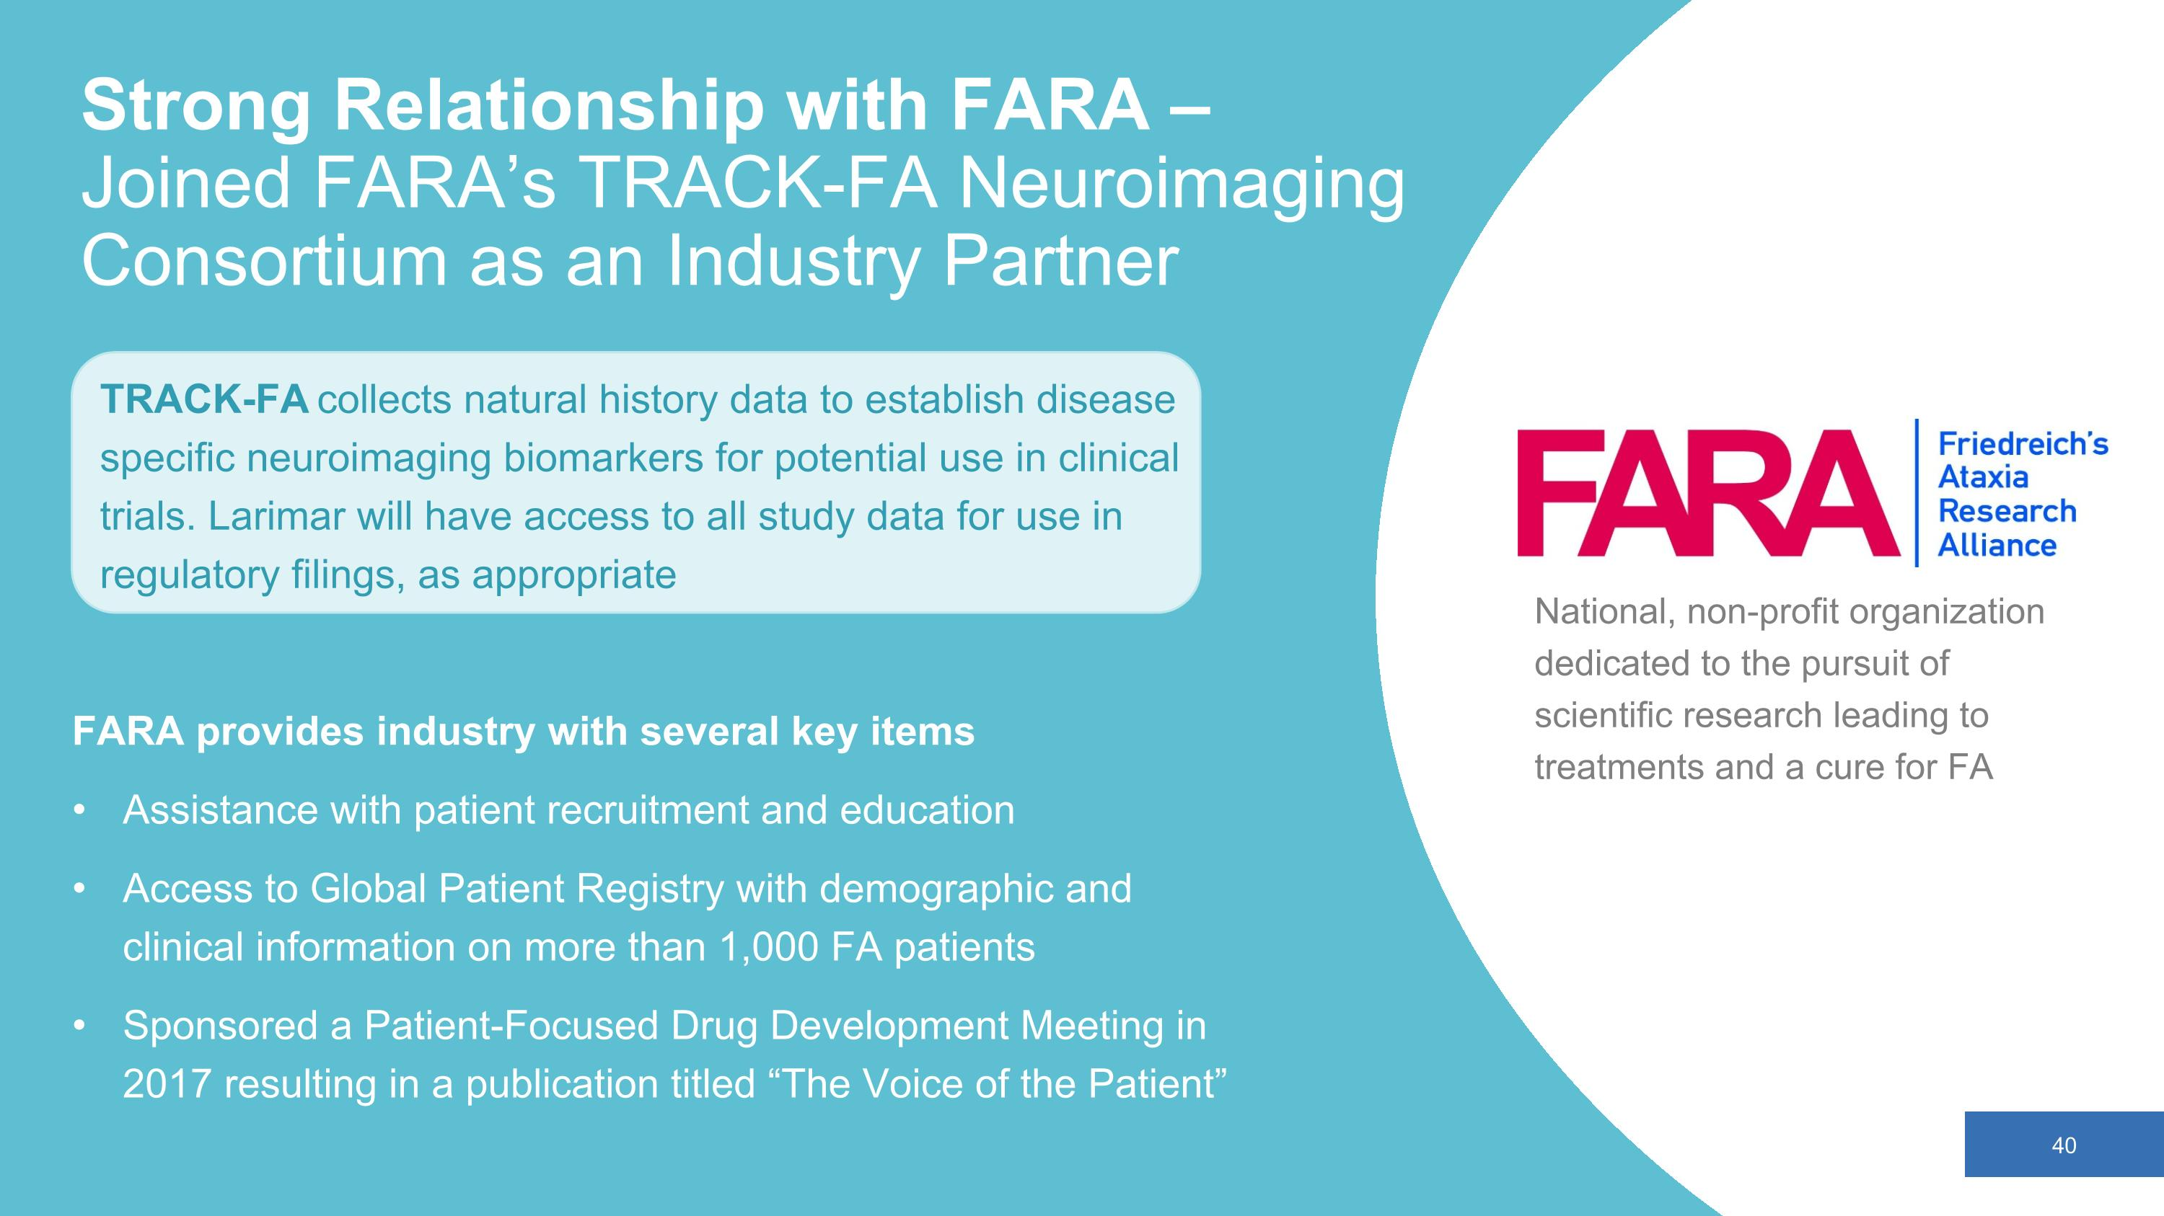
Strong Relationship with FARA – ?Joined FARA’s TRACK-FA Neuroimaging Consortium as an Industry Partner National, non-profit organization dedicated to the pursuit of scientific research leading to treatments and a cure for FA FARA provides industry with several key items Assistance with patient recruitment and education Access to Global Patient Registry with demographic and clinical information on more than 1,000 FA patients Sponsored a Patient-Focused Drug Development Meeting in 2017 resulting in a publication titled “The Voice of the Patient” TRACK-FA collects natural history data to establish disease specific neuroimaging biomarkers for potential use in clinical trials. Larimar will have access to all study data for use in regulatory filings, as appropriate

