UNITED STATES

SECURITIES AND EXCHANGE COMMISSION
Washington, D.C. 20549

SCHEDULE 14A INFORMATION

Proxy Statement Pursuant to Section 14(a) of

the Securities Exchange Act of 1934

Filed by the Registrant ☒ Filed by a Party other than the Registrant ☐

Check the appropriate box:

- Preliminary Proxy Statement

- Confidential, for Use of the Commission Only (as permitted by Rule 14a-6(e)(2))

- Definitive Proxy Statement

- Definitive Additional Materials

- Soliciting Material Pursuant to §240.14a-12

ZAFGEN, INC.

(Name of Registrant as Specified In Its Charter)

(Name of Person(s) Filing Proxy Statement, if other than the Registrant)

Payment of Filing Fee (Check the appropriate box):

- No fee required.

- Fee computed on table below per Exchange Act Rules 14a-6(i)(1) and 0-11.

  - Title of each class of securities to which transaction applies:

  - Aggregate number of securities to which transaction applies:

  - Per unit price or other underlying value of transaction computed pursuant to Exchange Act Rule 0-11 (set forth the amount on which the filing fee is calculated and state how it was determined):

  - Proposed maximum aggregate value of transaction:

  - Total fee paid:

- Fee paid previously with preliminary materials.

- Check box if any part of the fee is offset as provided by Exchange Act Rule 0-11(a)(2) and identify the filing for which the offsetting fee was paid previously. Identify the previous filing by registration statement number, or the Form or Schedule and the date of its filing.

  - Amount Previously Paid:

  - Form, Schedule or Registration Statement No.:

  - Filing Party:

- Date Filed:

This Schedule 14A consists of an investor presentation. Members of Zafgen, Inc. management will be participating in upcoming meetings with investors. The following presentation will be used in connection with the meetings with investors.

The presentation was first used or made available on February 5, 2020.

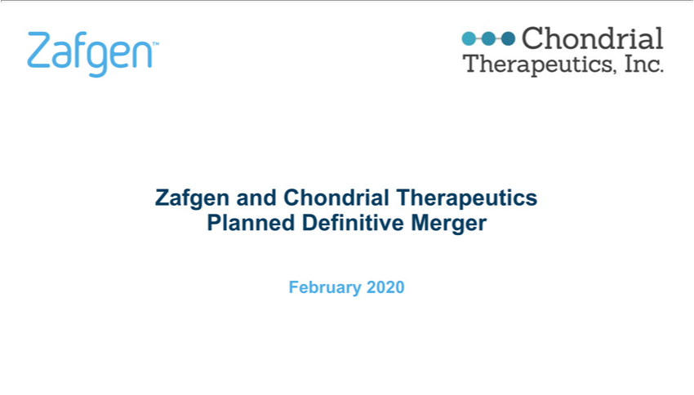

Zafgen and Chondrial Therapeutics Planned Definitive Merger February 2020

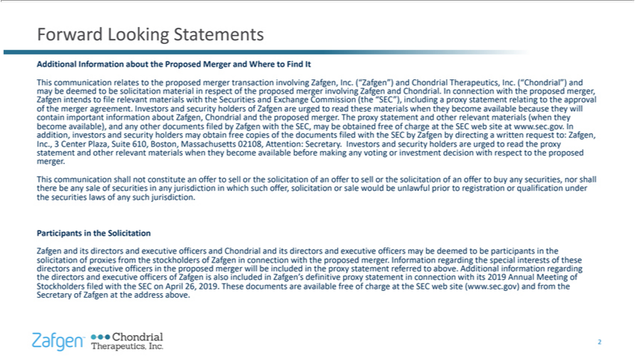

Forward Looking Statements Additional Information about the Proposed Merger and Where to Find It This may communication be deemed to be relates solicitation to the material proposed in merger respect
transaction of the proposed involving merger Zafgen, involving Inc. (“Zafgen”) Zafgen and and |  | . Chondrial In Therapeutics, connection with Inc. the (“Chondrial”) proposed merger, and Zafgen
intends to file relevant materials with the Securities and Exchange Commission (the “SEC”), includingChondrialproxy statement relating to the approval of contain |  |  | merger important agreement. information
Investors about and Zafgen, security Chondrial holders and of Zafgen the proposed are urged merger. to read The these proxy materials statement when and they |  |  |  | become relevant available materials
because (when they they will become addition, available), investors and and security any other holders documents may obtain filed by free Zafgen copies with ofotherthe SEC, documents may be filed obtained
with the free SEC of charge by Zafgen at the by directing SEC web site written at www. request sec.gov. to: In Zafgen, Inc. statement , 3 Center and Plaza, other Suite relevant 610, materials Boston,
Massachusetts when they become 02108, available Attention: before Secretary. making Investors |  | and or security investment holders decision are urged with respect to read to the the proxy proposed
merger. This there communication be any sale of securities shall not constitute in any jurisdiction anyoffervoting to which sell or such the solicitation offer, solicitation of an offer or sale to would sell or the be
unlawful solicitation prior of to an registration offer to buy or any qualification securities, nor under shall the securities laws of any such jurisdiction. Participants in the Solicitation Zafgen and its directors and
executive officers and Chondrial and its dir ctors and executive officers may be deemed to be participants in the solicitation directors and of executive proxies from officers the stockholders in the proposed of
Zafgen merger in will connection be included with the the | proxy statement merger. referred Information to above. regarding Additional the special information interests regarding of |  |  |  | the
directors and executive officers of Zafgen is also included in Zafgen’proposed definitive proxy statement in connection with its 2019 Annual Meeting of Stockholders Secretary of Zafgen filed with at thethese address SEC on above. April 26, 2019. These documents are available free of charge at the SEC web site (www.sec.gov) and from the 2

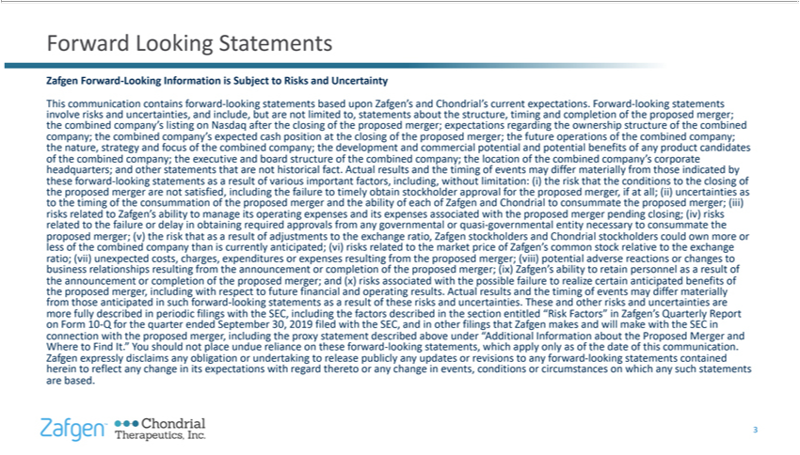

Forward Looking Statements Zafgen Forward-Looking Information is Subject to Risks and Uncertainty This involve communication risks and uncertainties, contains forward-looking and include, but
are not limited based to, upon statements Zafgen’ about and Chondrial’s the structure, current timing expectations. and completion Forward-looking of the proposed statements merger; the combined company’statements
listing on Nasdaq after the closing of the proposed merger; expectations regarding the ownership structure of the combined company; the nature, the strategy combined and focus |  |  |  |  |  |  |  |  | s of the expected
ombined cash comp ny; position the at develop |  | ent the closing of and the proposed commercial merger; potential the and future potential operations benefits of the of combinedcompany’product company;
candidates of headquarters; the combined and company; other statements the executive that and are not board historical structure fact. of Actual the combined results |  |  |  |  |  |  | company; the timing the location of
events of may the differ combined materially company’ from those corporate indicated by the these proposed forward-looking merger are |  |  |  |  |  | not satisfied, asandresult including of various the failure
important to timely factors, obtain including, stockholder without approval limitation: for the (i) proposed the risk that merger, the conditionsstatementsifall; (ii) to uncertainties the closing of as to the timing of the
consummation of the proposed merger and the ability of each of Zafgen and Chondrial to consummate the proposed merger; (iii) risks related related to the to failure Zafgen’s or delay ability in to obtaining
manage its required operating approvals expenses from and any its |  |  | expenses associated or quasi-governmental with the proposed entity merger necessary pending to consummate closing; (iv) risks
the | less of the merger; combined (v) company the risk thatgovernmentalthanasiscurrently result of adjustments anticipated; (vi) to the risks exchange related to ratio, the Zafgen market stockholders price of
Zafgen’proposedand Chondrial common stock stockholders relative to could the own exchange more or |  |  |  | ratio; (vii) relationships unexpected costs, resulting charges, from the expenditures announcement or
expenses or completion resulting of from the proposed the proposed merger; merger; (ix) Zafgen’business(viii)potential ability adverse to retainreactions personnel or as changes a result to of the the announcement
proposed merger, or including completion with of respect the proposed to future merger; financial and and (x) risks |  |  |  |  | associated results. with Actual the possible results and failure the to timing realize of
certain events anticipated may differ materially benefits of from those anticipated in such forward-looking statementsoperatingasresult of these risks and uncertainties. These and |  |  |  |  |  |  |  | risks and uncertainties are more
on Form fully 10-Q described for the in quarter periodic ended filings September with the SEC, 30, 2019 including filed the with factors the SEC, described and in other |  |  |  |  |  |  |  | otherfilings section that entitled Zafgen
“Risk makes Factors” and will in make Zafgen’ |  | with Quarterly the SEC Report in connection Where to Find with It. ” the You proposed should not merger, place including undue reliance the proxy on these
statement forward-looking described above statements, under “Additional which apply Information only as of the about date the of Proposed this communication. Merger and Zafgen herein to expressly reflect any_{statements}disclaims change any in obligation its expectations or undertaking with regard to thereto release publicly or any change any updates in events, or revisions conditions to any or circumstances forward-looking
on which any such contained statements are based. 3

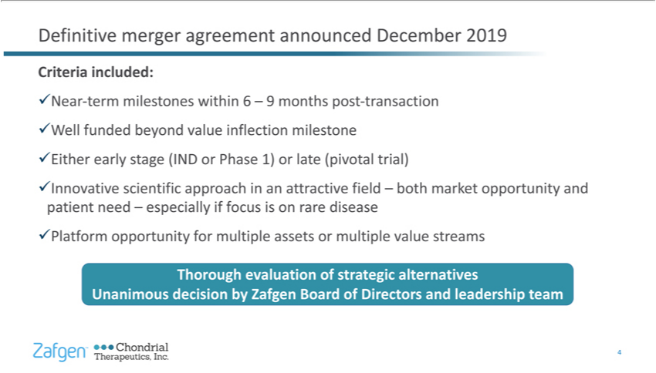

Definitive merger agreement announced December 2019 Criteria included: üNear-term milestones within 6 – 9 months post-transaction üWell funded ^{beyond} value inflection milestone üEither early stage (IND ^{or} Phase 1) or late (pivotal trial) üInnovative scientific approach in an attractive field – both market opportunity and patient need – especially if focus is rare disease üPlatform opportunity for multiple assets

multiple value streams Thorough evaluation of strategic alternatives Unanimous decision by Zafgen Board of Directors and leadership team 4

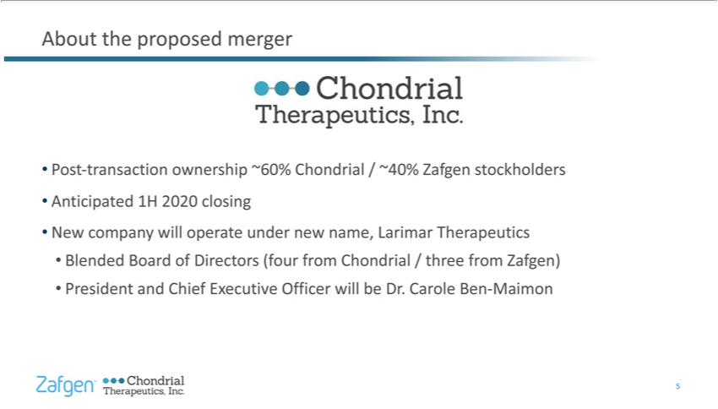

About the proposed merger Post-transaction ownership ~60% Chondrial / ~40% Zafgen stockholders Anticipated 1H 2020 closing New company will operate under new name, Larimar Therapeutics Blended Board of Directors (four from Chondrial / three from Zafgen) President and Chief Executive Officer will be Dr. Carole Ben-Maimon 5

Compelling value-creation opportunity Publicly traded, clinical-stage biopharmaceutical company focused on rare disease Strong scientific approach and platform opportunity Targeting significant market opportunities Upcoming near-term value creating events expected Experienced leadership team Potential to have impact on significant and devastating diseases 6

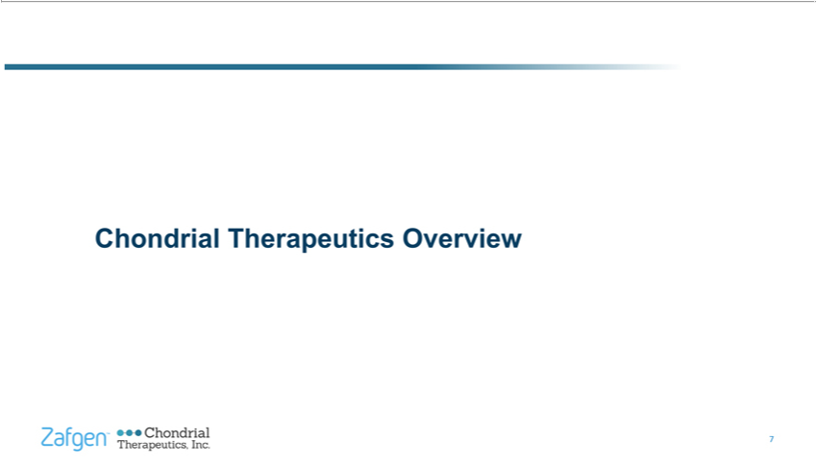

Chondrial Therapeutics Overview 7

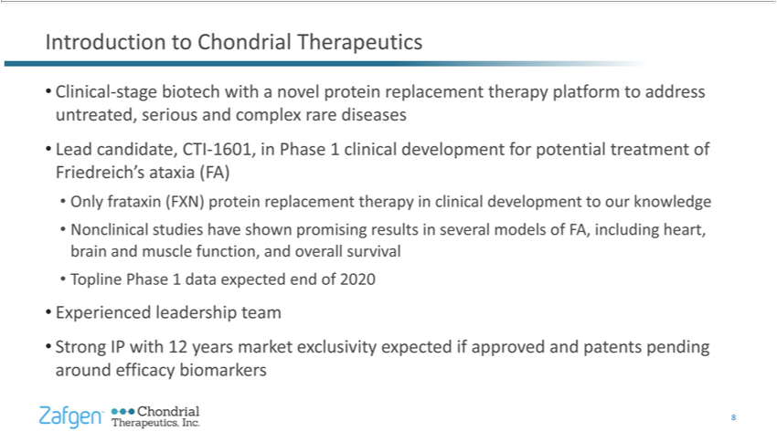

Introduction to Chondrial Therapeutics Clinical-stage biotech with a novel protein replacement therapy platform to address untreated,_{development}seriousad complex rare diseases Lead candidate, CTI-1601, _{promising}Phase1

clinical development for potential treatment of Friedreich’s ataxia (FA) Only frataxin (FXN) protein replacement therapy in clinical to our knowledge Nonclinical studies have shown results in several models of FA, including heart, brain and muscle function, and overall survival Topline Phase 1 data expected end of 2020 Experienced leadership team Strong IP with 12 years market exclusivity expected if approved and patents pending around efficacy biomarkers 8

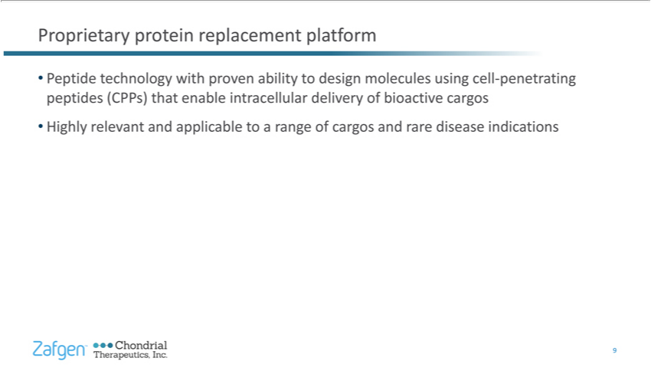

Proprietary protein replacement platform Peptide technology with proven ability to design molecules using cell-penetrating peptides (CPPs) that enable intracellular delivery of bioactive cargos Highly relevant and applicable to a range of cargos and rare disease indications 9

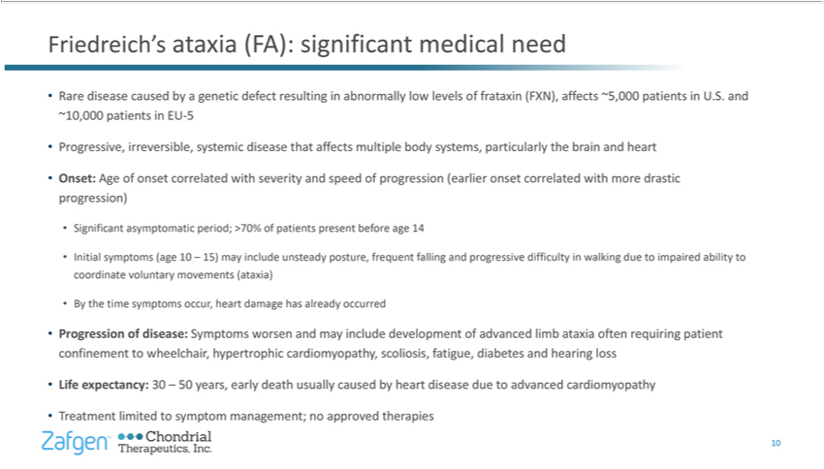

_{Progressive,}Fiedreich’ ataxia (FA): significant medical need Rare disease caused by a genetic defect resulting in abnormally low levels of frataxin (FXN), aff_{severity}cts~5,000 patients in U.S. and ~10,000 patients in EU-5
irrever_{progression)}ible,systemic disease that affects multiple body systems, particularly the brain and heart Onset: Age of onset correlated with and speed of progression (earlier onset correlated with
more drastic Significant asymptomatic period; >70% of patients present before age 14 Initial symptoms (age 10 – 15) may include unsteady posture, frequent falling and progressive difficulty in walking due to impaired ability to coordinate voluntary movements (ataxia) By the time symptoms occur, heart damage has already occurred Progression of disease: Symptoms worsen and may include development of advanced limb ataxia often requiring patient confinement to wheelchair, hypertrophic cardiomyopathy, scoliosis, fatigue, diabetes and hearing loss Life expectancy: 30 – 50 years, early death usually caused by heart disease due to advanced cardiomyopathy Treatment limited to symptom management; no approved therapies 10

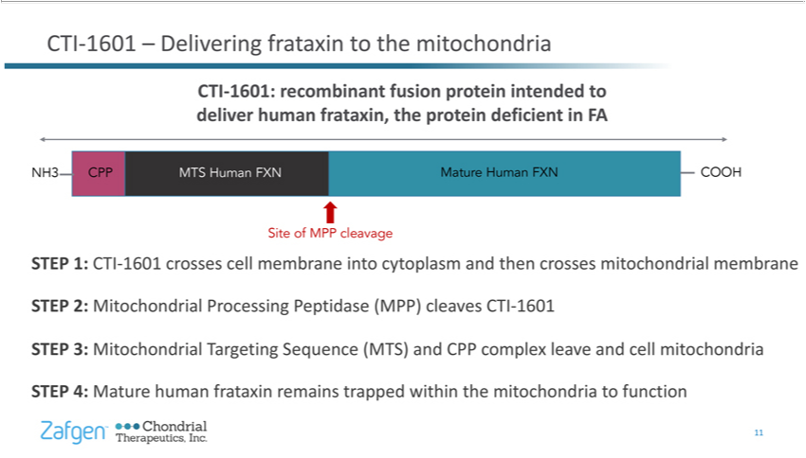

^{COOH}
TI-1601Site– ofDeliveringMPPcleavagefrataxinSTEPtothe1:mitochondriaCTI-1601crossesCTI-1601:cellmembranerecombinantintofusioncytoplasmproteinandintendedthencrossestodelivermitochondrialhumanfrataxin,membranethe proteinSTEP2:deficientMitochondrialinFANH3ProcessingCPPMTSPeptidaseHuman(MPP)FXN cleavesMature HumanCTI-1601FXNSTEP 3:

Mitochondrial Targeting Sequence (MTS) and CPP complex leave and cell mitochondria STEP 4: Mature human frataxin remains trapped within the mitochondria to function 11

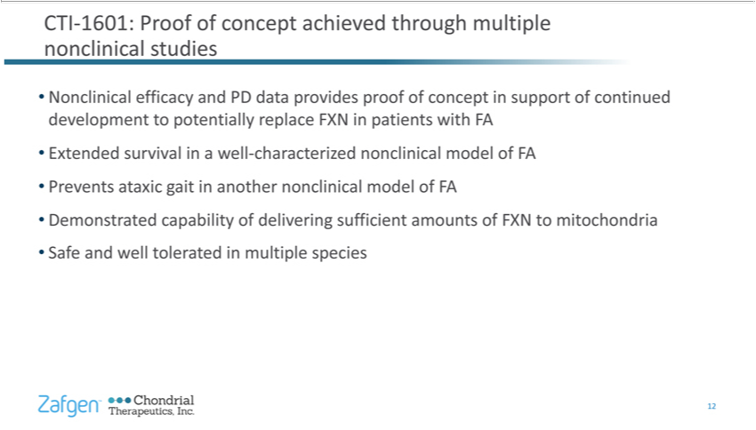

CTI-1601: Proof of concept _{achieved} through multiple nonclinical studies Nonclinical efficacy and PD data provides proof of concept in support of continued development to potentially replace FXN in patients with FA Extended survival in well-characterized nonclinical model of FA Prevents ataxic gait in another nonclinical model of FA Demonstrated capability of delivering sufficient amounts of FXN to mitochondria Safe and well tolerated in multiple species 12

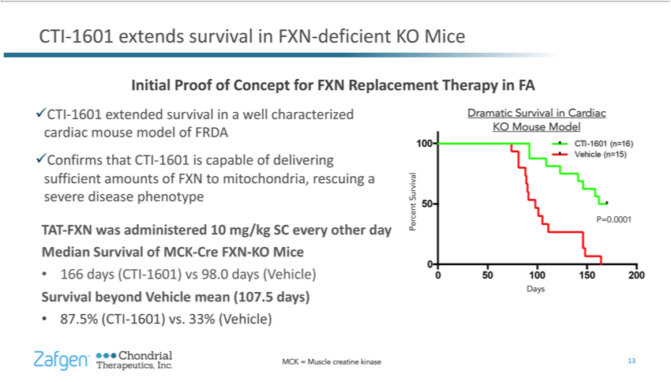

CTI-1601 extends survival in FXN-deficient KO Mice Initial Proof of Concept for FXN Replacement _{Therapy} in FA üCTI-1601 extended survival_{administered}awellcharacterized cardiac mouse model of FRDA

üConfirms that CTI-1601 is capable of delivering sufficient amounts of FXN to mitochondria, rescuing severe disease phenotype TAT-FXN was 10 mg/kg SC every other day Median Survival of MCK-Cre FXN-KO Mice 166 days (CTI-1601) vs 98.0 days (Vehicle) Survival beyond Vehicle mean (107.5 days) 87.5% (CTI-1601) vs. 33% (Vehicle) Dramatic Survival in Cardiac KO Mouse Model Survival Percent P=0.0001 Days MCK = Muscle creatine kinase 13

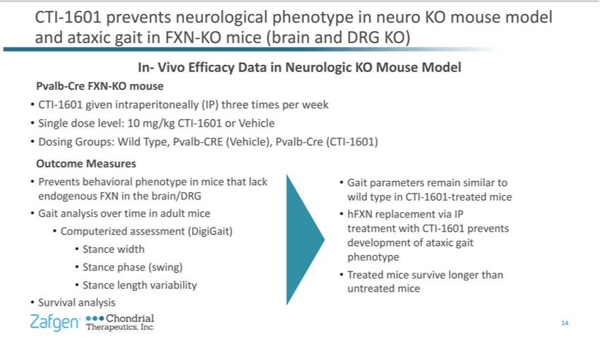

^{CTI-1601} prevents neurological phenotype in neuro KO mouse model and ataxic gait in FXN-KO mice (brain and DRG KO) In- Vivo Efficacy Data in Neurologic KO Mouse Model Pvalb-Cre FXN-KO mouse given intraperitoneally (IP) three times per week Single dose level: 10 mg/kg CTI-1601 or Vehicle Dosing Groups: Wild Type, Pvalb-CRE (Vehicle), Pvalb-Cre (CTI-1601) Outcome Measures

Prevents behavioral phenotype in mice that lack endogenous FXN in the brain/DRG Gait analysis over time in adult mice Computerized assessment (DigiGait) Stance width Stance phase (swing) Stance length variability Survival analysis Gait parameters remain similar to wild type in CTI-1601-treated mice hFXN replacement via IP treatment with CTI-1601 prevents development of ataxic gait phenotype Treated mice survive longer than untreated mice 14

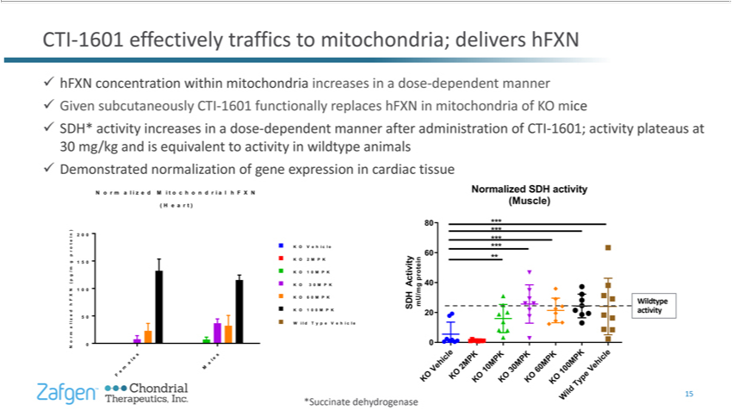

hFXN concentration within mitochondria increases inactivitydose-dependent manner ü Given subcutaneously CTI-1601 functionally replaces hFXN in mitochondria of KO mice ü SDH* activity increases in a dose-dependentmannerafteradministrationofCTI-1601;at30mg/kgtoinwildtypeanimalsüDemonstratednormalizationofgeneexpressionincardiactissueCTI-1601 plateaus and is equivalent activityeffectivelytrafficstomitochondria;delivershFXNNormaizdMitochonrahFXN(Her ) Normalized SDH activity (Muscle) *Succinate dehydrogenase

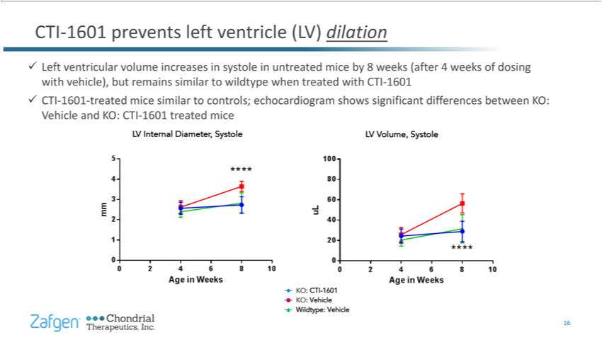

CTI-1601 prevents left ventricle (LV) dilation ü Left ventricular volume increases in systole in untreated mice by 8 weeks (after 4 weeks of dosing with vehicle), but remains similar to wildtype when treated with CTI-1601 ü CTI-1601-treated mice similar to controls; echocardiogram shows significant differences between KO: Vehicle and KO: CTI-1601 treated mice LV Internal Diameter, Systole LV Volume, Systole KO: CTI-1601 KO: Vehicle Wildtype: Vehicle 16

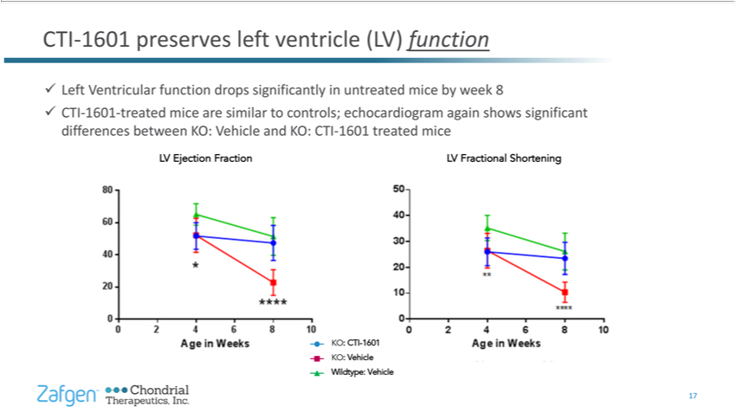

CTI-1601 preserves left ventricle (L^{V)} function ü Left Ventricular function drops significantly in untreated mice by week 8 ü CTI-1601-treated mice are similar to controls; echocardiogram again shows significant differences between KO: ehicle and KO: CTI-1601 treated mice LV Ejection Fraction LV Fractional Shortening KO: CTI-1601 KO: Vehicle Wildtype: Vehicle

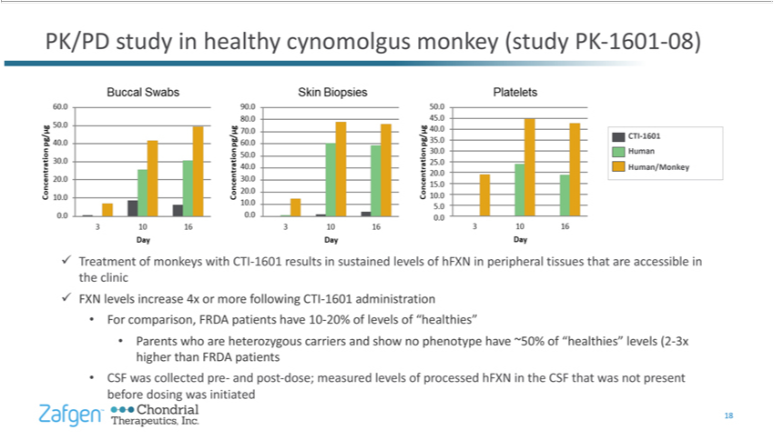

PK/PD study in healthy cynomolgus monkey (study PK-1601-08) ü Treatment of monkeys with CTI-1601 results in_{“healthies”}susained _{Parents}levlsof hFXN in peripheral tissues that are accessible in the clinic ü FXN levels

increase 4x or more following CTI-1601 administration For comparison, FRDA patients have 10-20% of levels of who are heterozygous carriers and show no phenotype have ~50% of “healthies” levels (2-3x higher than FRDA patients CSF was collected pre- and post-dose; measured levels of processed hFXN in the CSF that was not present before dosing was initiated 18

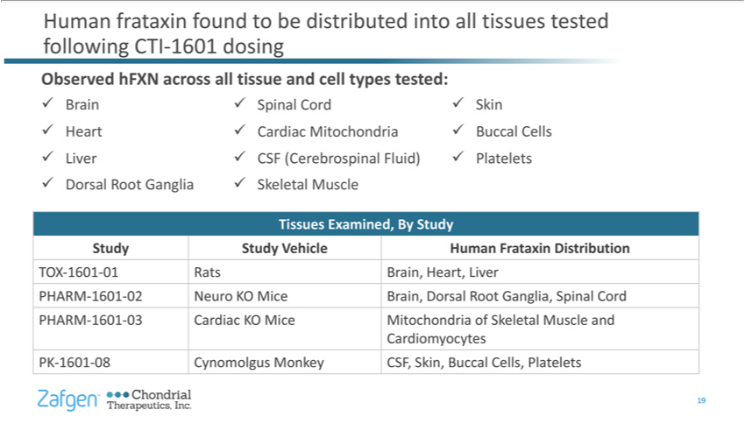

Human frataxin found to be distributed into all tissues_{Skeletal}testdfollowing CTI-1601 dosing Observed hFXN across all tissue and cell types tested: ü Brain ü Heart ü Liver ü Dorsal Root Ganglia ü Spinal Cord ü
Cardiac Mitochondria ü CSF (Cerebrospinal Fluid) ü Muscle ü Skin ü Buccal Cells ü Platelets Tissues Examined, By Study Study Study Vehicle Human Frataxin Distribution TOX-1601-01RatsBrain, Heart, Liver PHARM-1601-02Neuro KO MiceBrain, Dorsal Root Ganglia, Spinal Cord PHARM-1601-03Cardiac KO MiceMitochondria of Skeletal Muscle and Cardiomyocytes PK-1601-08Cynomolgus Monkey CSF, Skin, Buccal Cells, Platelets 19

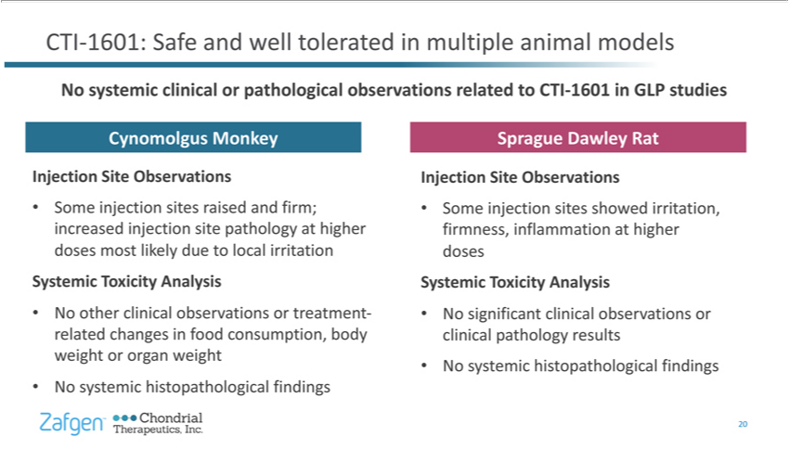

CTI-1601: Safe and well tolerated multiple animal models No systemic clinical r pathological observations related to -1601 in GLP studies Cynomolgus Monkey Injection Site Observations Some injection sites raised and firm; increased injection site pathology_{histopathological}higher doses most likely due to local irritation SystemicCTIoxicity Analysis No other clinical observations or treatment-related changes in food

consumption, body weight or organ weight No systemic findings Sprague Dawley Rat Injection Site Observations Some injection sites showed irritation, firmness, inflammation at higher doses Systemic Toxicity Analysis No significant clinical observations or clinical pathology results No systemic histopathological findings 20

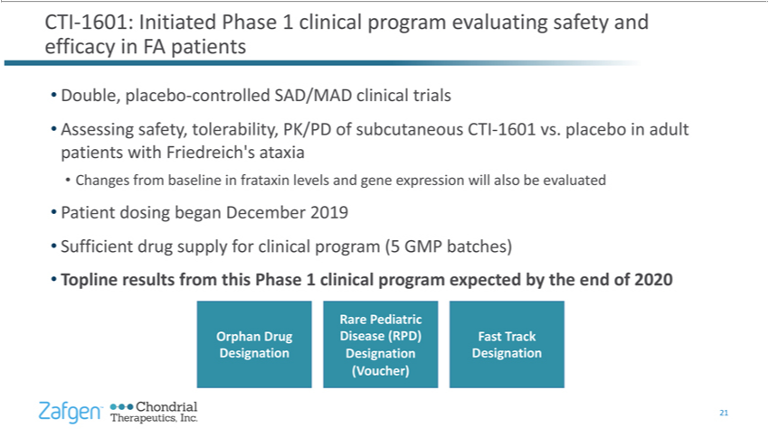

CTI-1601: Initiated Phase 1 clinical program ev^{ataxia}luting safety and efficacy in FA patients Double, placebo-controlled SAD/MAD clinical trials Assessing safety, tolerability, PK/PD of subcutaneous CTI-1601
_{program}vs.plcebo in adult patients with Friedreich’s Changes from baseline in frataxin levels and gene expression will also be evaluated Patient dosing began December 2019 Sufficient drug supply for clinical
₂₁ (5 GMP batches) Topline results from this Phase 1 clinical program expected by the end of 2020 Orphan Drug Designation Rare Pediatric Disease (RPD) Designation (Voucher) Fast Track Designation



