UNITED STATES

SECURITIES AND EXCHANGE COMMISSION
Washington, D.C. 20549

FORM 8-K

CURRENT REPORT

Pursuant to Section 13 or 15(d)

of The Securities Exchange Act of 1934

Date of Report (Date of earliest event reported): May 11, 2021

Larimar Therapeutics, Inc.

(Exact name of registrant as specified in its charter)

Delaware | 001-36510 | 20-3857670
(State or other jurisdiction | (Commission | (I.R.S. Employer
of incorporation) | File Number) | Identification No.)

Three Bala Plaza East, Suite 506

Bala Cynwyd, Pennsylvania

19004

(Address of principal executive offices)

(Zip Code)

Registrant’s telephone number, including area code: (844) 511-9056

(Former name or former address, if changed since last report.)

Check the appropriate box below if the Form 8-K filing is intended to simultaneously satisfy the filing obligation of the registrant under any of the following provisions (see General Instruction A.2. below):

- Written communications pursuant to Rule 425 under the Securities Act (17 CFR 230.425)

- Soliciting material pursuant to Rule 14a-12 under the Exchange Act (17 CFR 240.14a-12)

- Pre-commencement communications pursuant to Rule 14d-2(b) under the Exchange Act (17 CFR 240.14d-2(b))

- Pre-commencement communications pursuant to Rule 13e-4(c) under the Exchange Act (17 CFR 240.13e-4(c))

Securities registered pursuant to Section 12(b) of the Act:

 |  |  |  | Trading | Name of each exchange
 | Title of each class |  | Symbol(s) |  |  | on which registered
 |  | 0.001 per share
Common Stock, par value $ |  | 0.001 per share |  | LRMR | Nasdaq Global Market

Indicate by check mark whether the registrant is an emerging growth company as defined in Rule 405 of the Securities Act of 1933 (§230.405 of this chapter) or Rule 12b-2 of the Securities Exchange Act of 1934 (§240.12b-2 of this chapter).

Emerging growth company ☐

If an emerging growth company, indicate by check mark if the registrant has elected not to use the extended transition period for complying with any new or revised financial accounting standards provided pursuant to Section 13(a) of the Exchange Act. ☐

Item 8.01 Other Events.

Investor Presentation

On May 11, 2021, Larimar Therapeutics, Inc. (the “Company”) posted on its website an updated slide presentation, which is attached as Exhibit 99.1 to this Current Report on Form 8-K and is incorporated herein by reference. Representatives of the Company will use the presentation in various meetings with investors, analysts and other parties from time to time.

Press Release

On May 11, 2021, the Company issued a press release announcing topline data from the Company’s Phase 1 multiple ascending dose (MAD) clinical trial (n=27) evaluating CTI-1601 as a treatment for Friedreich’s ataxia (FA) and provided additional updates regarding future activities planned for 2021. A copy of this press release is filed as Exhibit 99.2 hereto and incorporated herein by reference.

Item 9.01 Financial Statements and Exhibits.

(d) Exhibits

Below is a list of exhibits included with this Current Report on Form 8-K.

Exhibit

No.

Document

99.1 Larimar Therapeutics, Inc. Corporate Presentation, dated May 11, 2021*

99.2 Press Release of Larimar Therapeutics, Inc., dated May 11, 2021*

- Filed herewith.

SIGNATURES

Pursuant to the requirements of the Securities Exchange Act of 1934, the registrant has duly caused this report to be signed on its behalf by the undersigned hereunto duly authorized.

Larimar Therapeutics, Inc.

By: /s/ Carole S. Ben-Maimon, M.D.

Name: Carole S. Ben-Maimon, M.D.

Title: President and Chief Executive Officer

Date: May 11, 2021



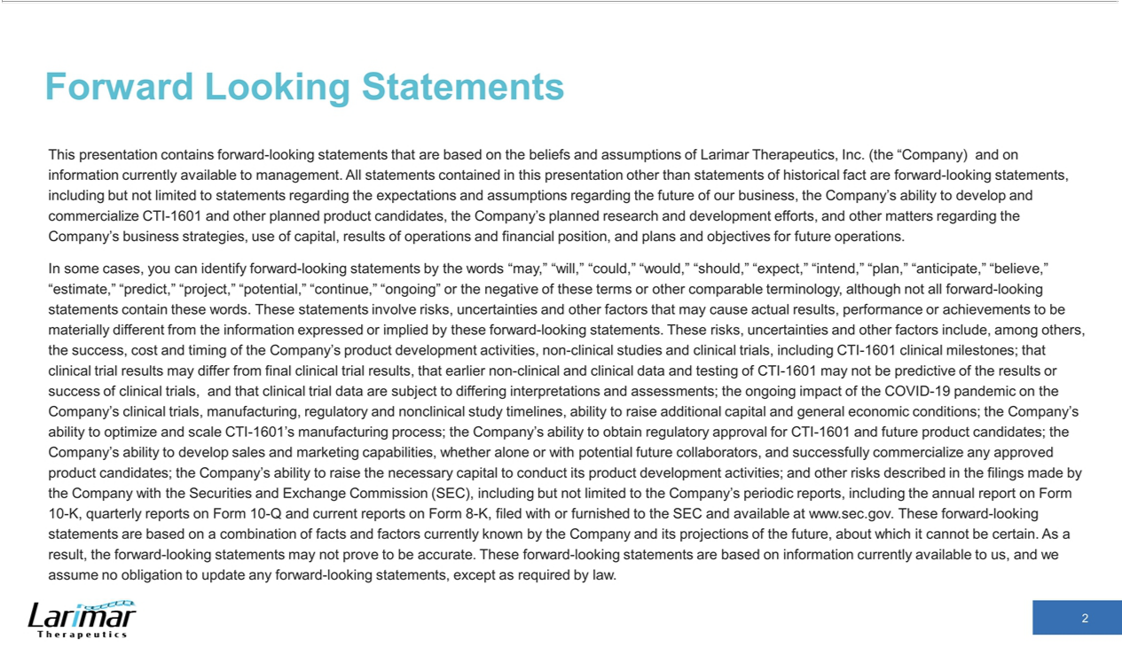

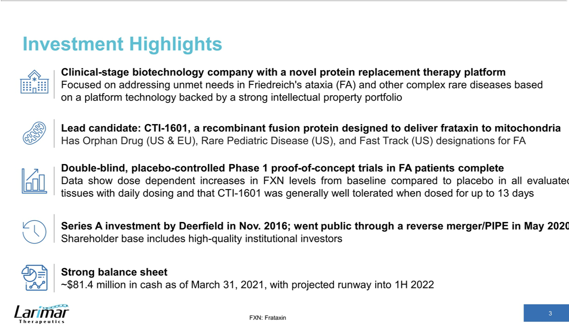

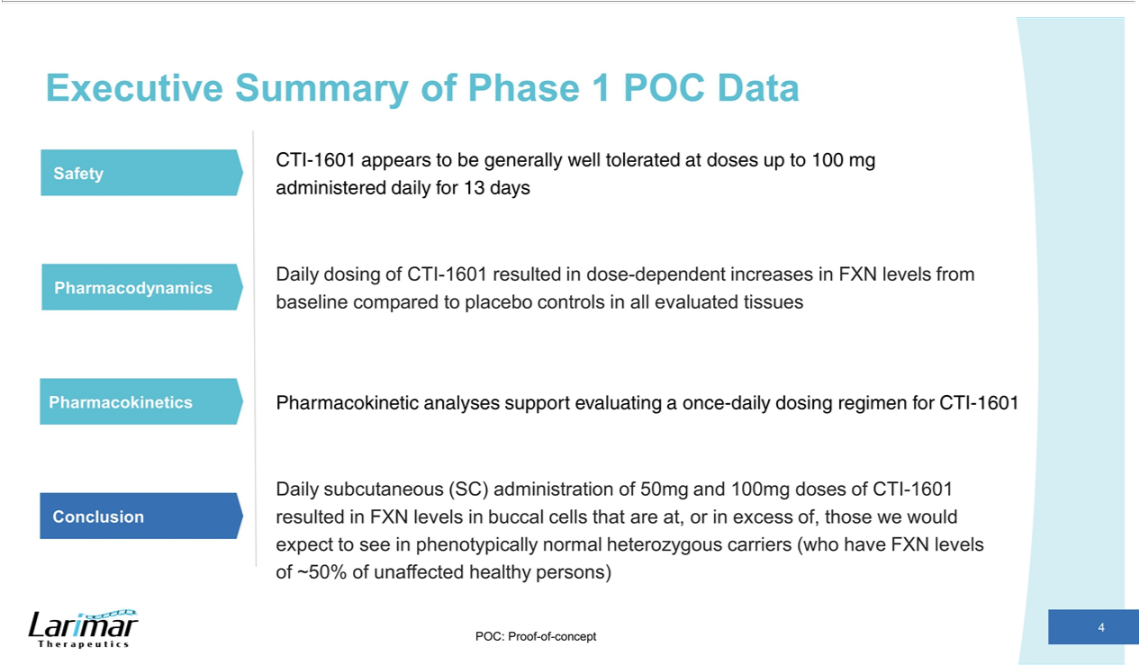

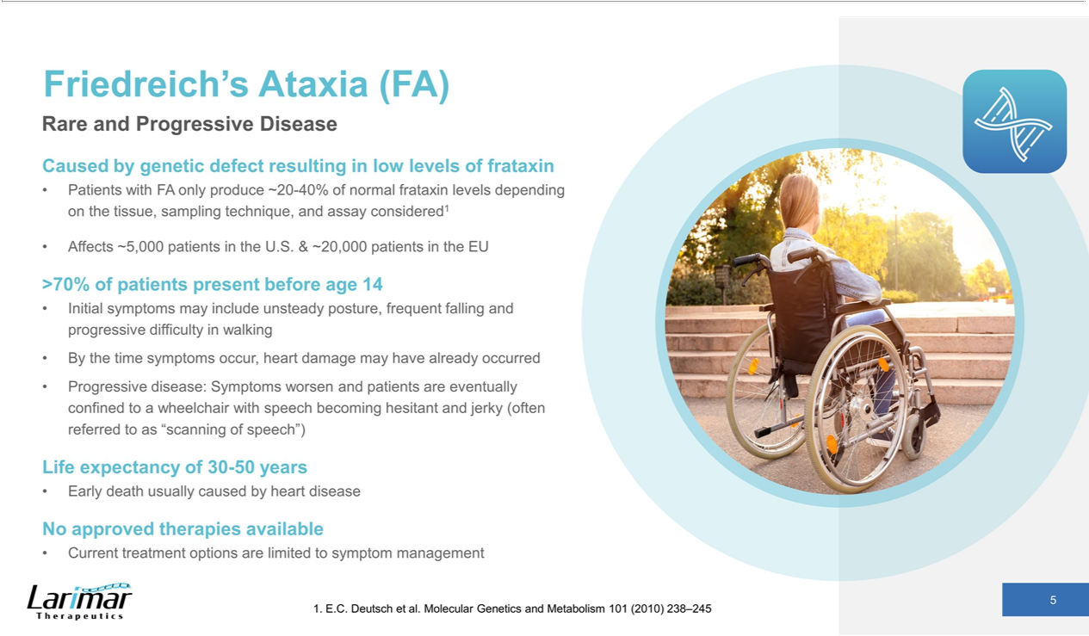

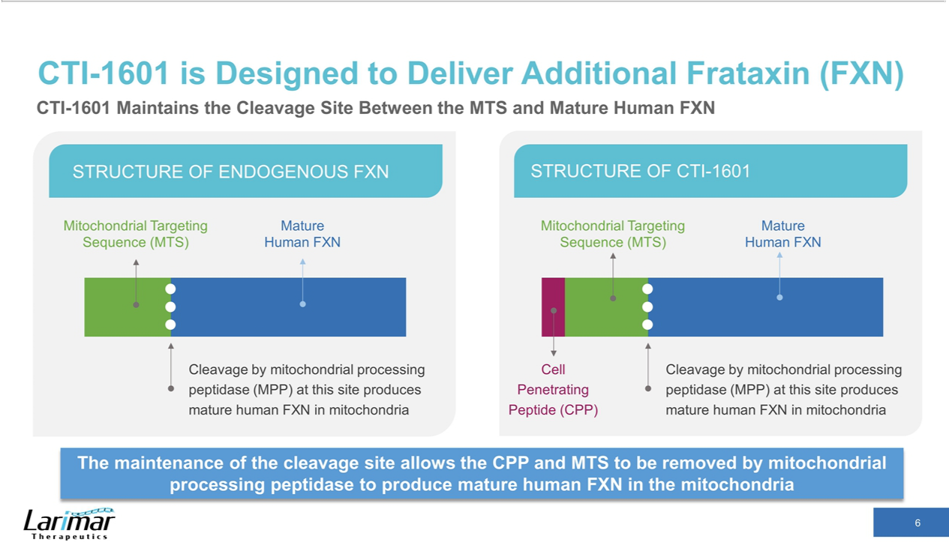

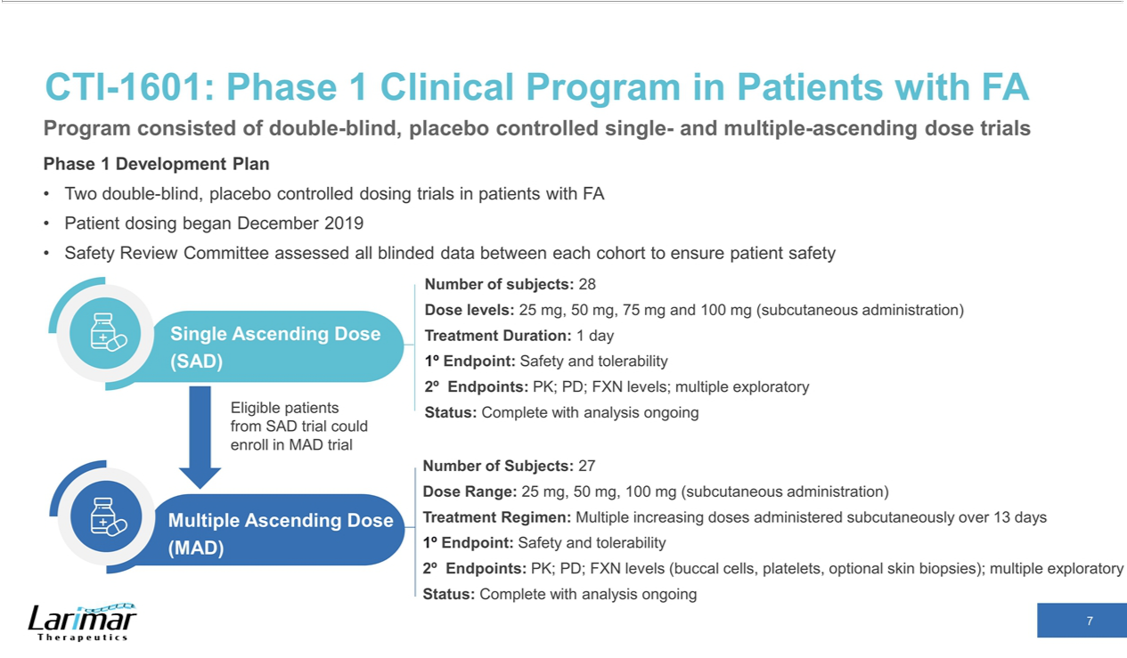

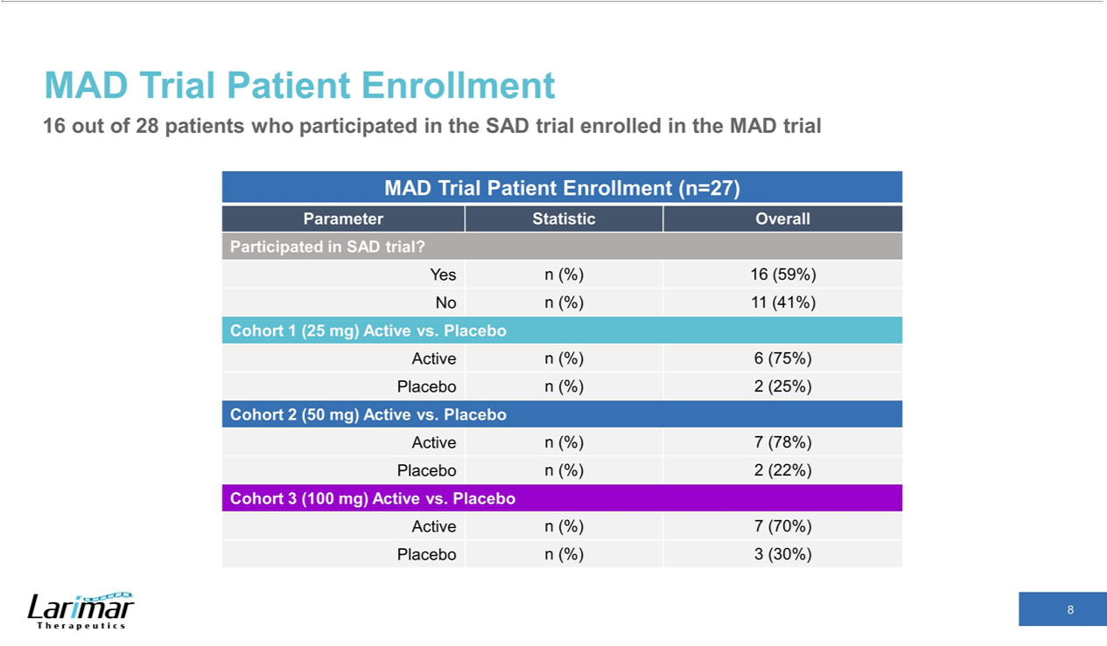

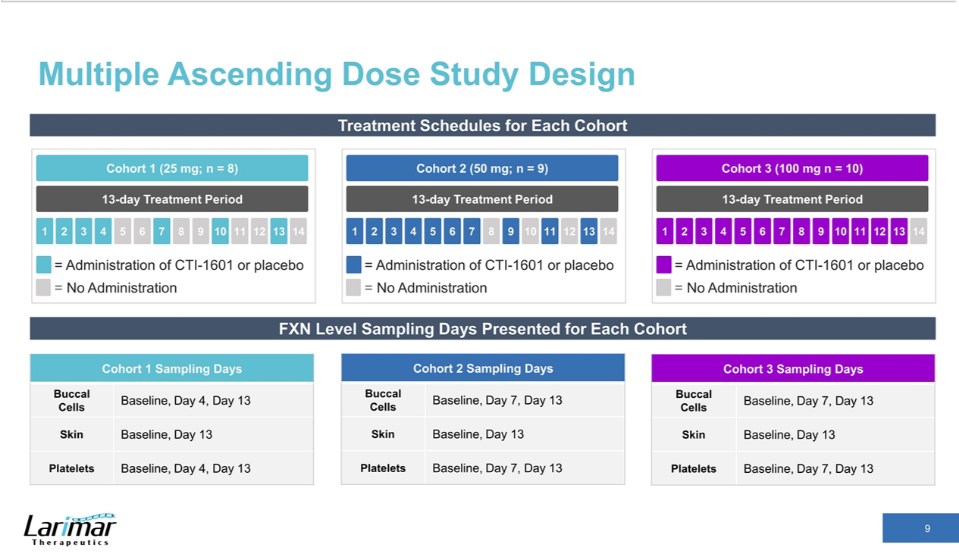

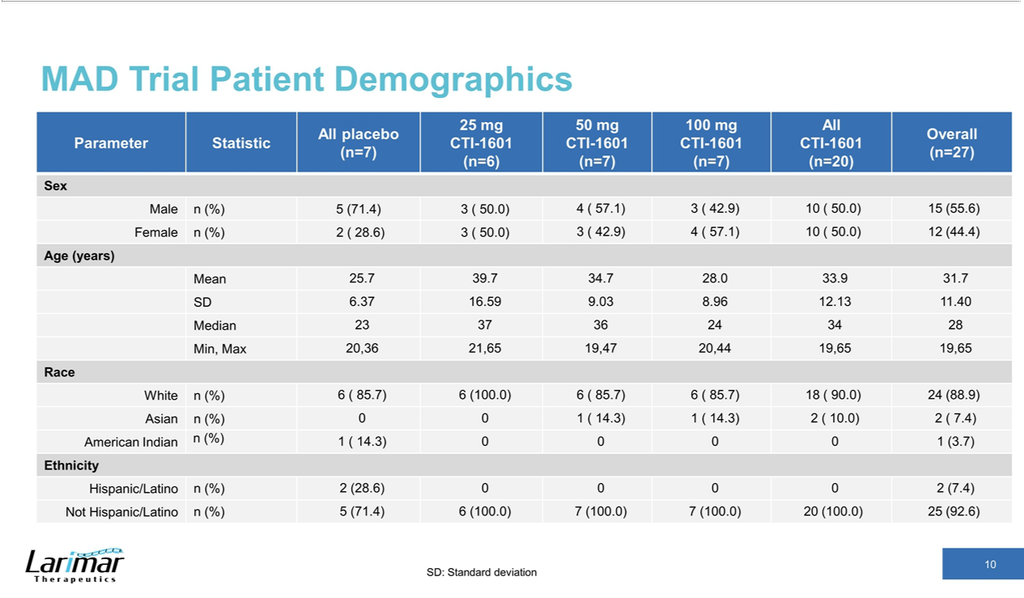

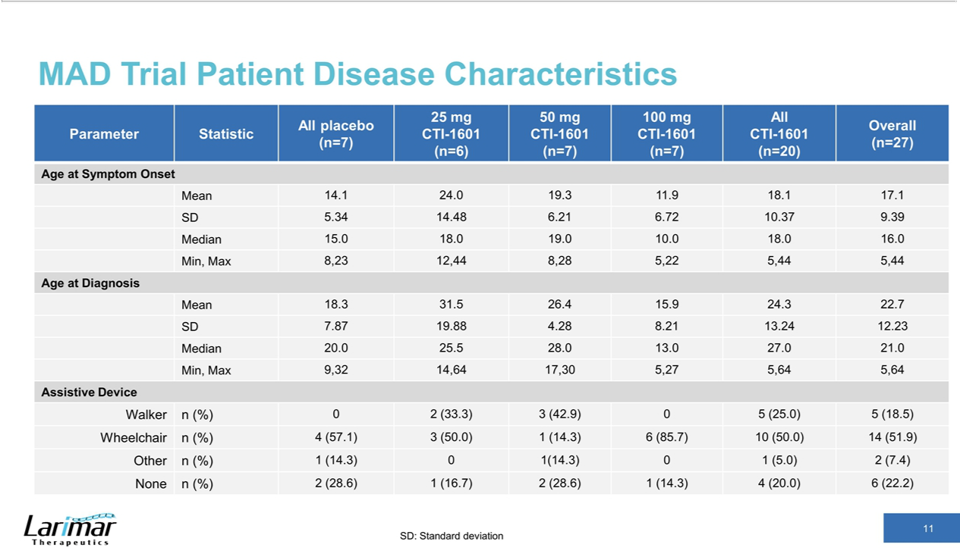

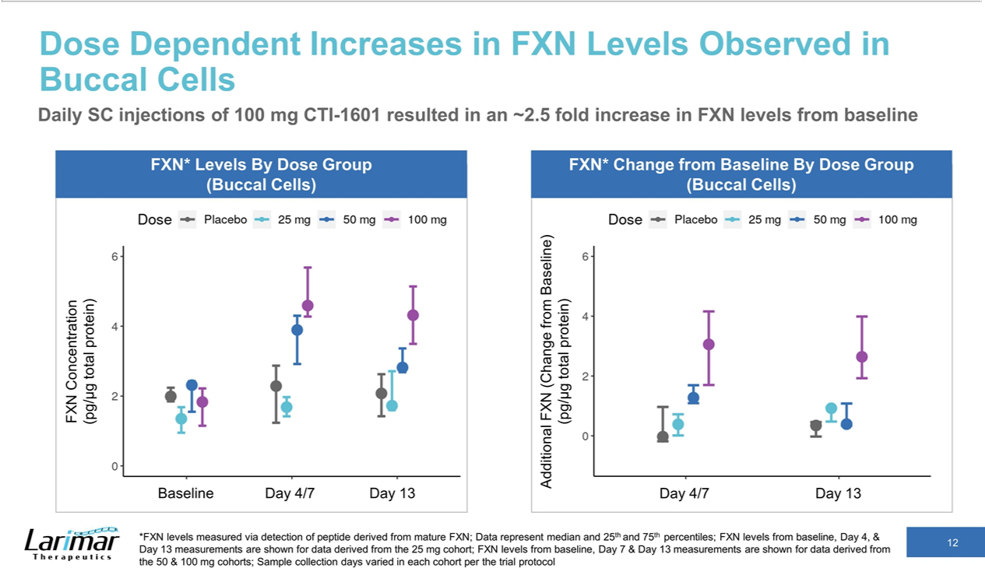

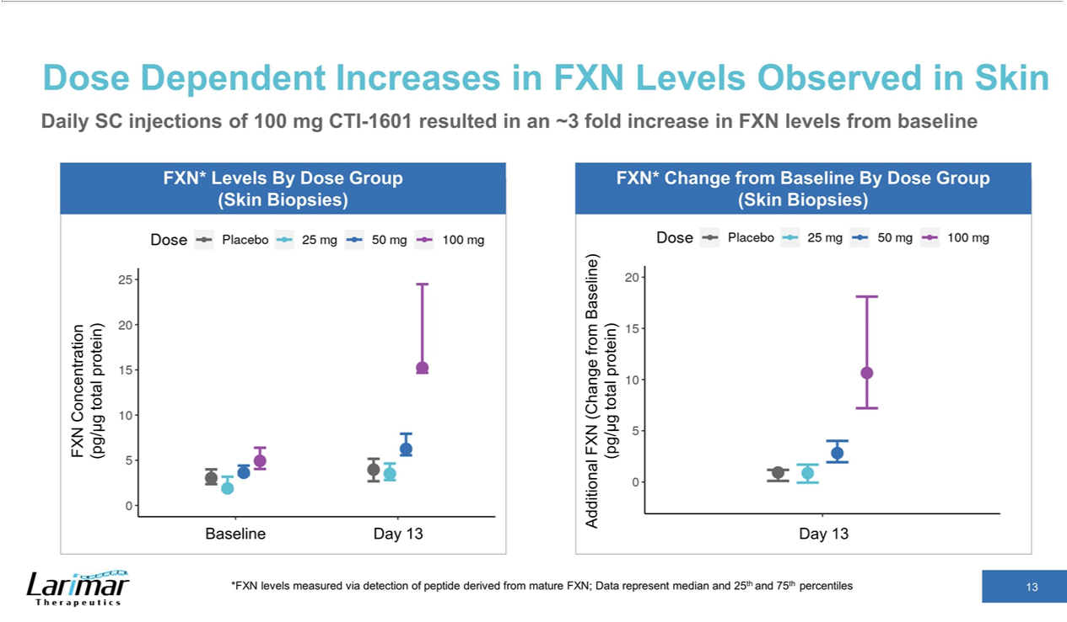

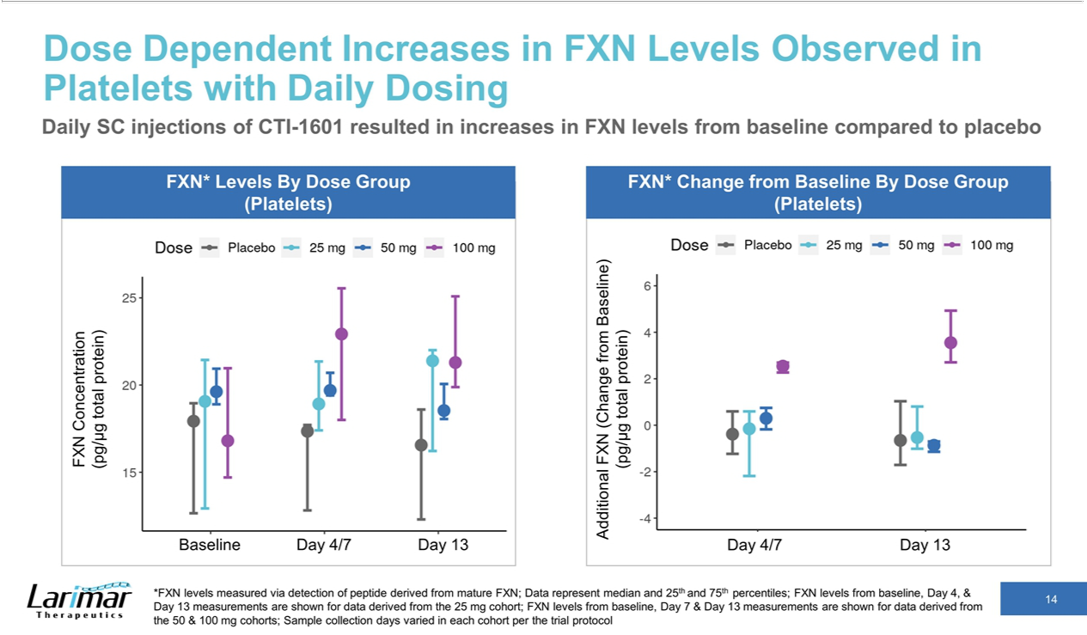

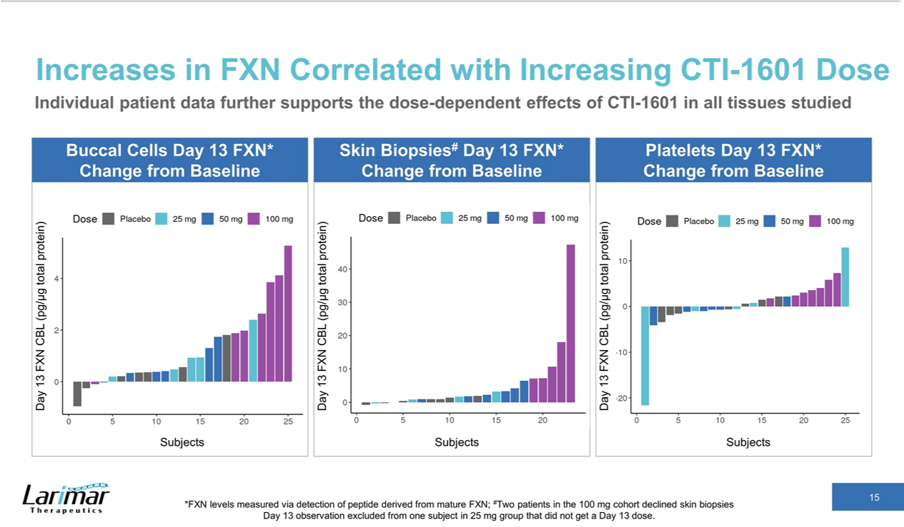

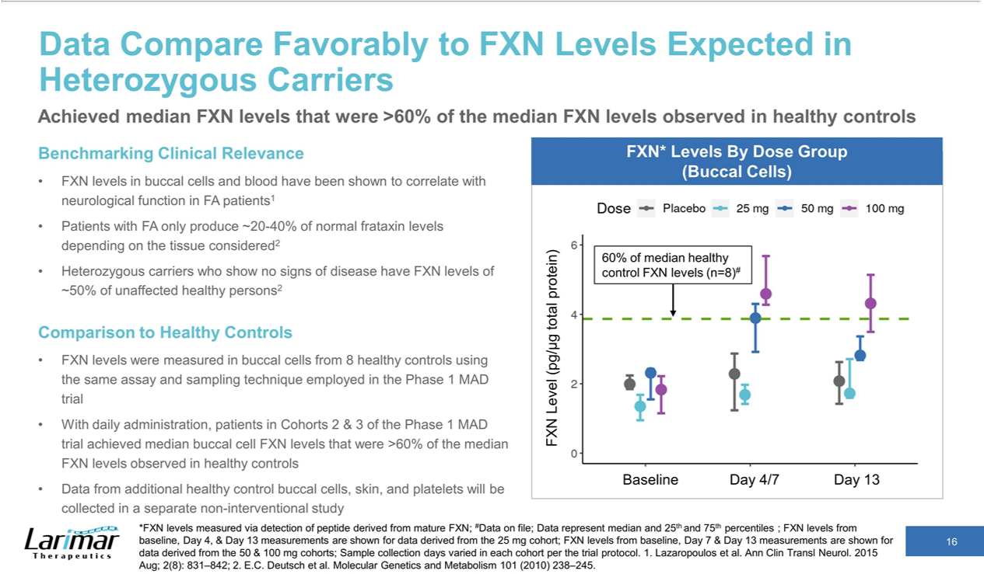

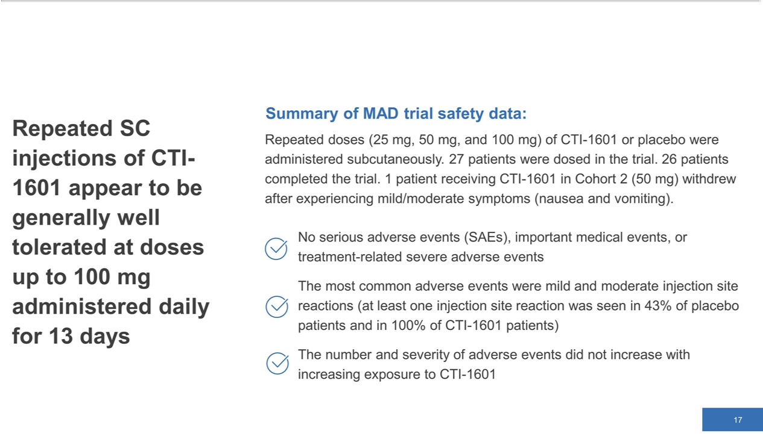

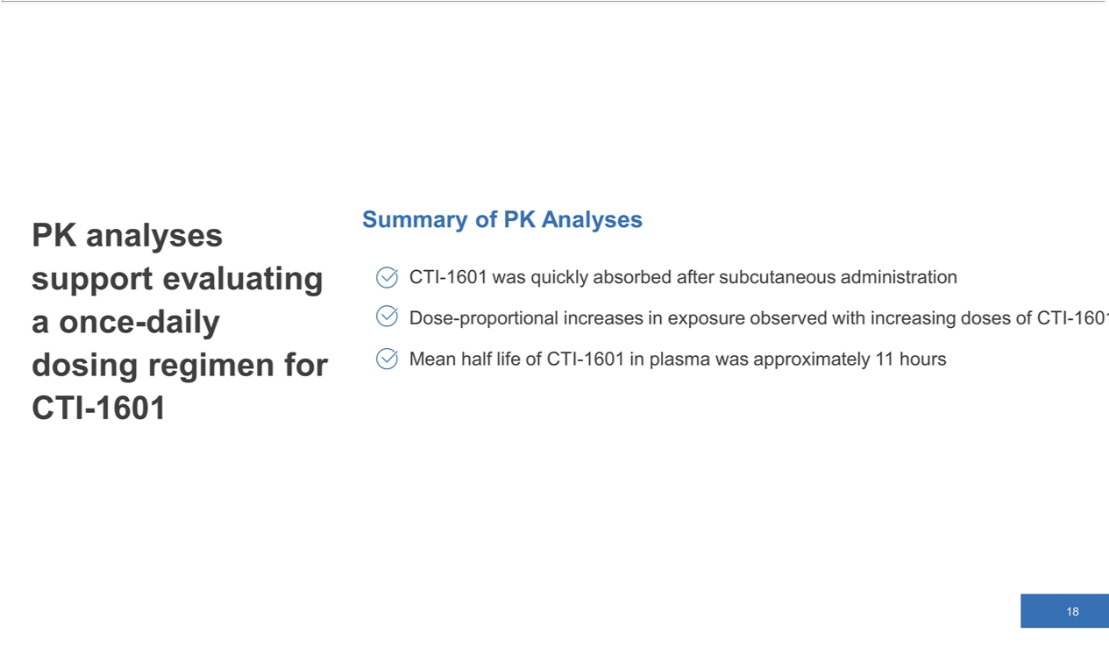

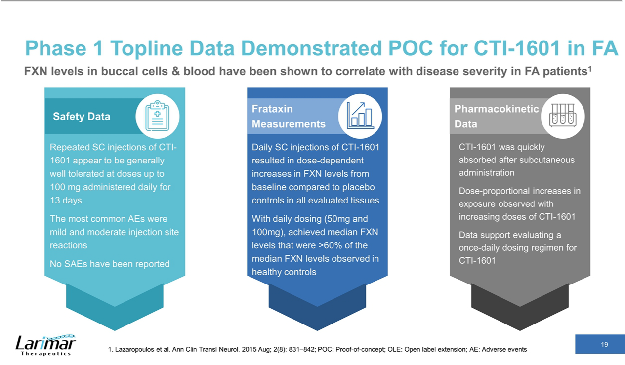

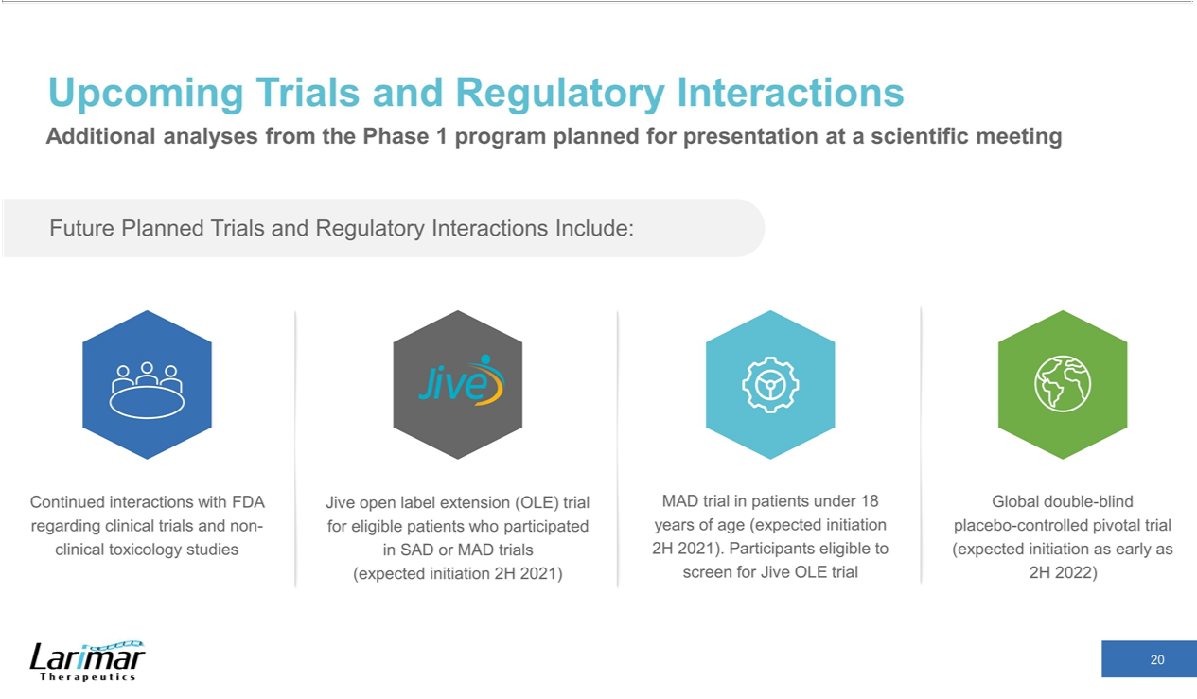

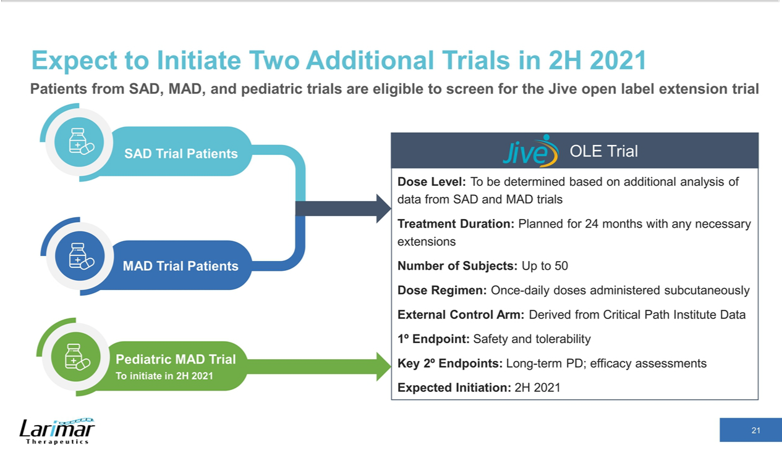

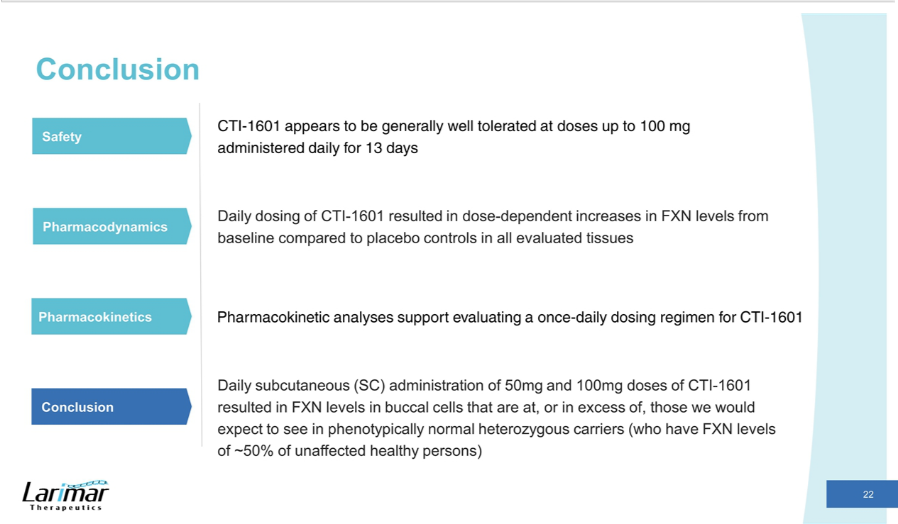

Exhibit 99.2


Larimar Therapeutics Reports Positive Topline Phase 1 Clinical Trial Data Showing Dose-Dependent Increases in Frataxin Levels in Patients

with Friedreich’s Ataxia

- Data demonstrate proof-of-concept by showing that daily subcutaneous injections of CTI-1601 for up to 13 days resulted in dose-dependent increases

in frataxin levels from baseline compared to placebo in all evaluated tissues

    - Data show that frataxin levels achieved in peripheral tissues (buccal cells) following daily 50 mg and 100 mg subcutaneous injections of CTI-1601 were at or in excess of those that would be expected in phenotypically normal heterozygous carriers

  - Safety data indicate that repeated subcutaneous injections of CTI-1601 were generally well tolerated at doses up to 100 mg administered daily for 13

days

      - Company management to host webcast and conference call today at 8:00 a.m. ET

Bala Cynwyd, PA, May 11, 2021 – Larimar Therapeutics, Inc. (“Larimar”) (Nasdaq: LRMR), a clinical-stage biotechnology company focused on developing treatments for Friedreich’s ataxia (FA) and other complex rare diseases, today announced topline data from its Phase 1 multiple ascending dose (MAD) clinical trial (n=27) evaluating CTI-1601 as a treatment for FA.

FA patients participating in the trial received subcutaneous injections of CTI-1601 or placebo at increasing dose levels and frequencies over a 13-day period. Patients in Cohort 1 were dosed with 25 mg of CTI-1601 or placebo daily for four days, and then every third day until Day 13. Cohort 2 patients were dosed with 50 mg of CTI-1601 or placebo daily for seven days, and then once every other day until Day 13. Patients in Cohort 3 received daily injections of 100 mg CTI-1601 or placebo for thirteen days.

Data show that repeated subcutaneous administration of CTI-1601 resulted in dose-dependent increases in frataxin (FXN) levels from baseline compared to placebo controls. These dose-dependent increases in frataxin levels were seen in all evaluated tissues (buccal cells, skin biopsies, and platelets) with daily dosing. The median change from baseline in frataxin levels observed for each dosing group and tissue are shown in the table below.

FXN Change from Baseline in Buccal Cells

Units: pg FXN / µg total protein

Data presented as: n median (25th percentile, 75th percentile)

Dose Group |  |  | Day 4/7* |  |  | Day 13
Placebo (n=7) |  | -0.03 | (-0.18, 0.97) |  | 0.35 | (-0.02, 0.46)
Cohort 1 | Active (25 mg, n=6) | 0.39 | (0.01, 0.72) |  | 0.92 | (0.48, 0.94)
Cohort 2 | Active (50 mg, n=6) | 1.28 | (1.09, 1.69) |  | 0.39 | (0.35, 1.08)
Cohort 3 | Active (100 mg, n=7) | 3.06 | (1.70, 4.16) |  | 2.64 | (1.93, 3.99)

FXN Change from Baseline in Skin Biopsies#

Units: pg FXN / µg total protein

Data presented as: median (25th percentile, 75th percentile)

 | Dose Group |  |  |  |  | Day 4/7* |  |  |  |  | Day 13
 | Placebo (n=7) |  |  |  |  |  | N/A |  | 0.92 |  | (0.10, 1.17)
 | Cohort 1 Active (25 mg, n=6) |  |  |  |  |  | N/A |  | 0.87 |  | (-0.07, 1.69)
 | Cohort 2 Active (50 mg, n=6) |  |  |  |  |  | N/A |  | 2.82 |  | (1.93, 4.01)
 | Cohort 3 Active (100 mg, n=7) |  |  |  |  |  | N/A |  | 10.6 |  | (7.20, 18.1)
 |  |  |  | FXN Change from Baseline in Platelets
 |  |  |  | Units: pg FXN / µg total protein
 |  |  |  | Data presented as: median (25th percentile, 75th percentile)
Dose Group |  |  |  |  |  | Day 4/7* |  |  |  |  |  | Day 13
Placebo (n=7) |  |  |  |  | -0.38 | (-1.23, 0.60) |  |  |  |  | -0.65 | (-1.71, 1.03)
Cohort 1 |  | Active (25 mg, n=6) |  | -0.15 |  | (-2.18, 0.60) |  |  |  |  | -0.53 | (-1.01, 0.80)
Cohort 2 |  | Active (50 mg, n=6) |  | 0.30 |  | (-0.18, 0.75) |  |  |  |  | -0.87 | (-1.14, -0.70)
Cohort 3 |  | Active (100 mg, n=7) |  | 2.54 |  | (2.27, 2.70) |  |  |  |  | 3.55 | (2.71, 4.93)
- FXN levels from Day 4 and 13 measurements are shown for data derived from Cohort 1. FXN levels from Day 7 and 13 measurements are shown for data derived from Cohorts 2 and 3. Sample collection days varied in each cohort per the clinical trial protocol.
- Skin biopsies were not collected on Day 4 or Day 7 per the clinical trial protocol. Skin biopsies were optional per the protocol and were collected in 5 of the 7 patients in Cohort 3.

“The ability of CTI-1601 to elevate frataxin in the evaluated tissues strongly supports its continued clinical evaluation, as frataxin levels in buccal cells and blood have been shown to be associated with disease severity in FA patients,” said Nancy M. Ruiz, MD, Chief Medical Officer of Larimar. “Notably, daily subcutaneous CTI-1601 administration resulted in median frataxin levels in buccal cells that are similar to, and even exceed, the levels we would expect to see in phenotypically normal heterozygous carriers (who have frataxin levels that are approximately 50% of unaffected healthy persons). These findings are exciting and represent a critical step forward in CTI-1601’s development as a frataxin replacement therapy for patients with FA. We believe CTI-1601 has the potential to address a critical unmet need, as FA is caused by patients’ inability to produce sufficient amounts of frataxin and current treatment options for this progressive and devastating disease are limited to symptom management. It is also important to note that CTI-1601 is the only drug candidate that we are aware of in clinical development that is designed to supplement frataxin levels in patients with FA, thus addressing the root cause of the disease.”

Safety data from the trial indicate that repeated subcutaneous injections of CTI-1601 were generally well tolerated at doses up to 100 mg administered daily for 13 days. A summary of the safety data, as well as pharmacokinetic data are shown below.

Safety:

- No serious adverse events (SAEs), important medical events, or treatment-related severe adverse events were reported in the trial

- The most common adverse events were mild and moderate injection site reactions (at least one injection site reaction was seen in 43% of placebo patients and in 100% of CTI-1601 patients)

- The number and severity of adverse events did not increase with increasing exposure to CTI-1601

- Of the 27 patients dosed, 26 completed the trial with one Cohort 2 patient receiving CTI-1601 withdrawing after experiencing mild to moderate nausea and vomiting

Pharmacokinetics:

- CTI-1601 was quickly absorbed after subcutaneous administration

- Dose-proportional increases in exposure were observed with increasing doses of CTI-1601

- The mean half-life of CTI-1601 in plasma was approximately 11 hours

Patients who completed the single ascending dose (SAD) and/or MAD clinical trials are eligible to screen for an open-label extension clinical trial, the Jive study, which Larimar expects to initiate in the second half of 2021. Larimar also expects to initiate a MAD clinical trial in patients under 18 years of age in the second half of 2021. Patients completing this pediatric trial will also be eligible to screen for the Jive study.

Carole Ben-Maimon, MD, President and Chief Executive Officer of Larimar, commented, “We are thrilled with these data, which demonstrate proof-of-concept for CTI-1601 and highlight its safety and tolerability profile. Our ability to generate these results amid the pandemic speaks to the commitment of the patients who participated in the trials and the broader FA community. It is also a testament to the great work being done by the Friedreich’s Ataxia Research Alliance and the talent of our employees, partners, and investigators. We extend our sincerest thanks to all of these individuals for the important roles they have played in CTI-1601’s clinical development to date. We look forward to sharing additional quantitative analyses from our Phase 1 clinical trials at a future scientific meeting. We anticipate this data will inform the design of our planned future clinical trials for CTI-1601.”

Conference Call and Webcast

Larimar will host a conference call and webcast today, May 11, 2021 at 8:00 a.m. ET. To access the webcast, please visit this link to the event. To participate by phone please dial 855-327-6837 (domestic) or 631-891-4304 (international) and refer to conference ID 10014696. Following the live event, the archived webcast will be available for 90 days.

About the Phase 1 MAD Clinical Trial

The Phase 1 MAD clinical trial was a double-blind, placebo-controlled, randomized clinical trial designed to assess the safety of subcutaneously administered CTI-1601 versus placebo in adult subjects with FA. The primary objective was to assess the safety and tolerability of multiple ascending doses of CTI-1601 in subjects with FA. Key secondary endpoints included pharmacokinetic and pharmacodynamic analyses following increasing multiple doses of subcutaneously administered CTI-1601. Patients from the MAD clinical trial are eligible to screen for an open-label extension trial that Larimar expects to initiate in the second half of 2021.

About CTI-1601

CTI-1601 is a recombinant fusion protein intended to deliver human frataxin into the mitochondria of patients with Friedreich’s ataxia who are unable to produce enough of this essential protein. Currently in Phase 1 clinical trials in the U.S., CTI-1601 has been granted Rare Pediatric Disease designation, Fast Track designation and Orphan Drug designation by the U.S. Food and Drug Administration (FDA) and orphan drug designation by the European Commission.

About Larimar Therapeutics

Larimar Therapeutics, Inc. (Nasdaq: LRMR), is a clinical-stage biotechnology company focused on developing treatments for complex rare diseases. Larimar’s lead compound, CTI-1601, is currently being evaluated in a Phase 1 clinical program in the U.S. as a potential treatment for FA. Larimar also plans to use its intracellular delivery platform to design other fusion proteins to target additional rare diseases characterized by deficiencies in intracellular bioactive compounds. For more information, please visit: https://larimartx.com.

Forward-Looking Statements

This press release contains forward-looking statements that are based on Larimar’s management’s beliefs and assumptions and on information currently available to management. All statements contained in this release other than statements of historical fact are forward-looking statements, including but not limited to statements regarding Larimar’s ability to develop and commercialize CTI-1601 and other planned product candidates, Larimar’s planned research and development efforts, and other matters regarding Larimar’s business strategies, use of capital, results of operations and financial position, and plans and objectives for future operations.

In some cases, you can identify forward-looking statements by the words “may,” “will,” “could,” “would,” “should,” “expect,” “intend,” “plan,” “anticipate,” “believe,” “estimate,” “predict,” “project,” “potential,” “continue,” “ongoing” or the negative of these terms or other comparable terminology, although not all forward-looking statements contain these words. These statements involve risks, uncertainties and other factors that may cause actual results, performance or achievements to be materially different from the information expressed or implied by these forward-looking statements. These risks, uncertainties and other factors include, among others, the success, cost and timing of Larimar’s product development activities, non-clinical studies and clinical trials, including CTI-1601 clinical milestones; that clinical trial results may differ from final clinical trial results, that earlier non-clinical and clinical data and testing of CTI-1601 may not be predictive of the results or success of clinical trials, and assessments; the ongoing impact of the COVID-19 pandemic on Larimar’s future clinical trials, manufacturing, regulatory and nonclinical study timelines, ability to raise additional capital and general economic conditions; Larimar’s ability to optimize and scale CTI-1601’s manufacturing process; Larimar’s ability to obtain regulatory approval for CTI-1601 and future product candidates; Larimar’s ability to develop sales and marketing capabilities, whether alone or with potential future collaborators, and to successfully commercialize any approved product candidates; Larimar’s ability to raise the necessary capital to conduct its product development activities; and other risks described in the filings made by the Larimar with the Securities and Exchange Commission (SEC), including but not limited to Larimar’s periodic reports, including the annual report on Form 10-K, quarterly reports on Form 10-Q and current reports on Form 8-K, filed with or furnished to the SEC and available at www.sec.gov. These forward-looking statements are based on a combination of facts and factors currently known by Larimar and its projections of the future, about which it cannot be certain. As a result, the forward-looking statements may not prove to be accurate. The forward-looking statements in this press release represent views as of the date hereof. Larimar undertakes no obligation to update any forward-looking statements for any reason, except as required by law.

Investor Contact: |  | Company Contact:
Joyce Allaire |  | Michael Celano
LifeSci Advisors |  | Chief Financial Officer
jallaire@lifesciadvisors.com |  | mcelano@larimartx.com
(212) 915-2569 |  | (484) 414-2715

