UNITED STATES

SECURITIES AND EXCHANGE COMMISSION
Washington, DC 20549

FORM 8-K

CURRENT REPORT

Pursuant to Section 13 or 15(d)

of the Securities Exchange Act of 1934

Date of Report (Date of earliest event reported): December 8, 2020

Larimar Therapeutics, Inc.

(Exact name of registrant as specified in its charter)

Delaware | 001-36510 | 20-3857670
(State or other jurisdiction of | (Commission | (I.R.S. Employer
incorporation or organization) | File Number) | Identification No.)

Three Bala Plaza East. Suite 506

Bala Cynwyd, Pennsylvania

19004

(Address of principal executive offices)

(Zip Code)

Registrant’s telephone number, including area code: (844) 511-9056

(Former name or former address, if changed since last report)

Check the appropriate box below if the Form 8-K filing is intended to simultaneously satisfy the filing obligation of the registrant under any of the following provisions (see General Instruction A.2. below):

- Written communications pursuant to Rule 425 under the Securities Act (17 CFR 230.425)

- Soliciting material pursuant to Rule 14a-12 under the Exchange Act (17 CFR 240.14a-12)

- Pre-commencement communications pursuant to Rule 14d-2(b) under the Exchange Act (17 CFR 240.14d-2(b))

- Pre-commencement communications pursuant to Rule 13e-4(c) under the Exchange Act (17 CFR 240.13e-4(c))

Securities registered pursuant to Section 12(b) of the Act:

Title of each class |  | Trading |  | Name of each exchange
 |  | Symbol(s) |  | on which registered
Common Stock, par value $0.001 per share |  | LRMR |  | Nasdaq Global Market

Indicate by check mark whether the registrant is an emerging growth company as defined in Rule 405 of the Securities Act of 1933 (§230.405 of this chapter) or Rule 12b-2 of the Securities Exchange Act of 1934 (§240.12b-2 of this chapter).

Emerging growth company ☐

If an emerging growth company, indicate by check mark if the registrant has elected not to use the extended transition period for complying with any new or revised financial accounting standards provided pursuant to Section 13(a) of the Exchange Act. ☐

Item 7.01 Regulation FD Disclosure.

Attached as Exhibit 99.1, and furnished for the purposes of Regulation FD, is a presentation that Larimar Therapeutics, Inc. (the “Company”) will post on its website on December 8, 2020. Representatives of the Company will use the presentation in various meetings with investors, analysts and other parties from time to time.

The information in this Item 7.01 (including Exhibit 99.1) is being furnished solely to satisfy the requirements of Regulation FD and shall not be deemed to be “filed” for purposes of Section 18 of the Securities Exchange Act of 1934, as amended (the “Exchange Act”), or otherwise subject to the liabilities of that Section, nor shall it be deemed to be incorporated by reference in any filing under the Securities Act of 1933, as amended, or the Exchange Act.

Item 8.01 Other Events.

On December 8, 2020, the Company issued a press release announcing the completion of dosing of the Company’s Phase 1 single ascending dose (SAD) study evaluating CTI-1601 as a treatment for Friedreich’s Ataxia (FA) and provided additional updates regarding the status of a multiple ascending dose (MAD) FA study, the timing of Phase 1 topline results, and future activities planned for 2021. A copy of this press release is filed as Exhibit 99.2 hereto and incorporated herein by reference.

Item 9.01 Financial Statements and Exhibits.

(d) Exhibits

Below is a list of exhibits included with this Current Report on Form 8-K.

Exhibit
No. Document

99.1 Larimar Therapeutics, Inc. Corporate Presentation, dated December 8, 2020**

99.2 Press Release of Larimar Therapeutics, Inc., dated December 8, 2020*

* Filed herewith.

** Furnished herewith.

SIGNATURES

Pursuant to the requirements of the Securities Exchange Act of 1934, the registrant has duly caused this report to be signed on its behalf by the undersigned hereunto duly authorized.

Larimar Therapeutics, Inc.

By: | /s/ Carole S. Ben-Maimon, M.D.
Name: | Carole S. Ben-Maimon, M.D.
Title: | President and Chief Executive Officer

Date: December 8, 2020



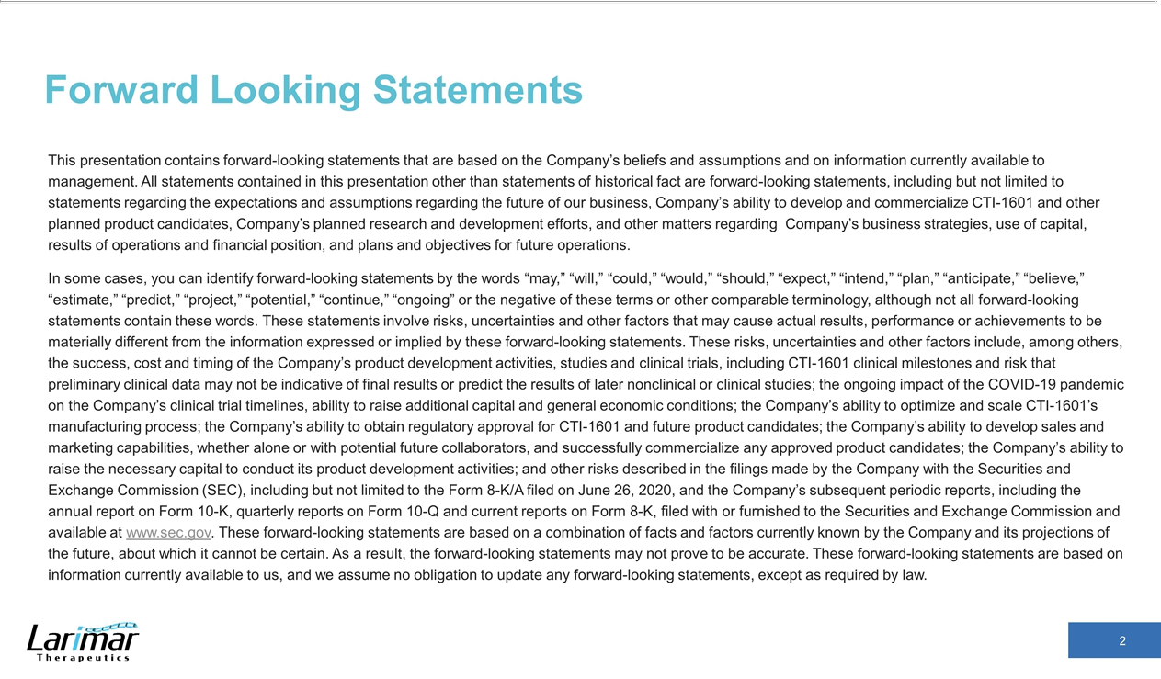

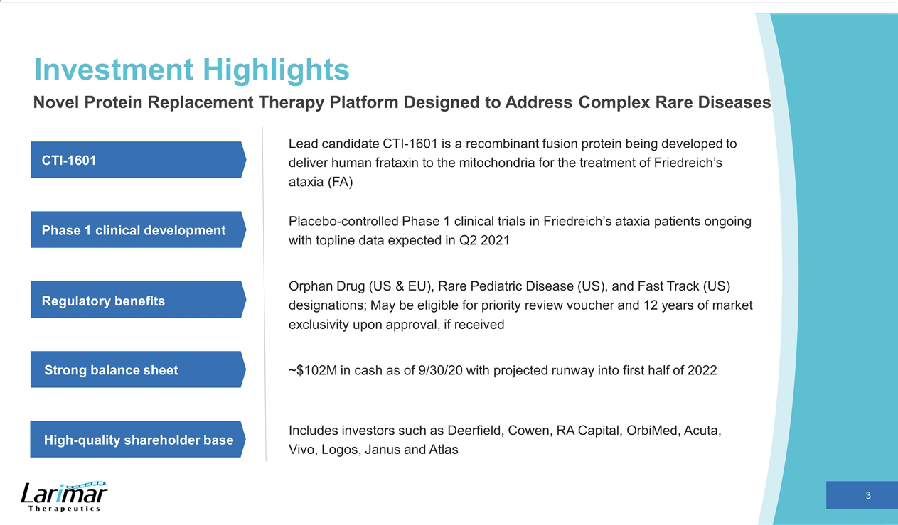



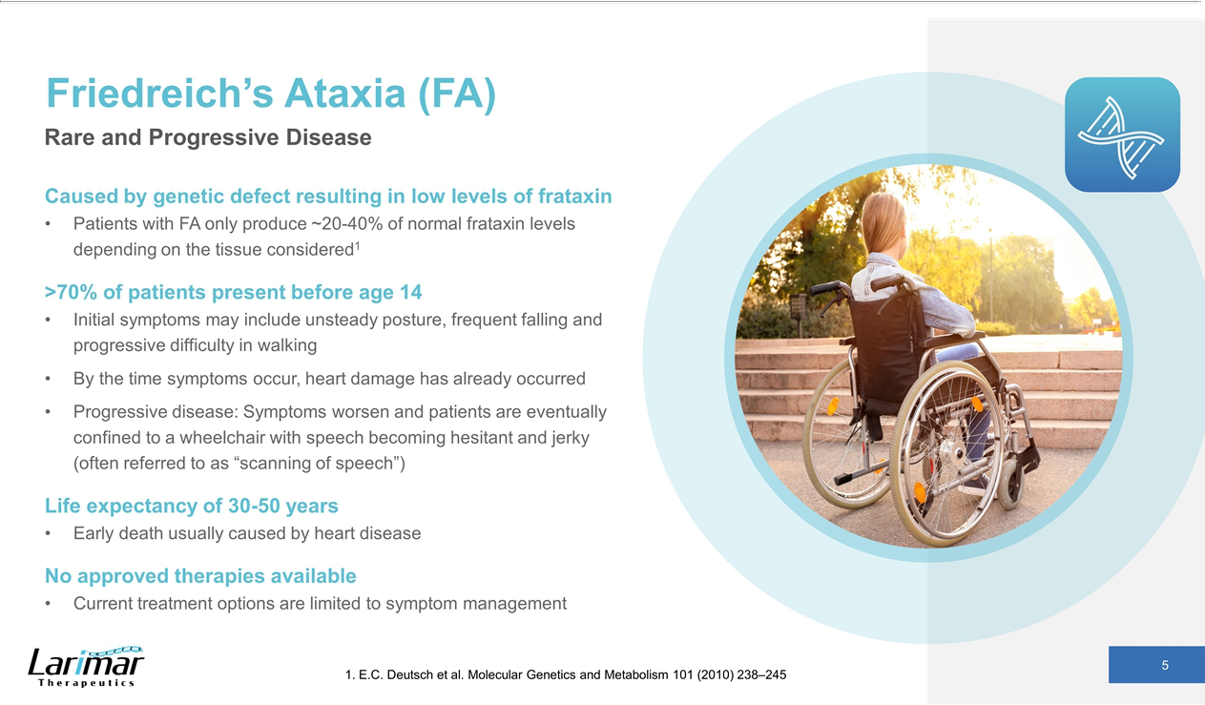

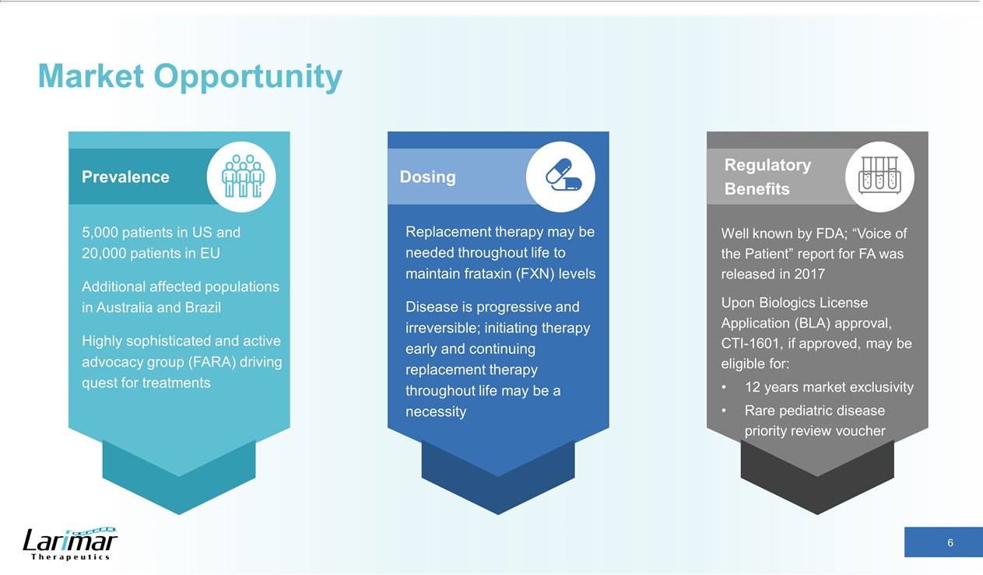

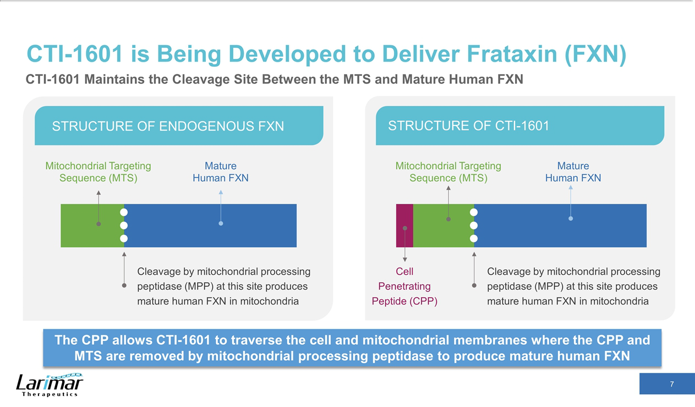

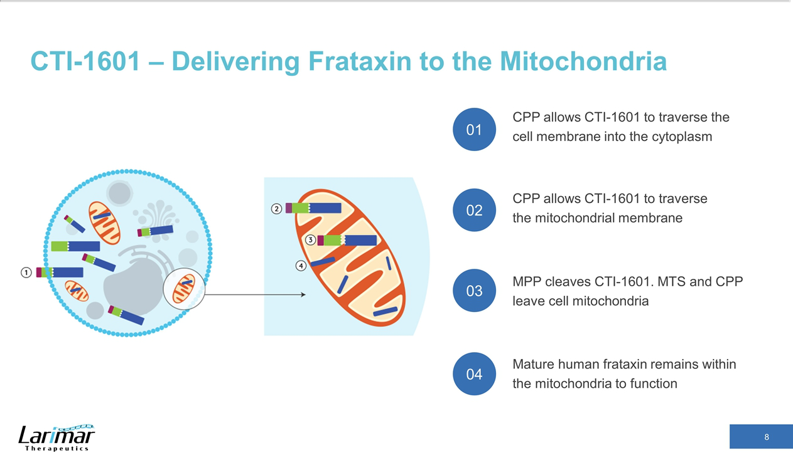

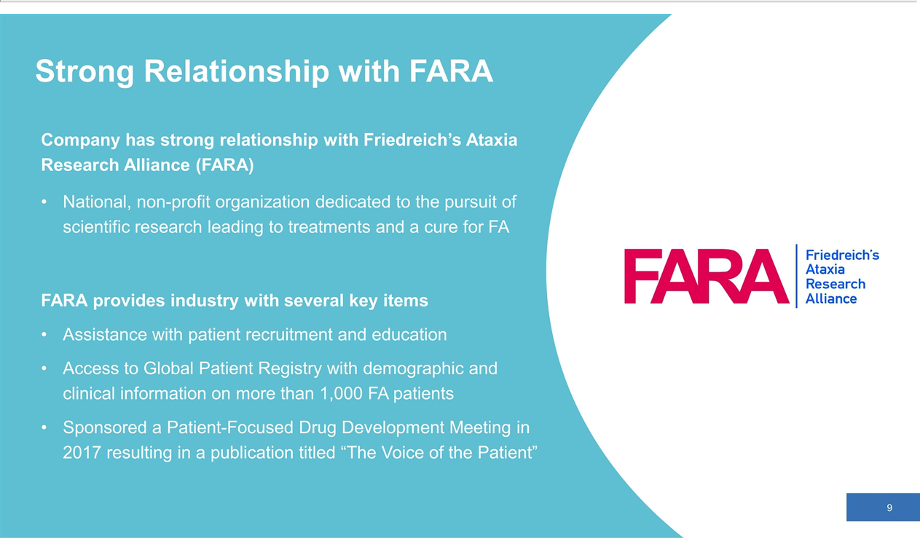

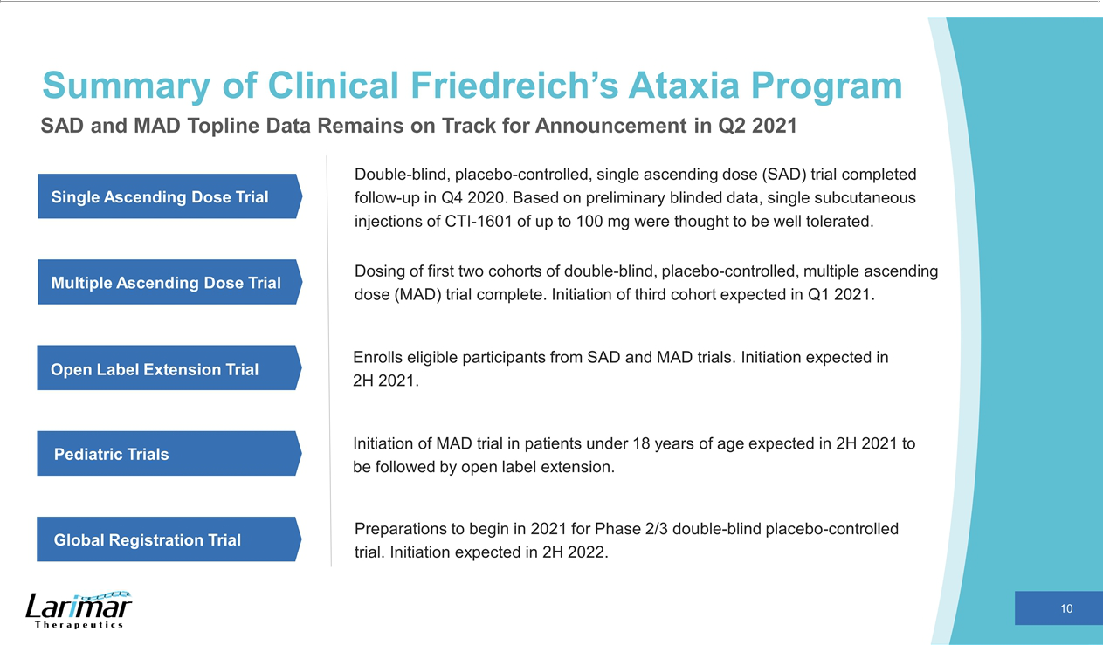

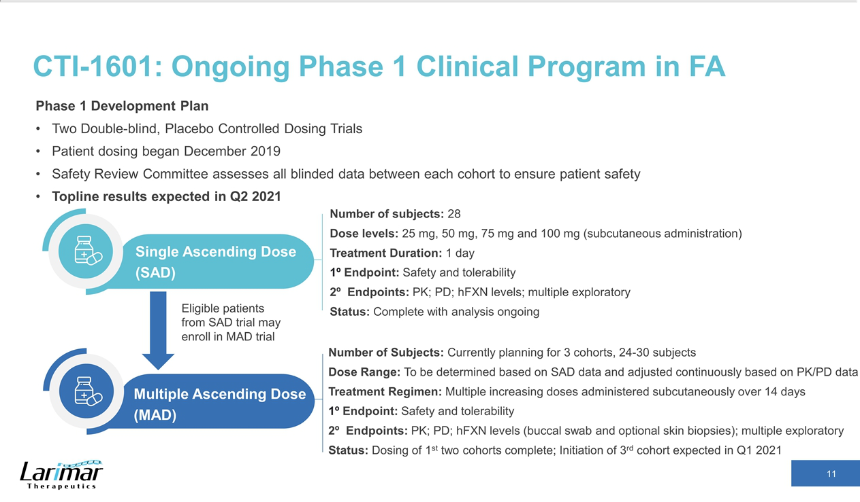

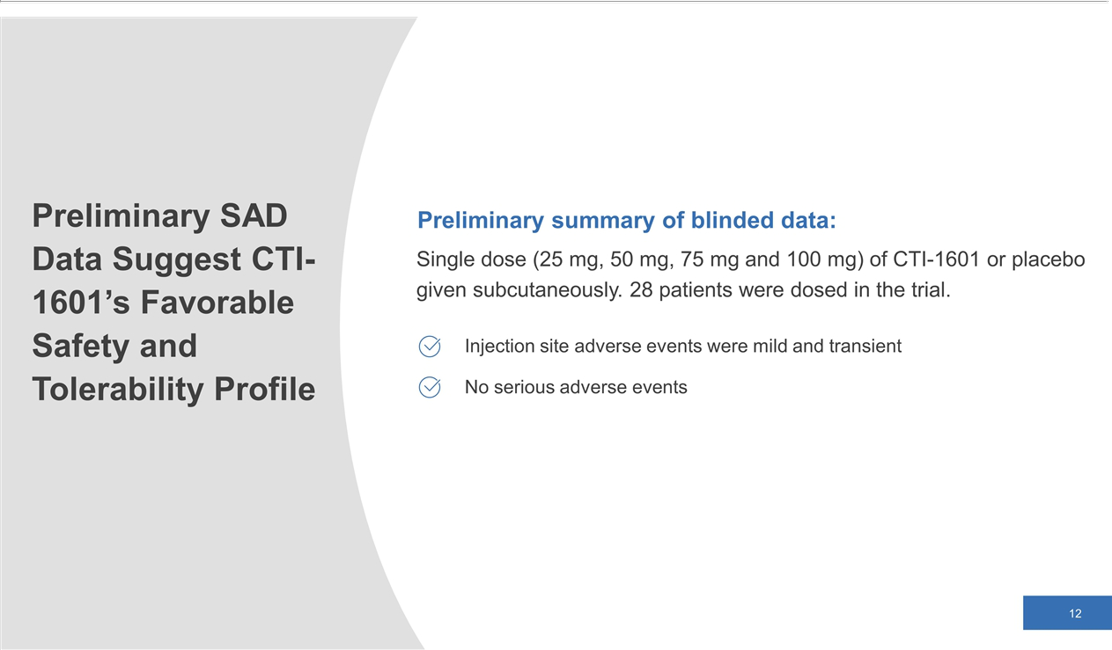

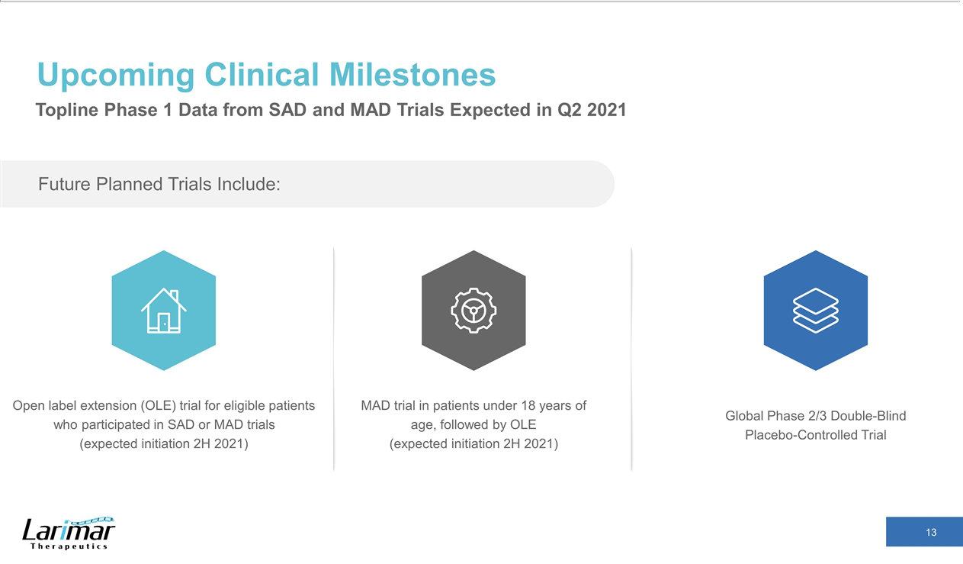

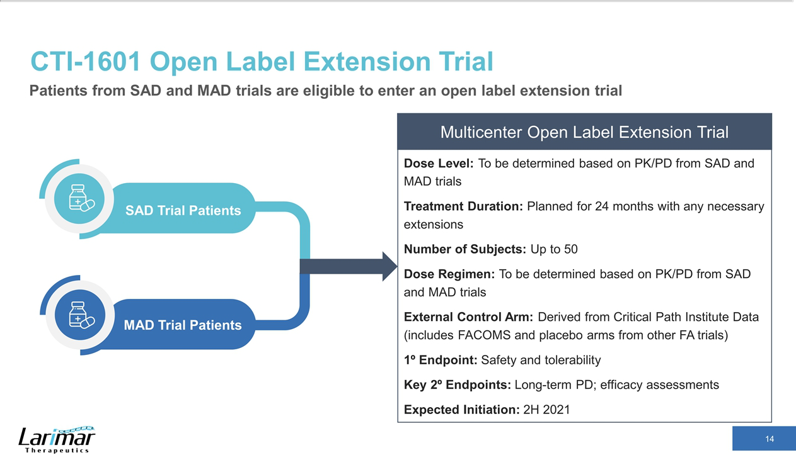

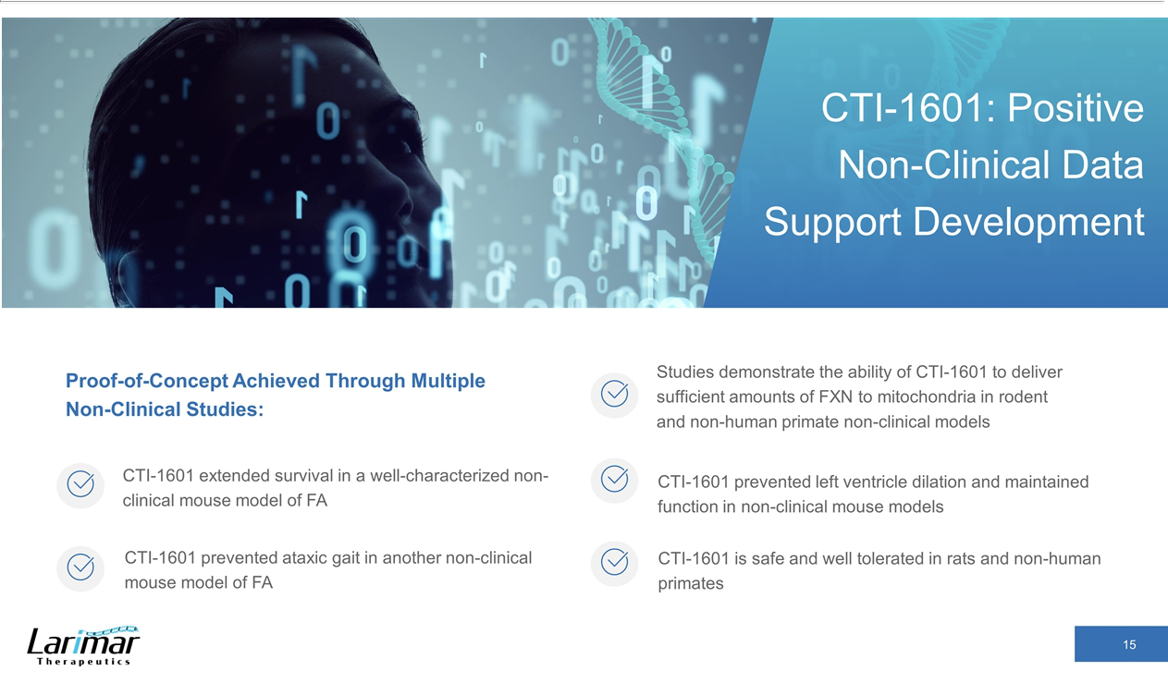

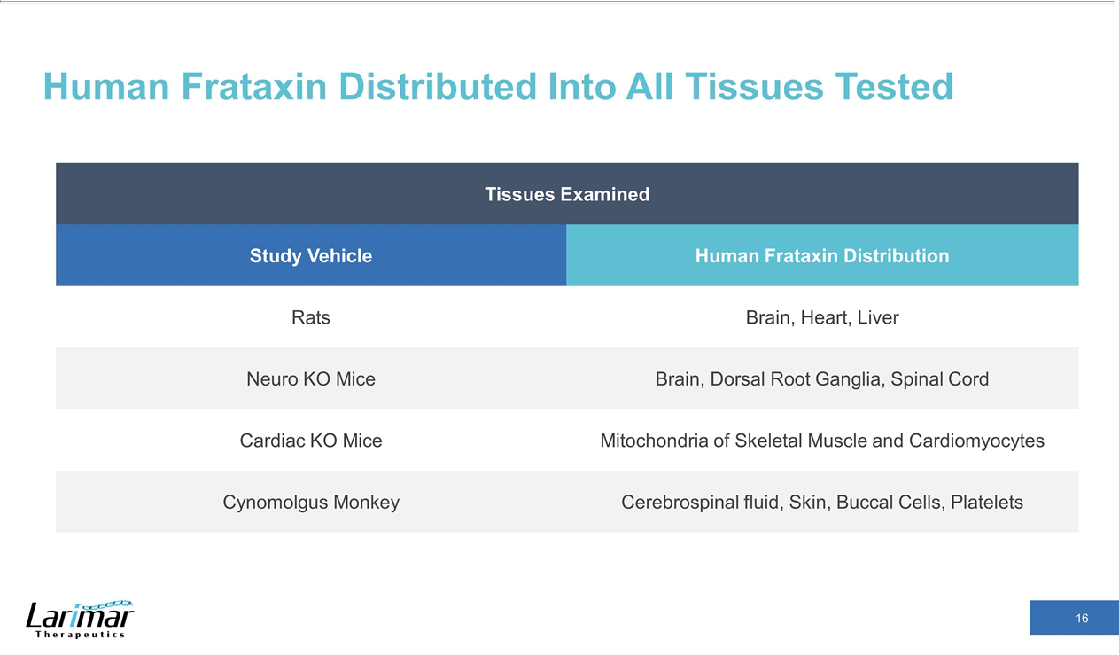

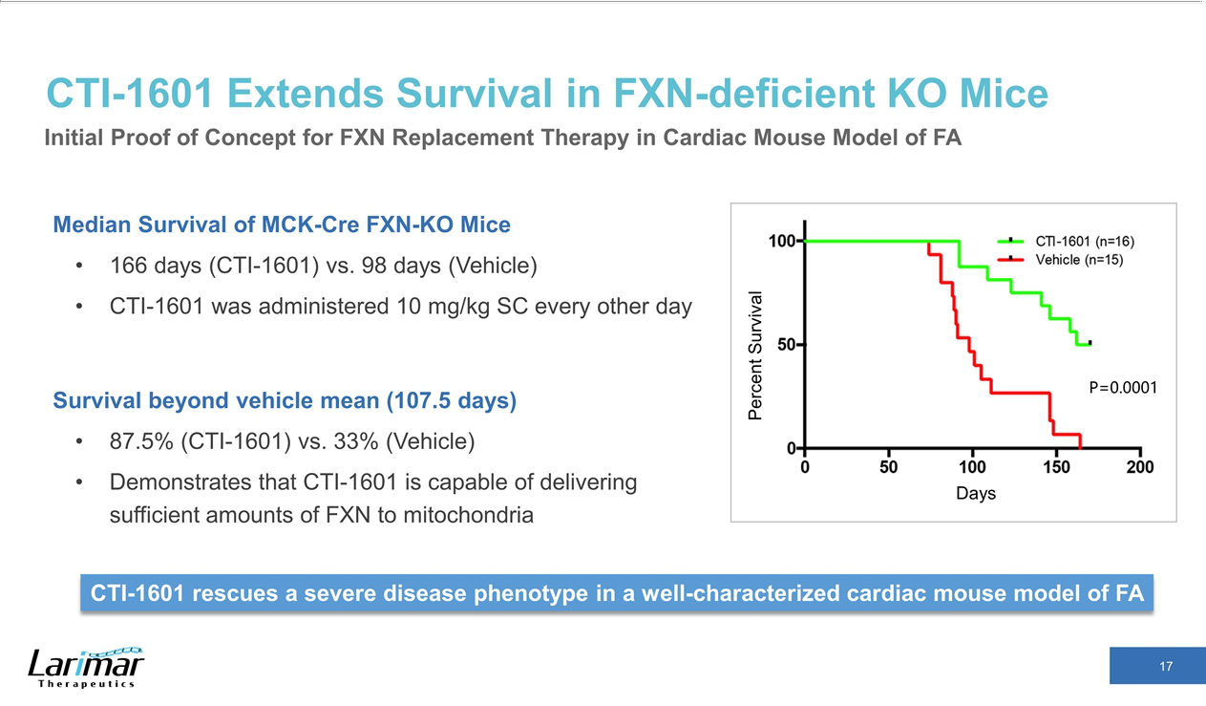

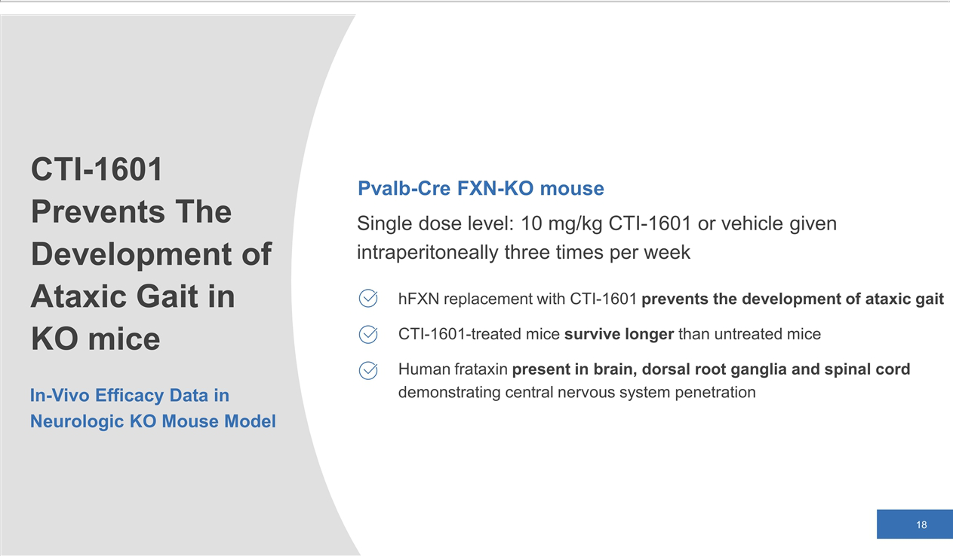

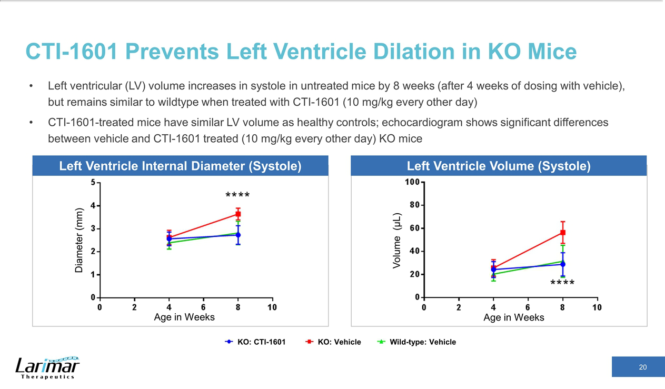

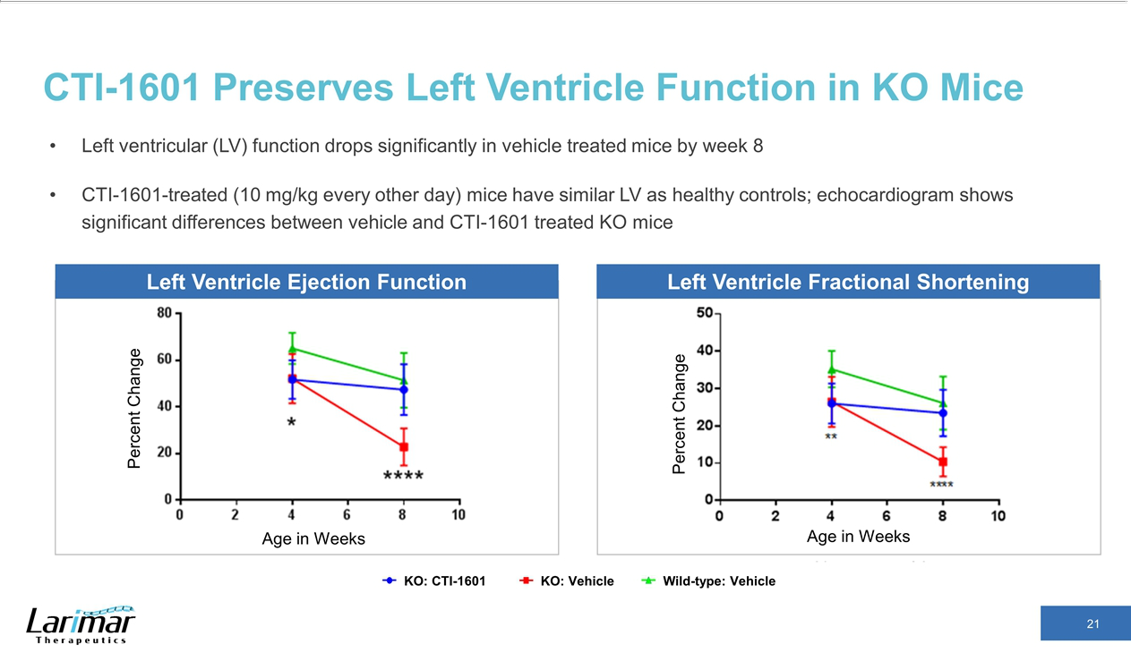

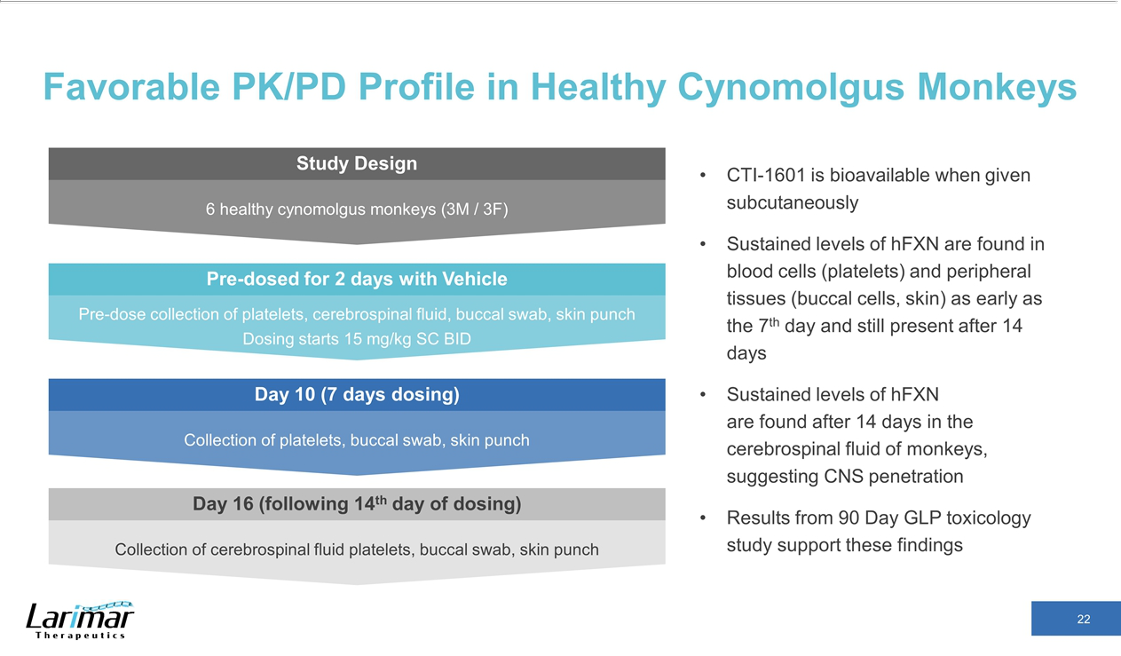

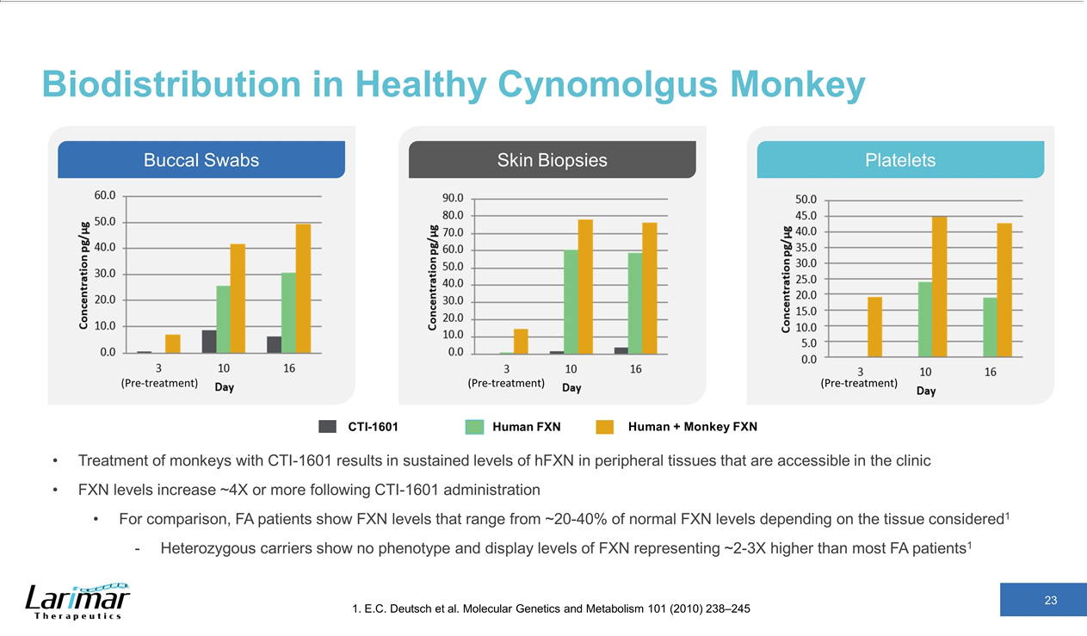

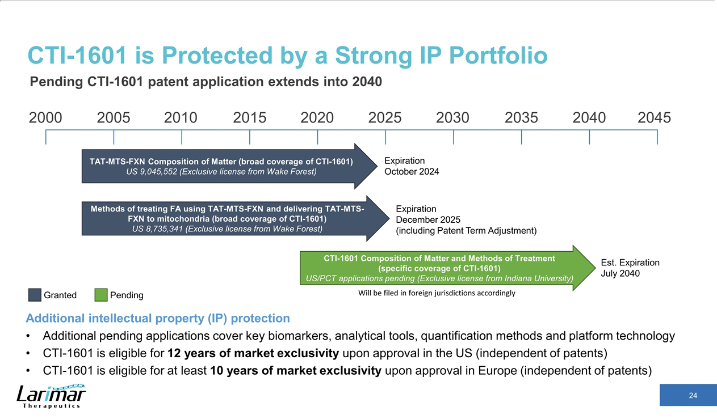

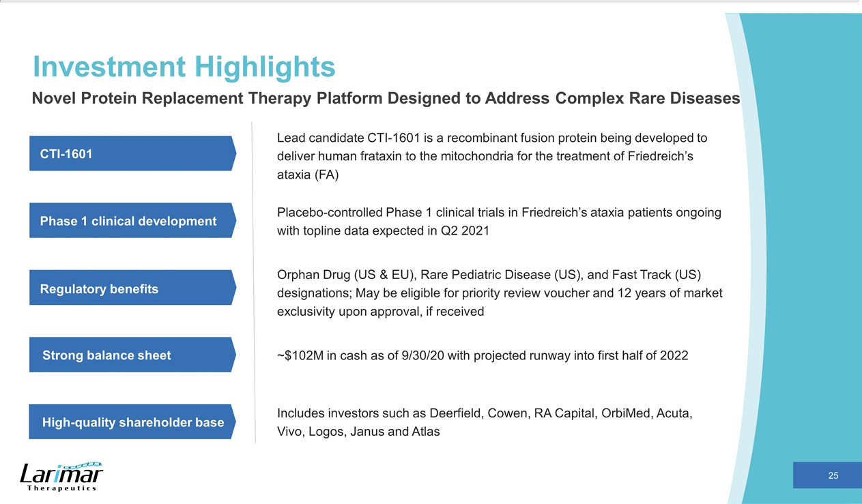



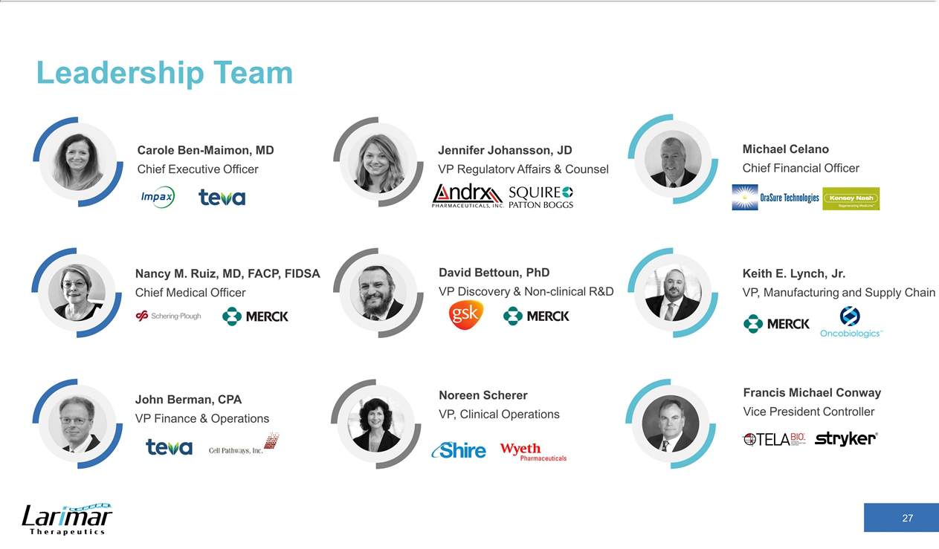

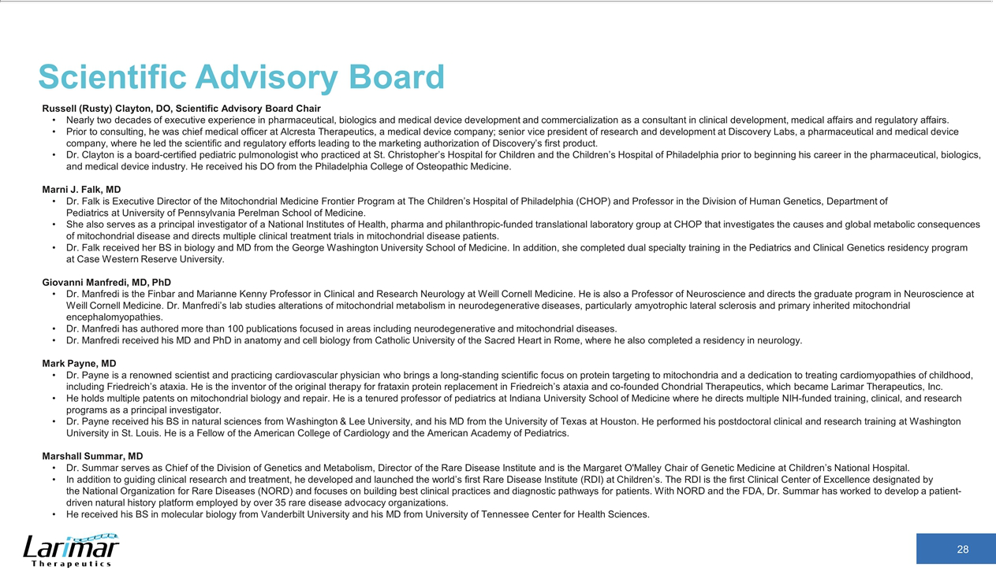

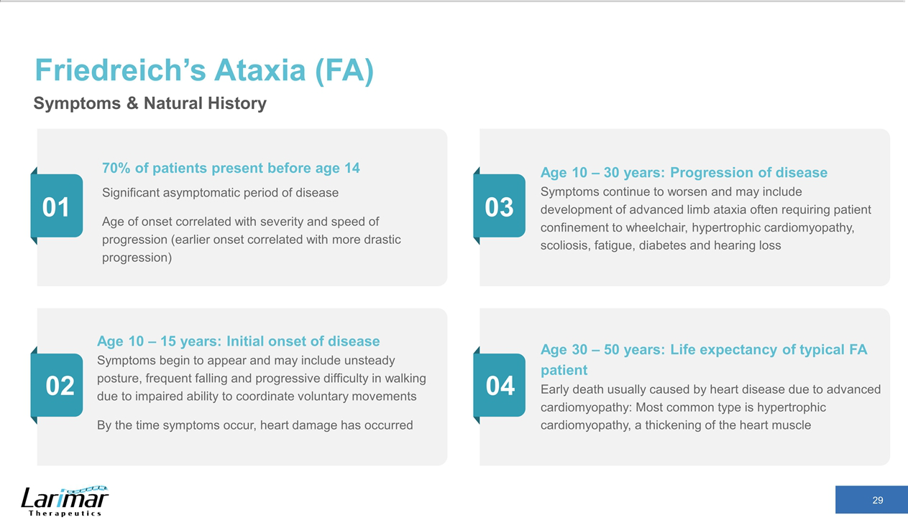

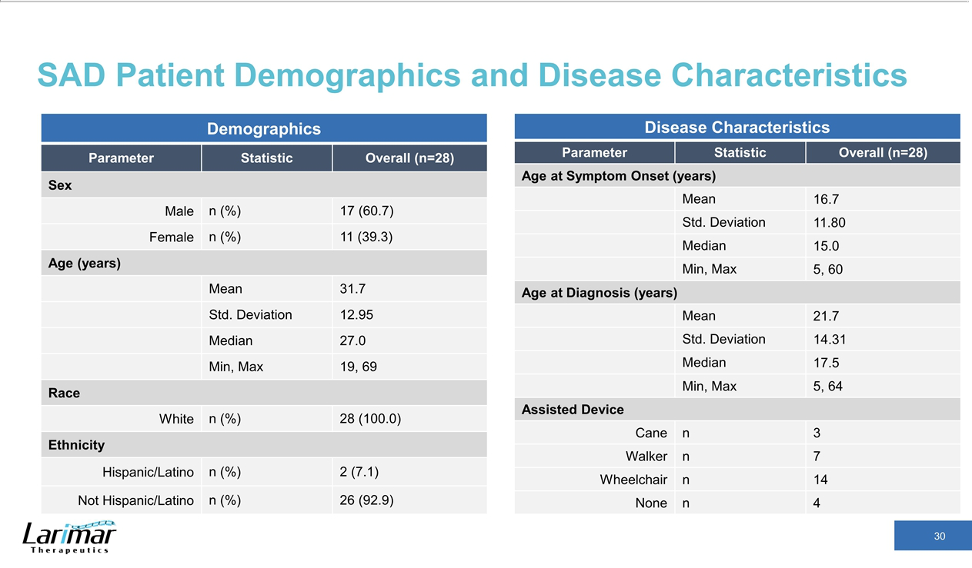

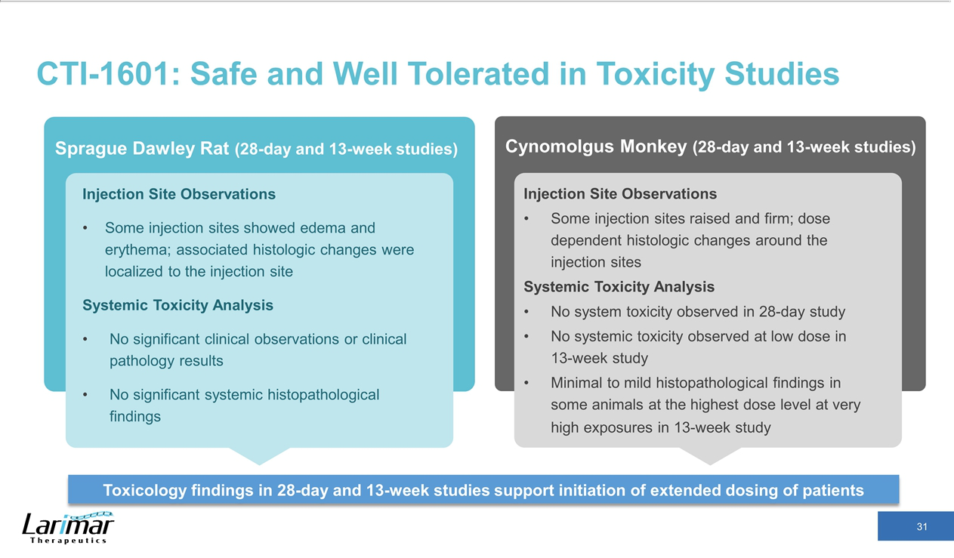

Exhibit 99.2
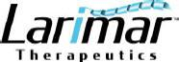

Larimar Therapeutics Announces Completion of Dosing of the Single Ascending Dose Clinical Trial in Friedreich’s Ataxia Patients and

Provides Program Update

- Preliminary data suggest that single subcutaneous injections of CTI-1601 were well tolerated at doses up to 100 mg

- Company remains on track to report topline data from placebo-controlled single and multiple ascending dose clinical trials in Q2 2021

Bala Cynwyd, PA, December 8, 2020 – Larimar Therapeutics, Inc. (“Larimar”) (Nasdaq: LRMR), a clinical-stage biotechnology company focused on developing treatments for complex rare diseases, today announced the completion of dosing from the Company’s Phase 1 single ascending dose (SAD) clinical trial (n=28) evaluating CTI-1601 as a treatment for Friedreich’s ataxia (FA) and provided additional updates regarding the status of an ongoing multiple ascending dose (MAD) clinical trial, the timing of Phase 1 topline results, and future activities planned for 2021.

A Safety Review Committee reviewed preliminary blinded data after each cohort of the placebo-controlled SAD clinical trial and recommended continuation of the trial. Dosing has been completed and based on preliminary data, single subcutaneous injections of CTI-1601 at doses up to 100 mg are thought to have been well tolerated. Injection site adverse events were mild and transient, and no serious adverse events were reported. Analysis of clinical trial results remains ongoing.

“At all doses tested, the Phase 1 SAD data support further investigation of CTI-1601,” said Nancy M. Ruiz, MD, Chief Medical Officer of Larimar. “FA is a rare and progressive disease that has a devastating impact on patient quality of life and mortality. Current treatment options are limited to symptom management. These preliminary Phase 1 findings represent a critical step forward in developing CTI-1601 as a potential frataxin replacement therapy for patients with FA and we look forward to its continued advancement through the clinic.”

Eligible participants from the SAD trial may enroll in an ongoing double-blind, placebo-controlled, MAD clinical trial. To date, dosing of the first two MAD cohorts has been completed, with dosing of the third cohort expected to begin in the first quarter of 2021. Larimar expects to report unblinded topline data from both the SAD and MAD trials in the second quarter of 2021.

Patients completing the SAD and/or MAD clinical trials are eligible to screen for an open-label extension clinical trial, which is expected to initiate in the second half of 2021. Larimar also expects to initiate a MAD clinical trial in patients under 18 years of age in the second half of 2021.

Carole Ben-Maimon, MD, President and Chief Executive Officer of Larimar, commented, “That our Phase 1 program remains on track for topline data in the second quarter of 2021 despite the industry-wide challenges posed by COVID-19 is a testament to the talent and unwavering commitment of our employees, partners, and investigators. Their hard work has allowed us to advance CTI-1601’s clinical development without compromising the safety of our patients. These patients have shown a steadfast dedication to our clinical trials despite the pandemic, and for this we are extremely grateful. Looking forward, the safety of patients and employees will remain our top priority as we work to execute on clinical and corporate milestones in pursuit of our goal of developing this FA therapy.”

About the Phase 1 Single Ascending Dose (SAD) Clinical Trial

The Phase 1 SAD clinical trial is a double-blind, placebo-controlled, randomized clinical trial to assess the safety of subcutaneously administered CTI-1601 versus placebo in adult subjects with Friedreich’s ataxia (FA). Subjects receive either placebo or treatment consisting of 25 mg, 50 mg, 75 mg, or 100 mg of CTI-1601. The primary objective is to assess the safety and tolerability of single ascending doses of CTI-1601 in subjects with FA. Key secondary endpoints include pharmacokinetic and pharmacodynamic analyses following increasing single doses of subcutaneously administered CTI-1601. Patients from the SAD trial are eligible to screen for an ongoing MAD clinical trial and/or an open-label extension trial that is expected to initiate in the second half of 2021.

About the Phase 1 Multiple Ascending Dose (MAD) Clinical Trial

The Phase 1 MAD clinical trial is a double-blind, placebo-controlled, randomized clinical trial to assess the safety of subcutaneously administered CTI-1601 versus placebo in adult subjects with Friedreich’s ataxia (FA). The primary objective is to assess the safety and tolerability of multiple ascending doses of CTI-1601 in subjects with FA. Key secondary endpoints include pharmacokinetic and pharmacodynamic analyses following increasing multiple doses of subcutaneously administered CTI-1601. Two cohorts of dosing have been completed and the third cohort is expected to begin dosing in the first quarter of 2021. Patients from the MAD trial are eligible to screen for an open-label extension trial that is expected to initiate in the second half of 2021.

About CTI-1601

CTI-1601 is a recombinant fusion protein intended to deliver human frataxin into the mitochondria of patients with Friedreich’s ataxia who are unable to produce enough of this essential protein. Currently in Phase 1 clinical trials in the U.S., CTI-1601 has been granted Rare Pediatric Disease designation, Fast Track designation and Orphan Drug designation by the U.S. Food and Drug Administration (FDA) and orphan drug designation by the European Commission. Topline results from the Phase 1 clinical program are planned for the second quarter of 2021.

About Larimar Therapeutics

Larimar Therapeutics, Inc. (Nasdaq: LRMR), is a clinical-stage biotechnology company focused on developing treatments for complex rare diseases. The company’s lead compound, CTI-1601, is currently being evaluated in a Phase 1 clinical program in the U.S. as a potential treatment for Friedreich’s ataxia. Larimar also plans to use its intracellular delivery platform to design other fusion proteins to target additional rare diseases characterized by deficiencies in intracellular bioactive compounds. For more information, please visit: https://larimartx.com.

Forward-Looking Statements

This press release contains forward-looking statements that are based on Larimar’s management’s beliefs and assumptions and on information currently available to management. All statements contained in this release other than statements of historical fact are forward-looking statements, including but not limited to statements regarding Larimar’s ability to develop and commercialize CTI-1601 and other planned product candidates, Larimar’s planned research and development efforts, and other matters regarding Larimar’s business strategies, use of capital, results of operations and financial position, and plans and objectives for future operations.

In some cases, you can identify forward-looking statements by the words “may,” “will,” “could,” “would,” “should,” “expect,” “intend,” “plan,” “anticipate,” “believe,” “estimate,” “predict,” “project,” “potential,” “continue,” “ongoing” or the negative of these terms or other comparable terminology, although not all forward-looking statements contain these words. These statements involve risks, uncertainties and other factors that may cause actual results, performance, or achievements to be materially different from the information expressed or implied by these forward-looking statements. These risks, uncertainties and other factors include, among others, the success, cost and timing of Larimar’s product development activities, studies and clinical trials, including CTI-1601 clinical milestones, and risk that preliminary clinical data may not be indicative of final results or predict the results of later nonclinical or clinical trials; the ongoing impact of the COVID-19 pandemic on Larimar’s clinical trial timelines, ability to raise additional capital and general economic conditions; Larimar’s ability to optimize and scale CTI-1601’s manufacturing process; Larimar’s ability to obtain regulatory approval for CTI-1601 and future product candidates; Larimar’s ability to develop sales and marketing capabilities, whether alone or with potential future collaborators, and successfully commercialize any approved product candidates; Larimar’s ability to raise the necessary capital to conduct its product development activities; and other risks described in the filings made by the Company with the Securities and Exchange Commission (SEC), including but not limited to Larimar’s periodic reports, including the annual report on Form 10-K, quarterly reports on Form 10-Q and current reports on Form 8-K, filed with or furnished to the Securities and Exchange Commission and available at www.sec.gov. These forward-looking statements are based on a combination of facts and factors currently known by Larimar and its projections of the future, about which it cannot be certain. As a result, the forward-looking statements may not prove to be accurate. The forward-looking statements in this press release represent views as of the date hereof. Larimar undertakes no obligation to update any forward-looking statements for any reason, except as required by law.

Investor Contact:

Joyce Allaire

LifeSci Advisors

jallaire@lifesciadvisors.com

(212) 915-2569

Media Contact:

Gina Cestari

- Degrees gcestari@6degreespr.com (917) 797-7904

