UNITED STATES

SECURITIES AND EXCHANGE COMMISSION
Washington, D.C. 20549

SCHEDULE 14A

Proxy Statement Pursuant to Section 14(a) of the

Securities Exchange Act of 1934
(Amendment No. )

Filed by the Registrant ☒ Filed by a Party other than the Registrant ☐

Check the appropriate box:

- Preliminary Proxy Statement

- Confidential, for Use of the Commission Only (as permitted by Rule 14a-6(e)(2))

- Definitive Proxy Statement

- Definitive Additional Materials

- Soliciting Material under Rule 14a-12


Larimar Therapeutics, Inc.

(Name of Registrant as Specified In Its Charter)

(Name of Person(s) Filing Proxy Statement, if other than the Registrant)

Payment of Filing Fee (Check the appropriate box):

- No fee required.

- Fee computed on table below per Exchange Act Rules 14a-6(i)(4) and 0-11.

  - Title of each class of securities to which transaction applies:

  - Aggregate number of securities to which transaction applies:

  - Per unit price or other underlying value of transaction computed pursuant to Exchange Act Rule 0-11 (Set forth the amount on which the filing fee is calculated and state how it was determined):

  - Proposed maximum aggregate value of transaction:

  - Total fee paid:

- Fee paid previously with preliminary materials.

- Check box if any part of the fee is offset as provided by Exchange Act Rule 0-11(a)(2) and identify the filing for which the offsetting fee was paid previously. Identify the previous filing by registration statement number, or the Form or Schedule and the date of its filing.

  - Amount Previously Paid:

  - Form, Schedule or Registration Statement No.:

  - Filing Party:

  - Date Filed:

*** Exercise Your Right to Vote ***

Important Notice Regarding the Availability of Proxy Materials for the


Shareholder Meeting to Be Held on September 29, 2020

LARIMAR THERAPEUTICS, INC.
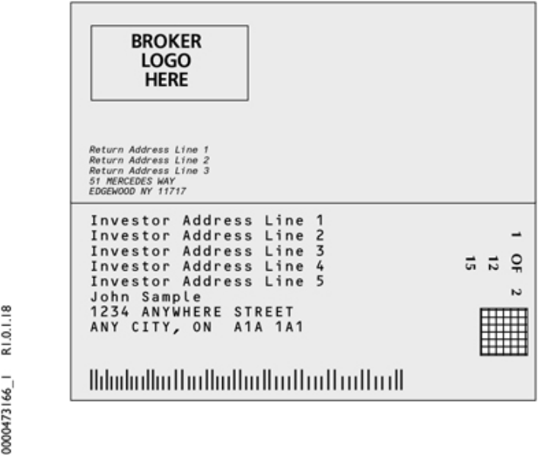

Meeting Information

Meeting Type: Special Meeting

For holders as of: August 12, 2020
Date: September 29, 2020 Time: 9:00 AM EDT

Location: Virtually via the internet at:

www.meetingcenter.io/202792612

To access the virtual meeting, you must refer to the

“General Information” section of the proxy statement.

You are receiving this communication because you hold shares in the above named company.

This is not a ballot. You cannot use this notice to vote these shares. This communication presents only an overview of the more complete proxy materials that are available to you on the Internet. You may view the proxy materials online at www.proxyvote.com or easily request a paper copy (see reverse side).

We encourage you to access and review all of the important information contained in the proxy materials before voting.

See the reverse side of this notice to obtain proxy materials and voting instructions.
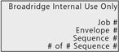

— Before You Vote—

How to Access the Proxy Materials


Proxy Materials Available to VIEW or RECEIVE:

1. Notice & Proxy Statement

How to View Online:

Have the information that is printed in the box marked by the arrow following page) and visit: www.proxyvote.com.

(located on the

How to Request and Receive a PAPER or E-MAIL Copy:

If you want to receive a paper or e-mail copy of these documents, you must request one. There is NO charge for requesting a copy. Please choose one of the following methods to make your request:
1) BY INTERNET: www.proxyvote.com
  - BY TELEPHONE: 1-800-579-1639
  - BY E-MAIL*:sendmaterial@proxyvote.com
* If requesting materials by e-mail, please send a blank e-mail with the information that is printed in the box marked by

the arrow (located on the following page) in the subject line.

Requests, instructions and other inquiries sent to this e-mail address will NOT be forwarded to your investment advisor.

Please make the request as instructed above on or before September 14, 2020 to facilitate timely delivery.

—How To Vote —

Please Choose One of the Following Voting Methods


Vote In Person: If you choose to vote these shares in person at the meeting, you must request a “legal proxy.” To do so, please follow the instructions at www.proxyvote.com or request a paper copy of the materials, which will contain the appropriate instructions. Many shareholder meetings have attendance requirements including, but not limited to, the possession of an attendance ticket issued by the entity holding the meeting. Please check the meeting materials for any special requirements for meeting attendance.

Vote By Internet: To vote now by Internet, go to www.proxyvote.com. Have the information that is printed in the box

marked by the arrow available and follow the instructions.


Vote By Mail: You can vote by mail by requesting a paper copy of the materials, which will include a voting instruction form.

Voting Items


The Board of Directors recommends

you vote FOR the following

proposal(s):

- Approve the Larimar Therapeutics, Inc. 2020 Equity Incentive Plan and certain conditional grants thereunder

NOTE: Such other business as may properly come before the meeting or any adjournment thereof.
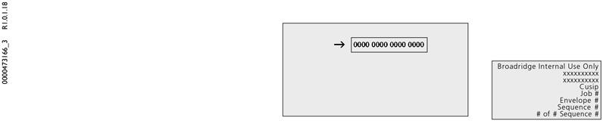

Reserved for Broadridge Internal Control Information


Voting Instructions


THIS SPACE RESERVED FOR LANGUAGE PERTAINING TO

BANKS AND BROKERS

AS REQUIRED BY THE NEW YORK STOCK EXCHANGE

THIS SPACE RESERVED FOR SIGNATURES IF APPLICABLE

Broadridge Internal Use Only

Job #
Envelope #
Sequence #
# of # Sequence #

